**Event App Use Case Deployment**

**MongoDB database using Azure Cosmos DB:**

* Select Azure Cosmos DB for MongoDB.
* Select RU database account.
* Select Resource Group, give unique account name, select region, capacity mode and version.
* Then click on Review + Create. After validation success click on create.
* Once created click on Go to resource and copy Primary Connection string and paste in your appsetting.json mongo dB connection string.

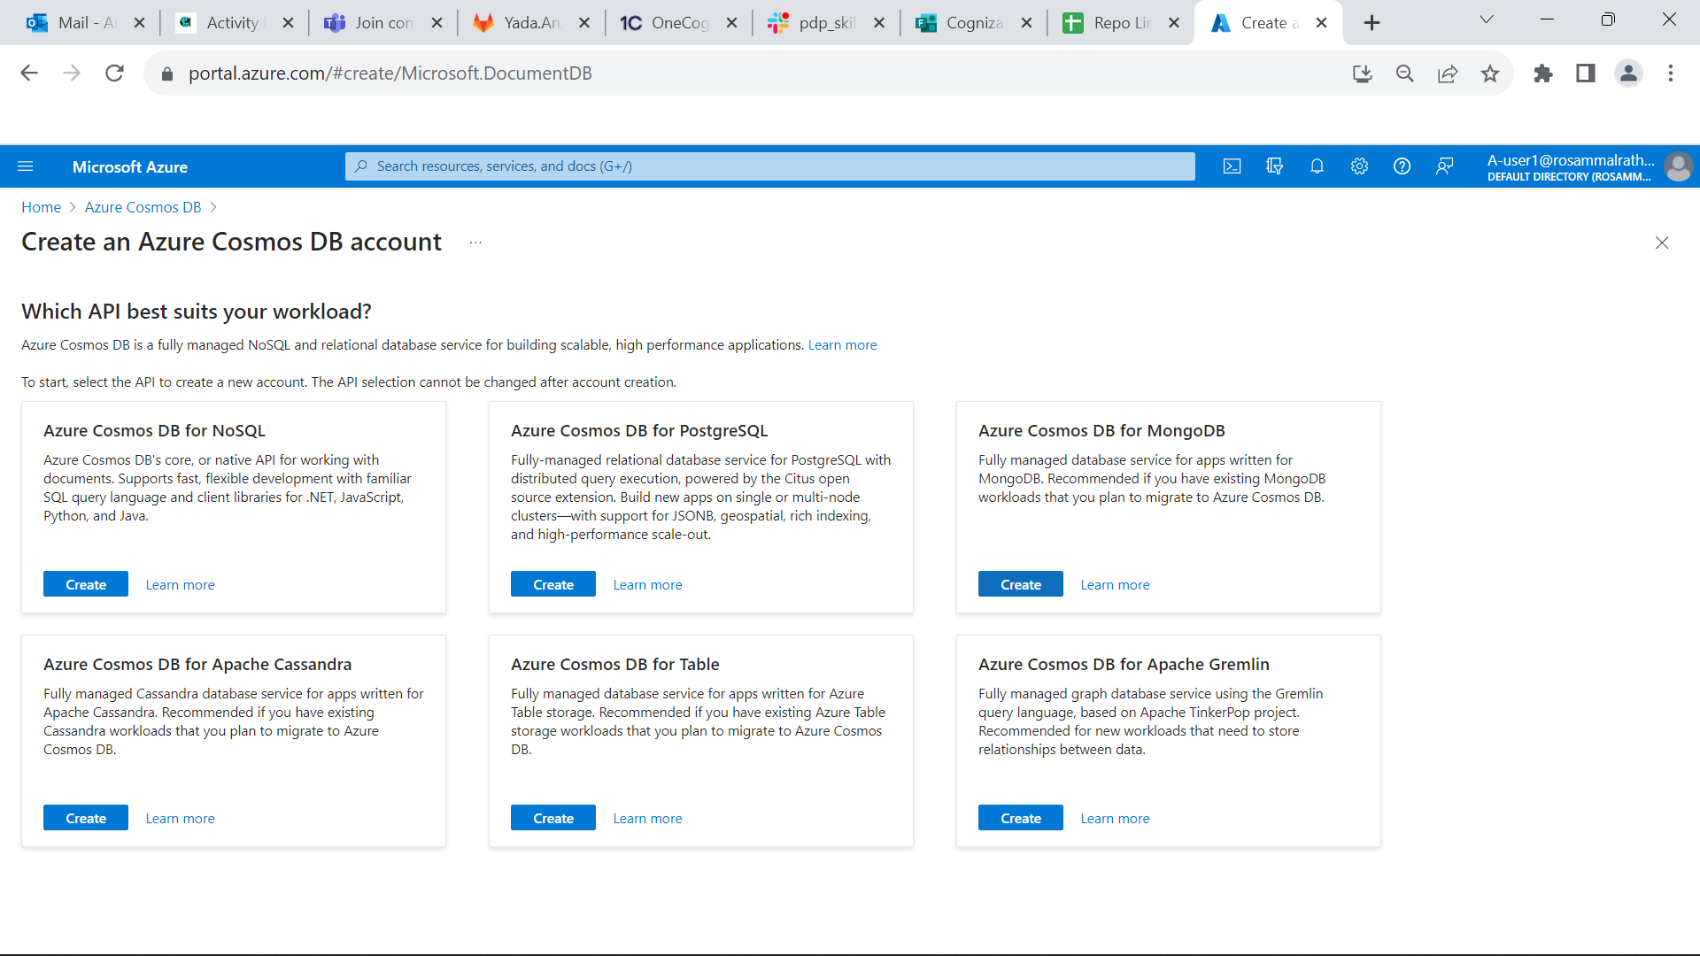

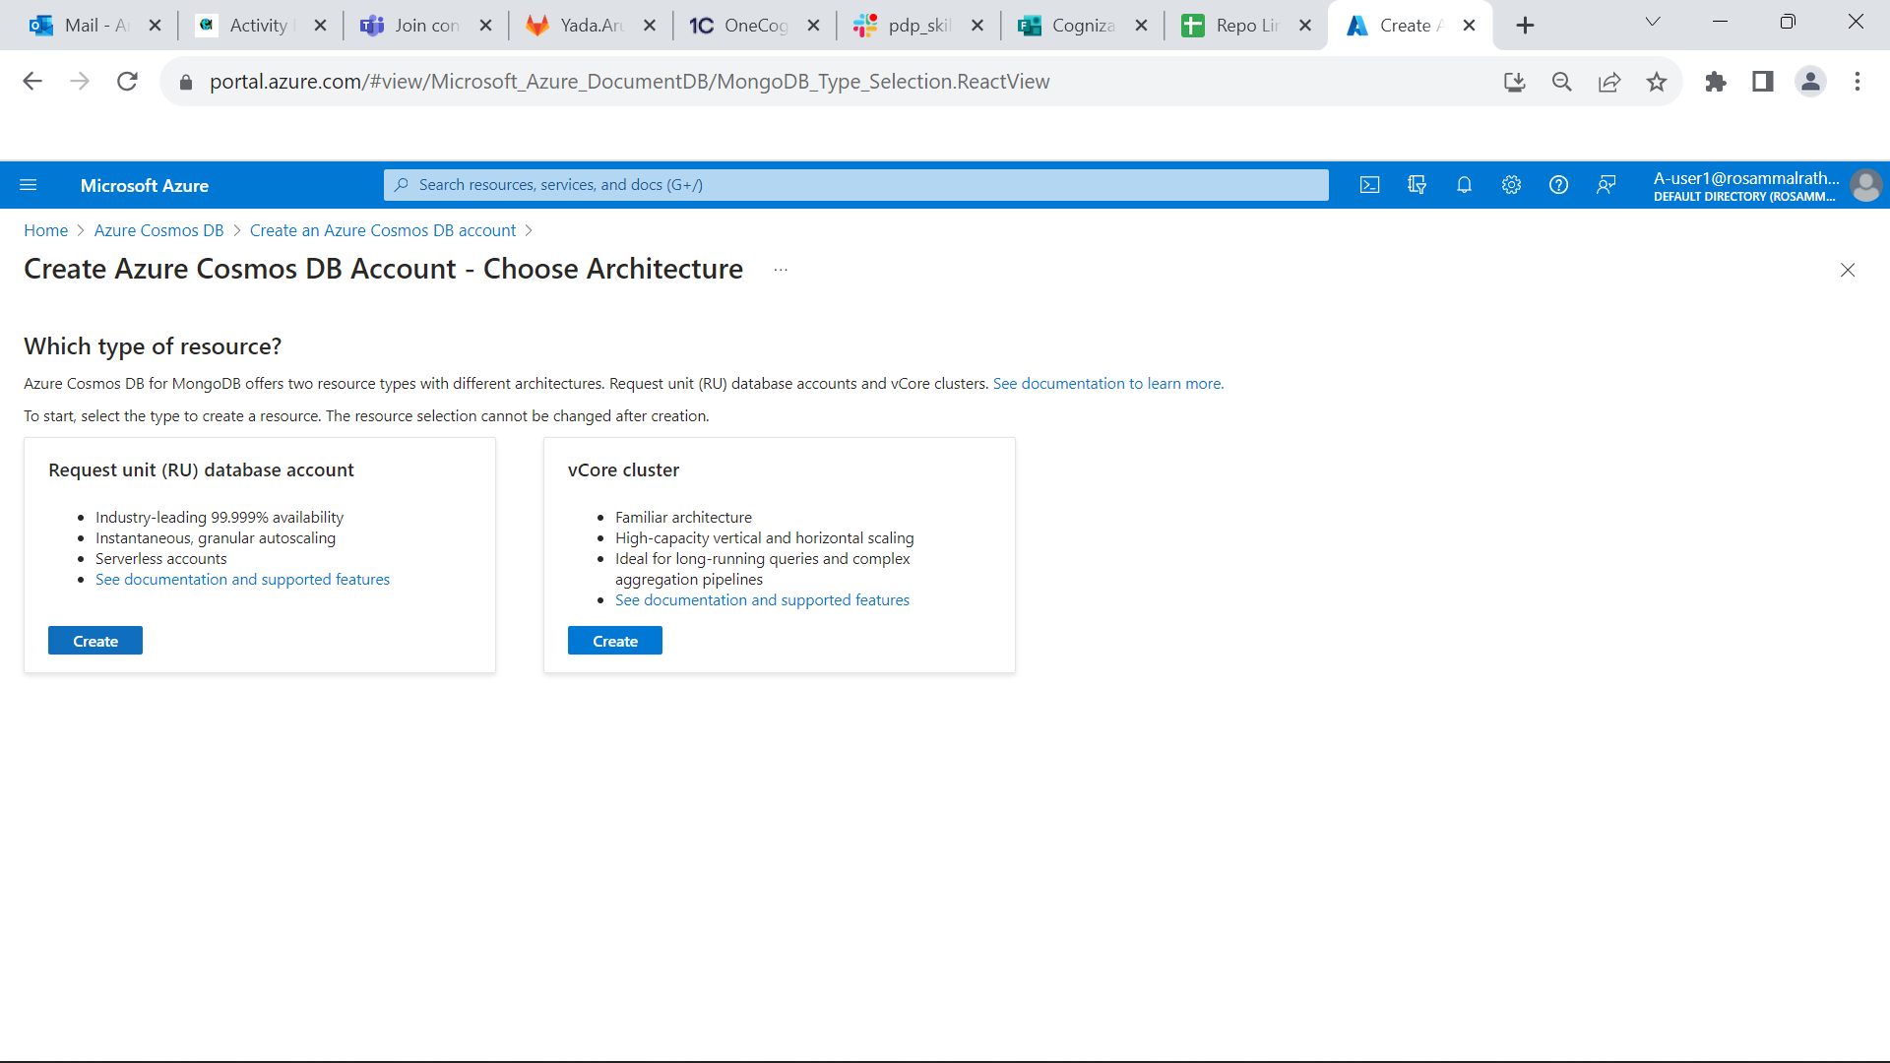

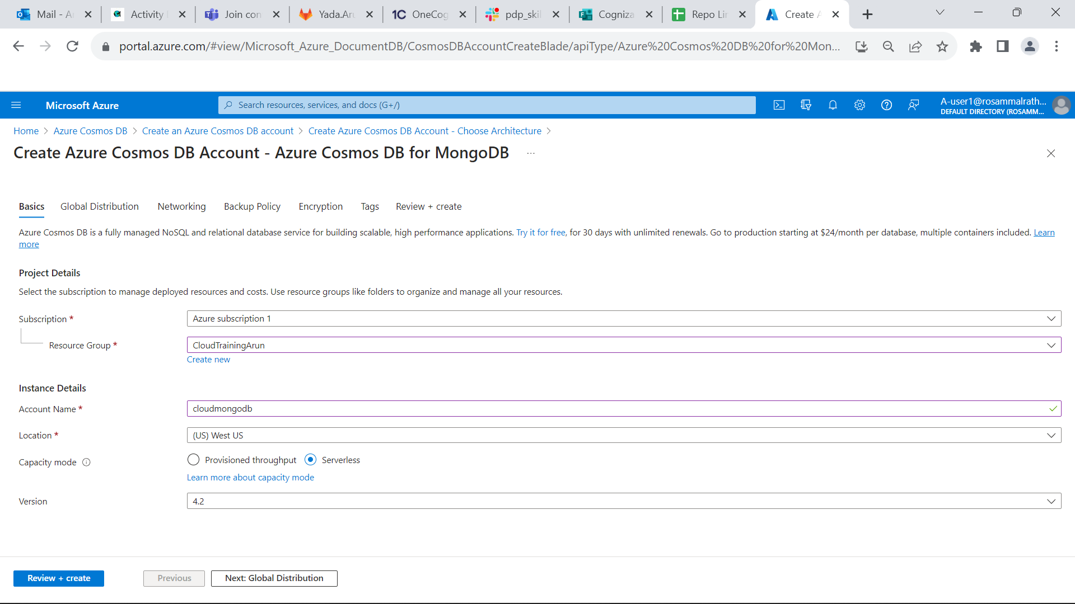

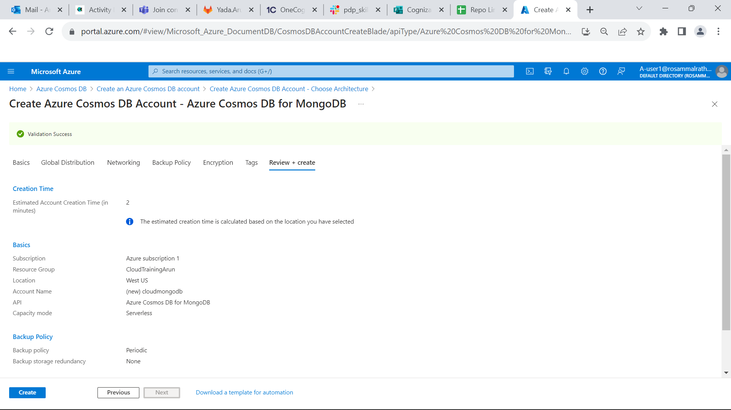

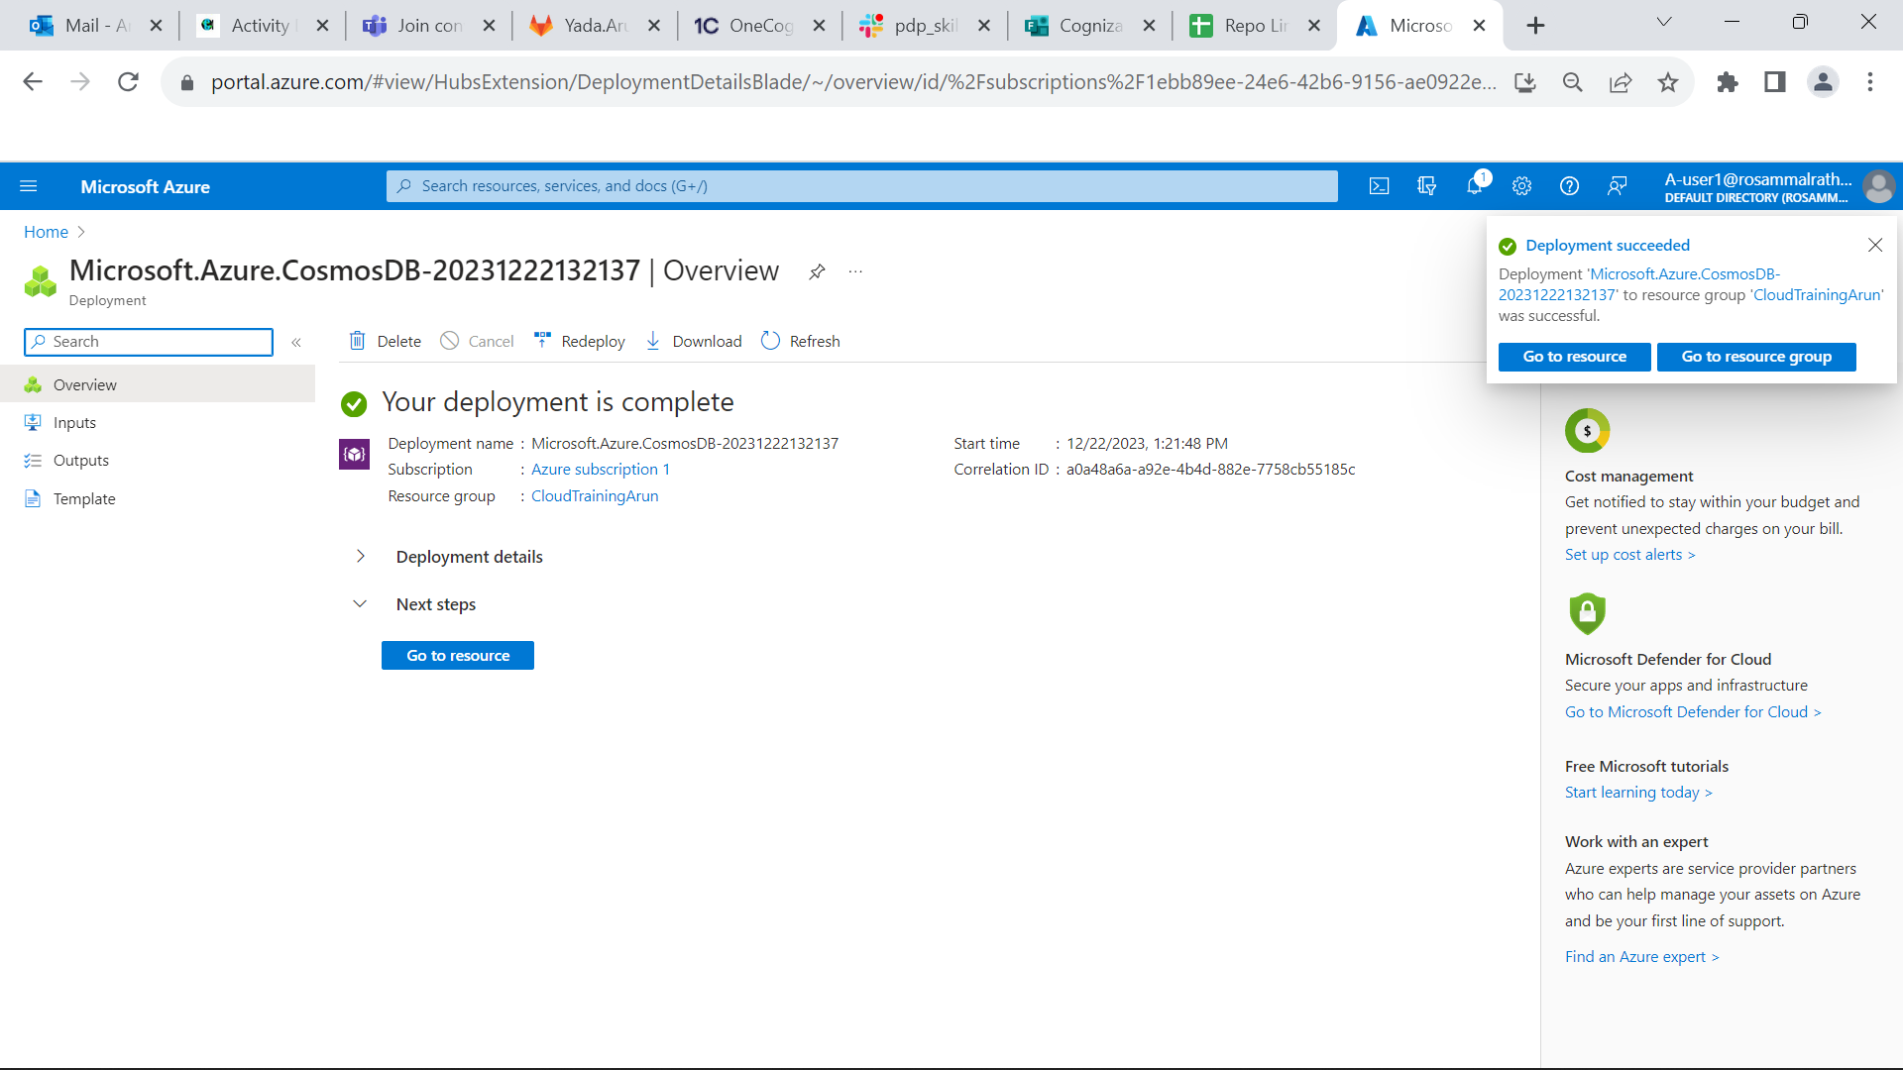

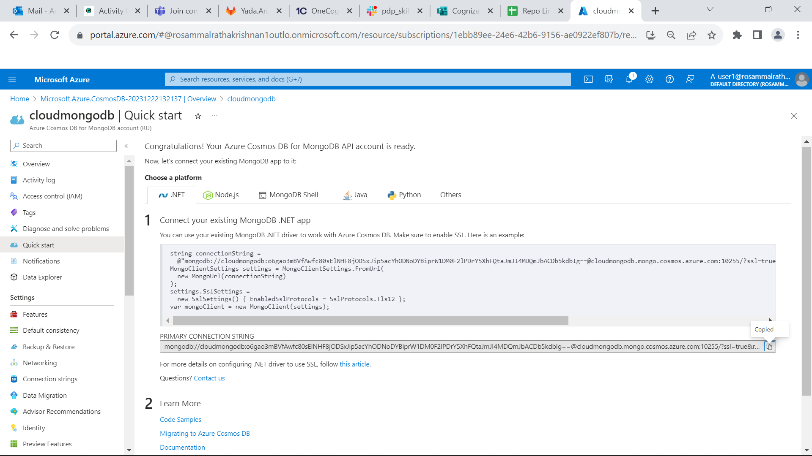

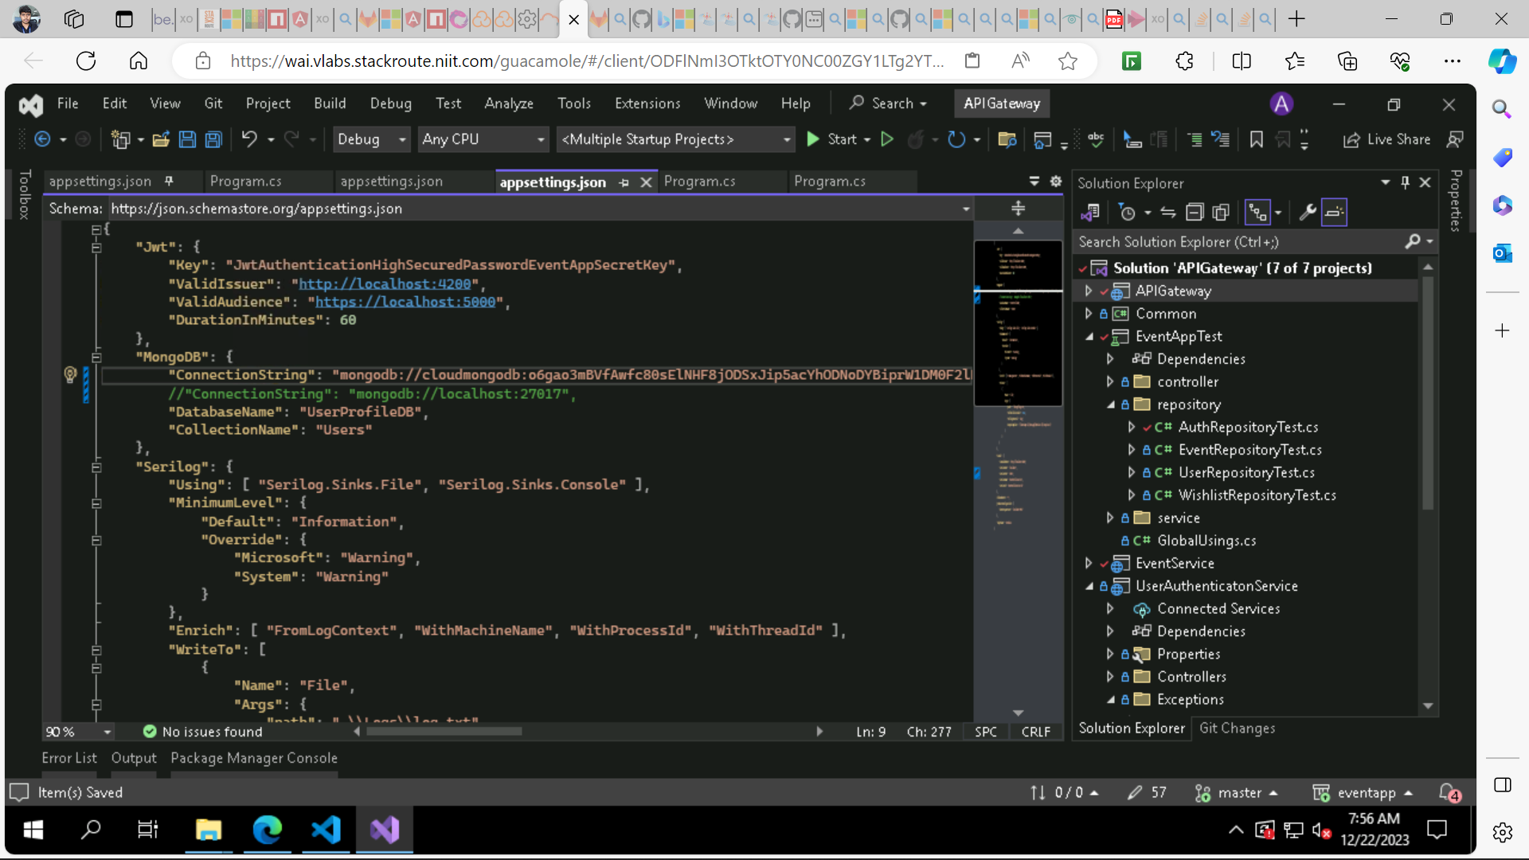

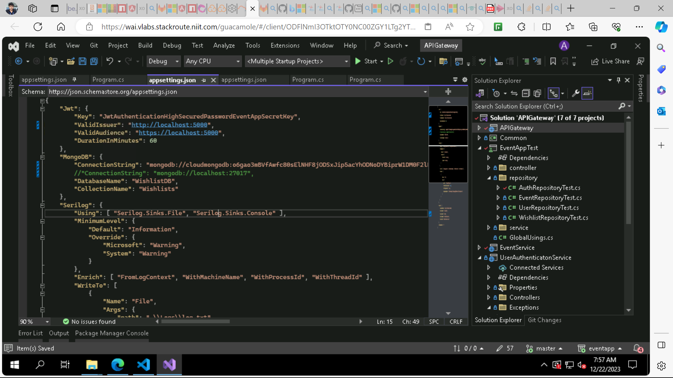

**Azure SQL Database:**

* Select resource group, give unique database name, click create new and create SQL database server.
* Give unique name to server name, select location, authentication method – SQL authentication.
* set admin. Click ok.
* Select workload environment – development, backup storage redundancy – LRS.

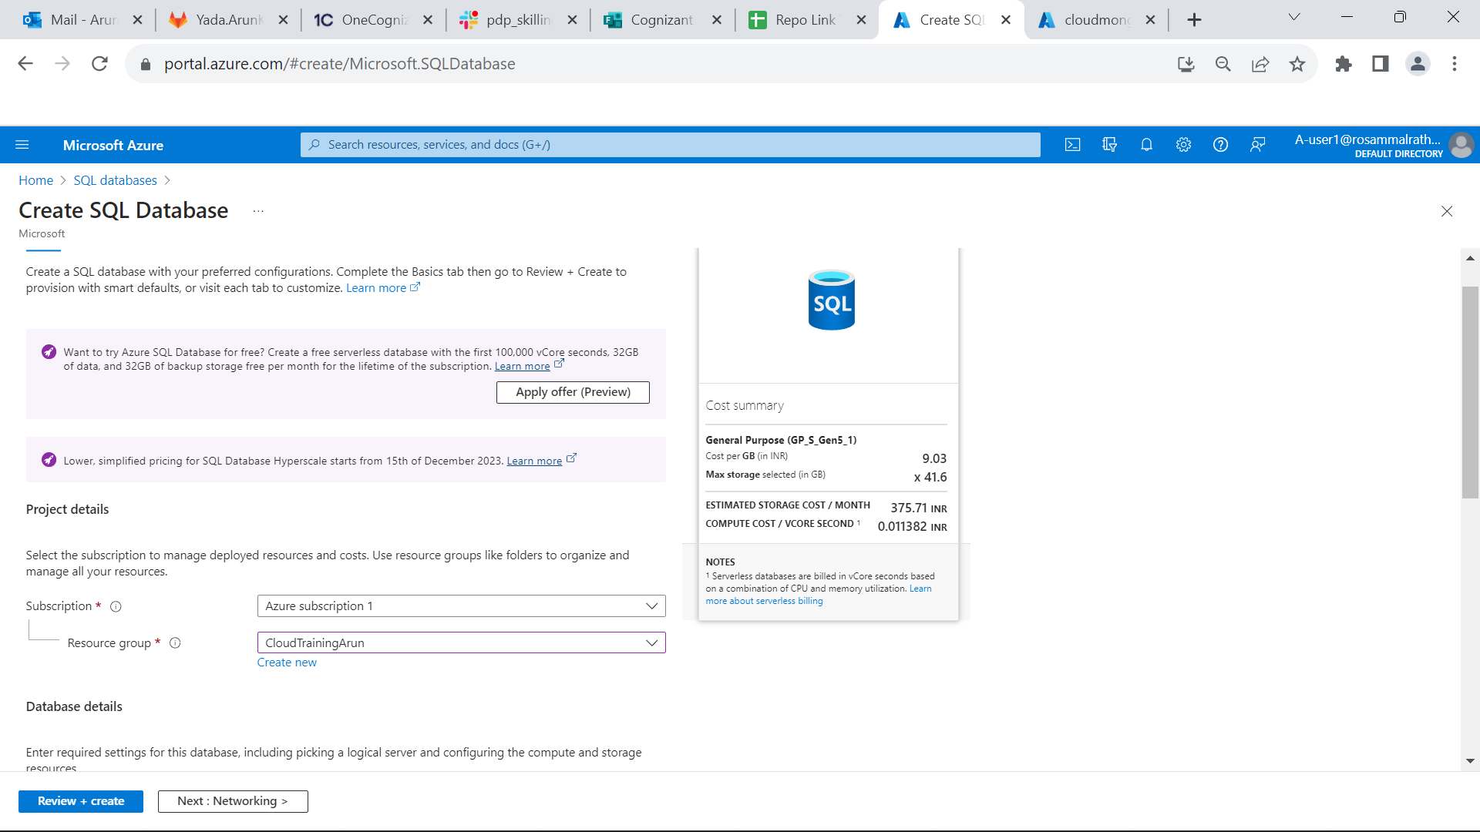

* Network connectivity- select enable public endpoint.
* Change Allow Azure services and resources to yes and client Ip address to yes.
* Then click on Review+ create and create.

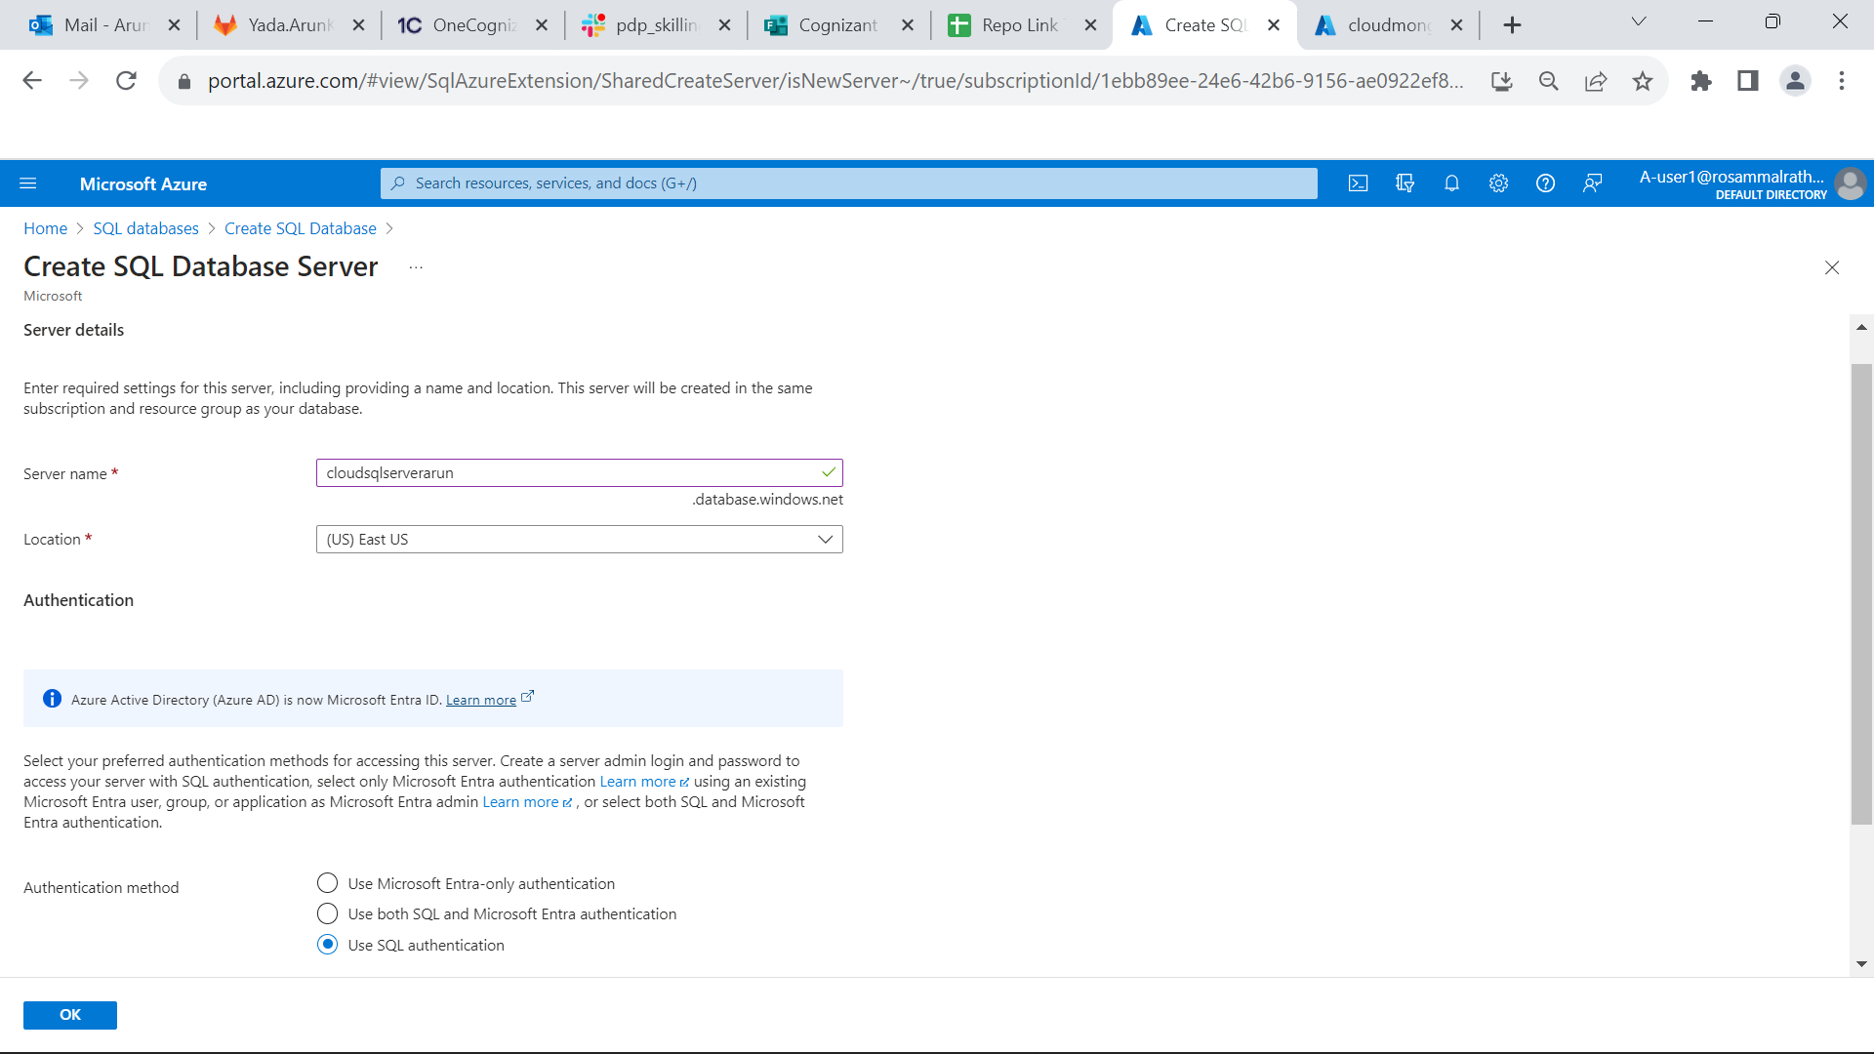

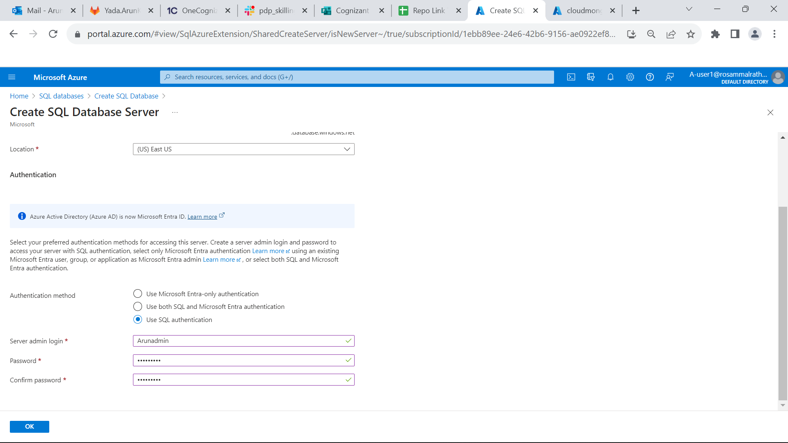

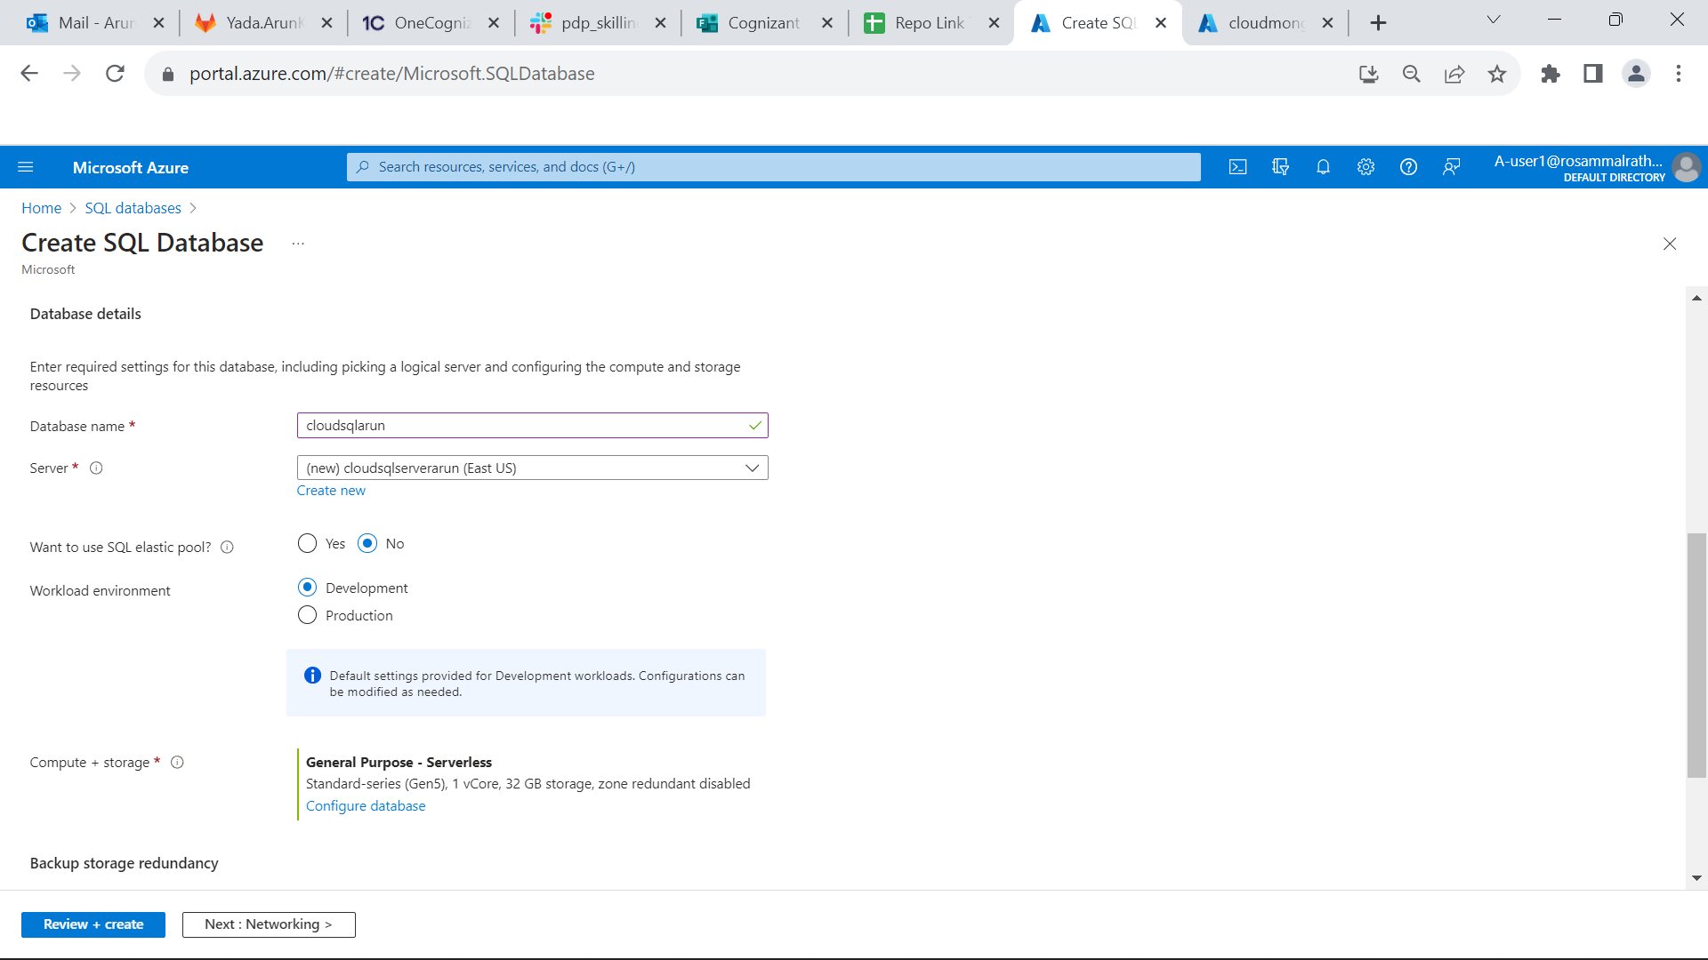

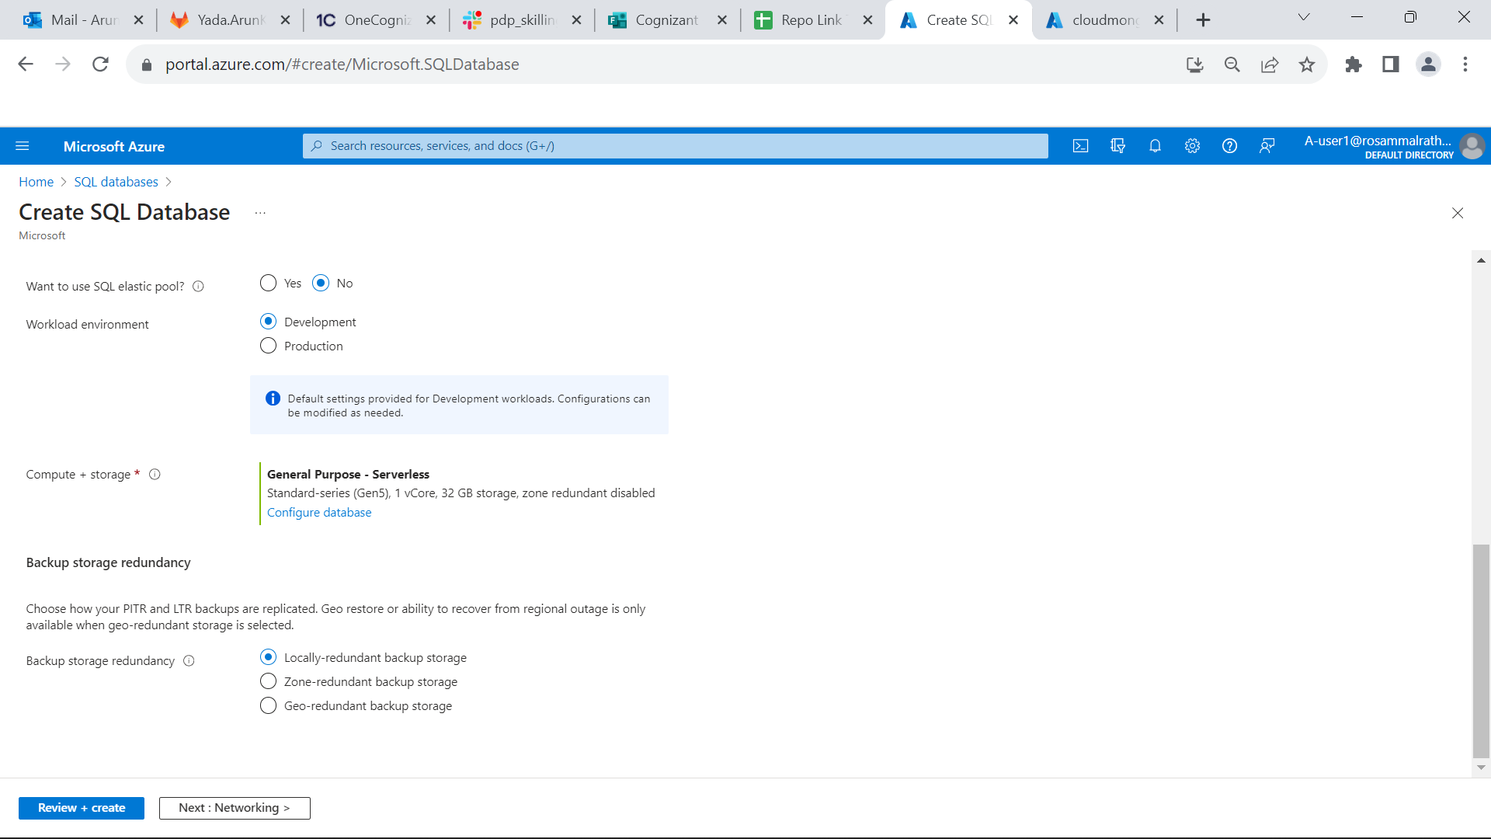

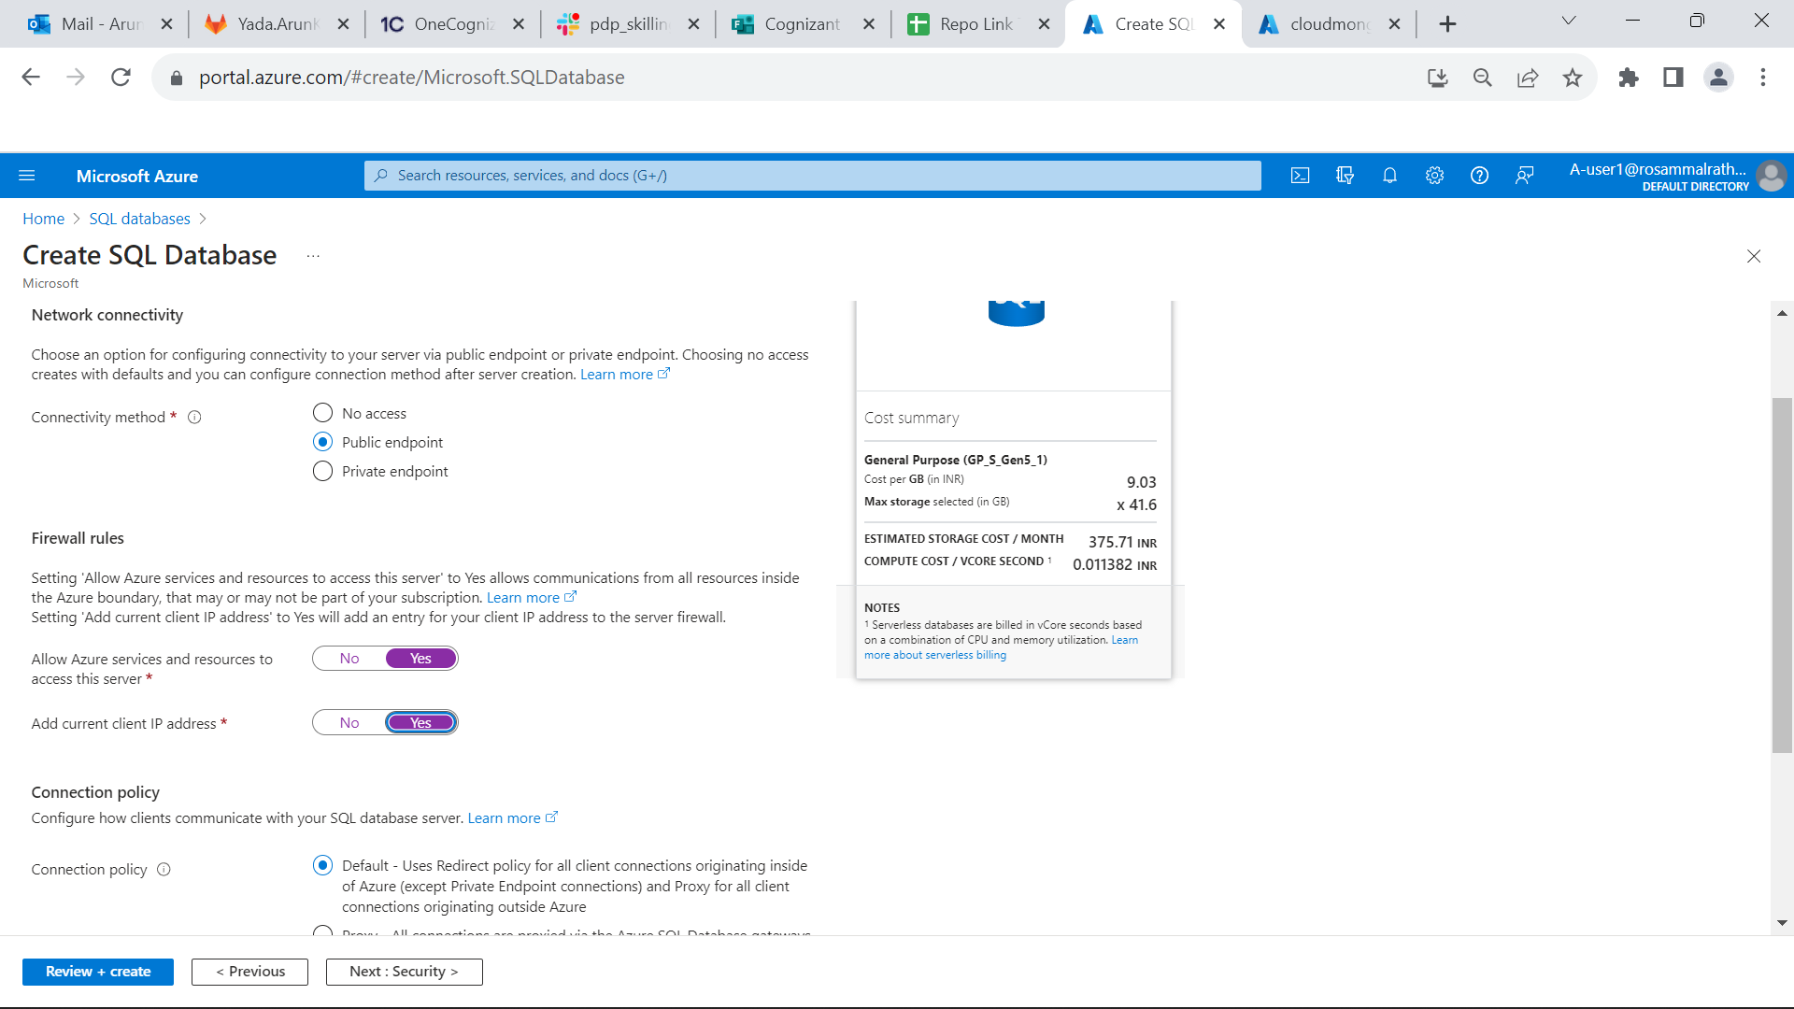

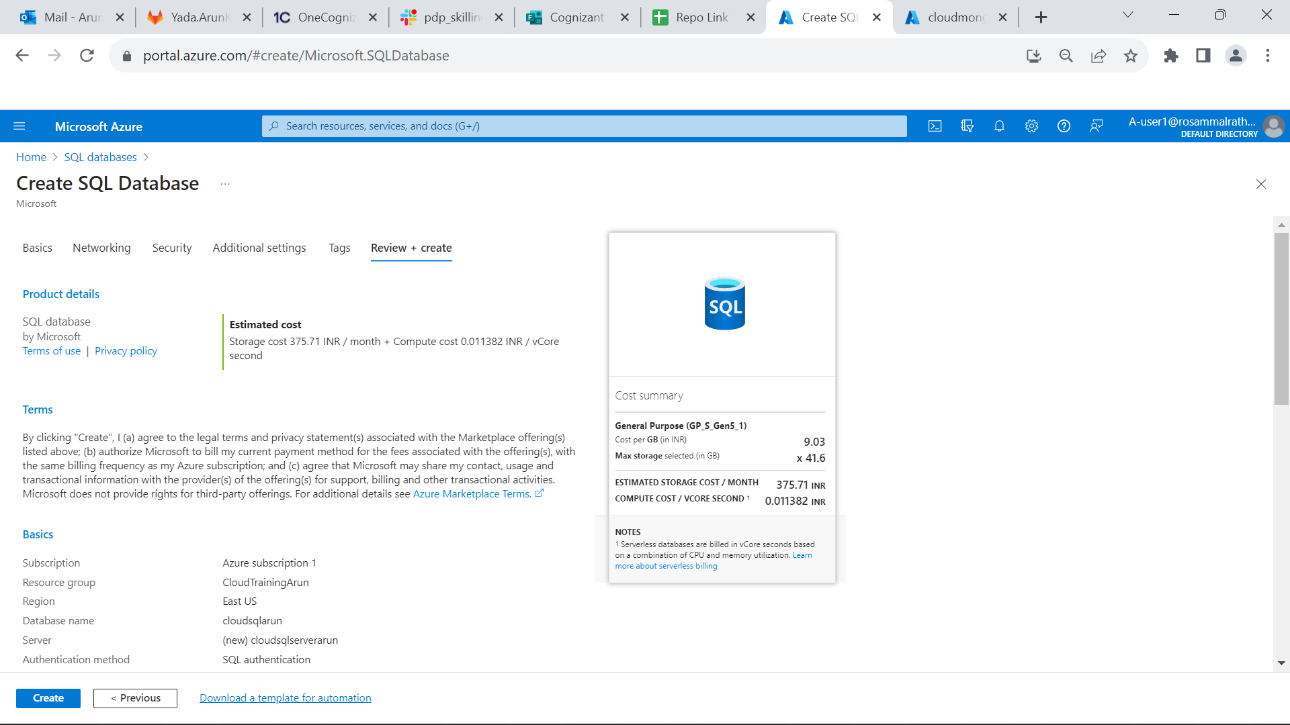

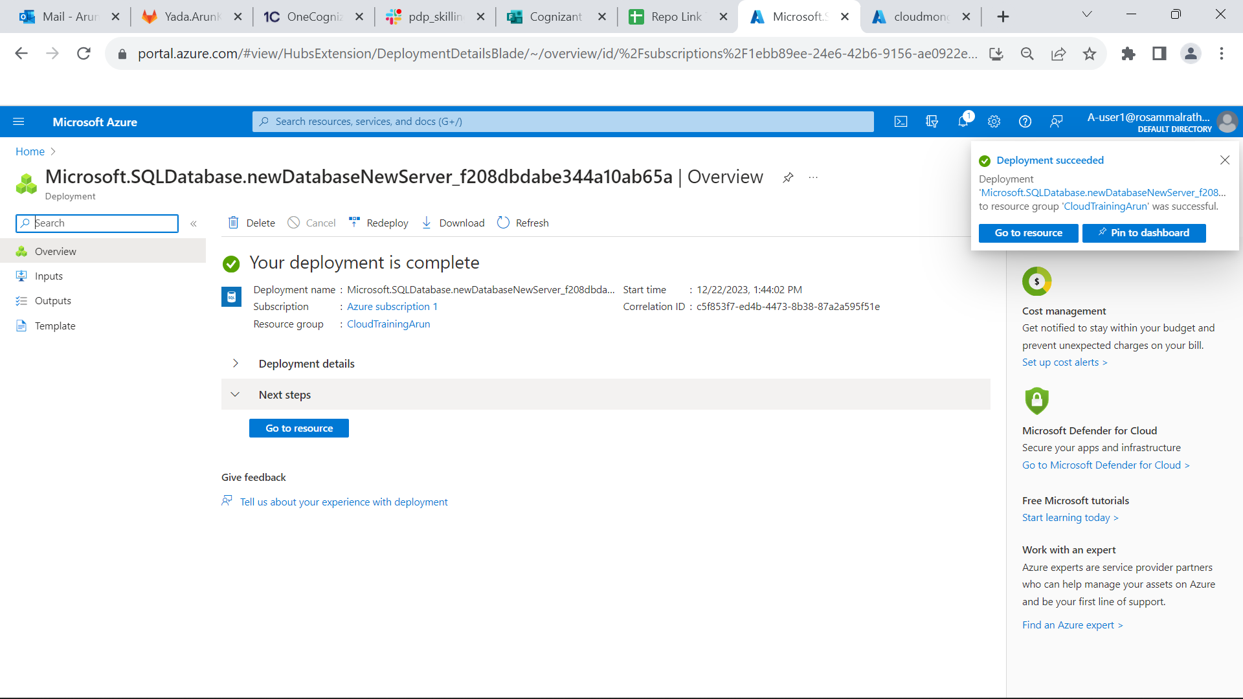

* After successful deployment add the ADO.Net connection string in your backend appsetting.json file.
* Don’t forget to add password in the connection string.
* And go to query editor and login with admin credentials.
* Now open package manager console and run update-database.
* And check that the tables are created or not in query editor.

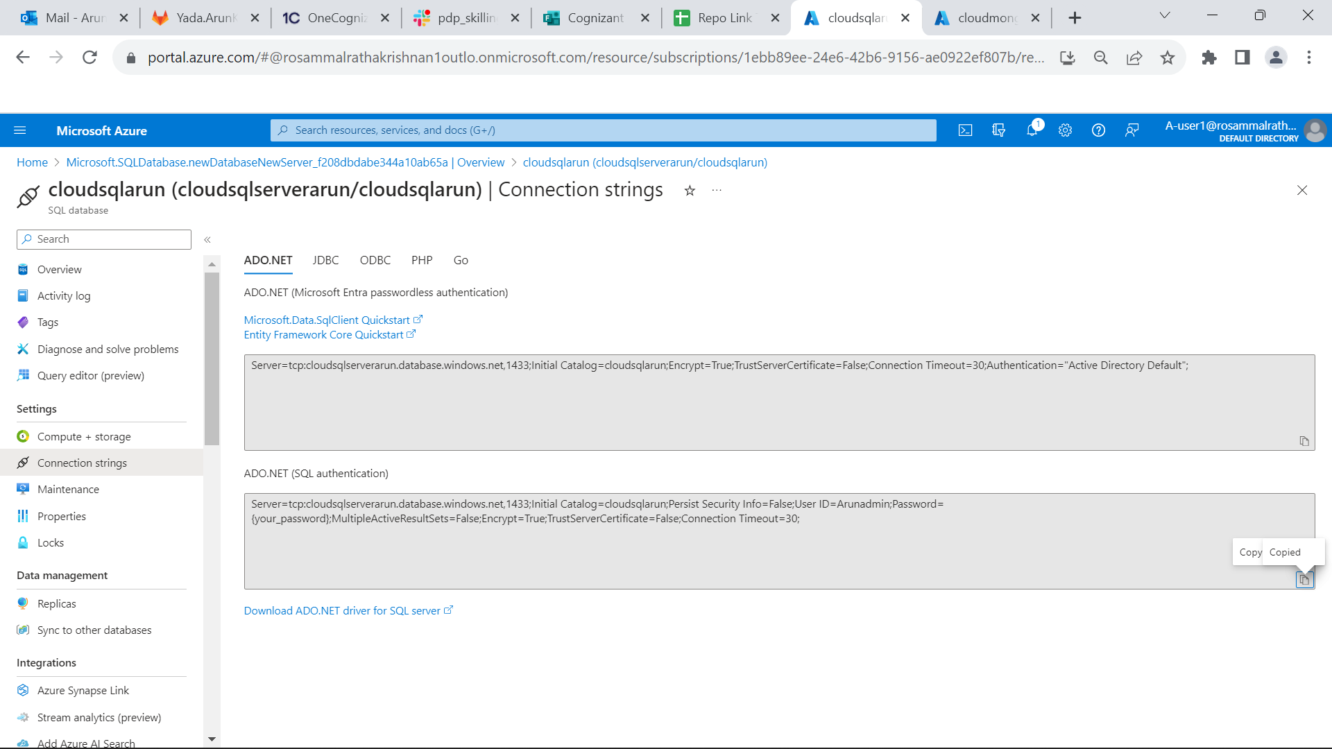

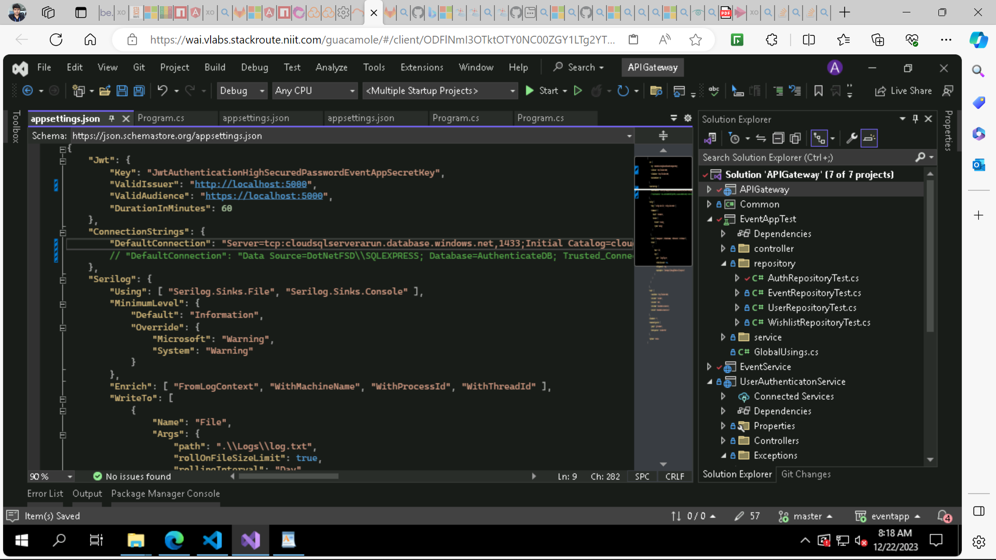

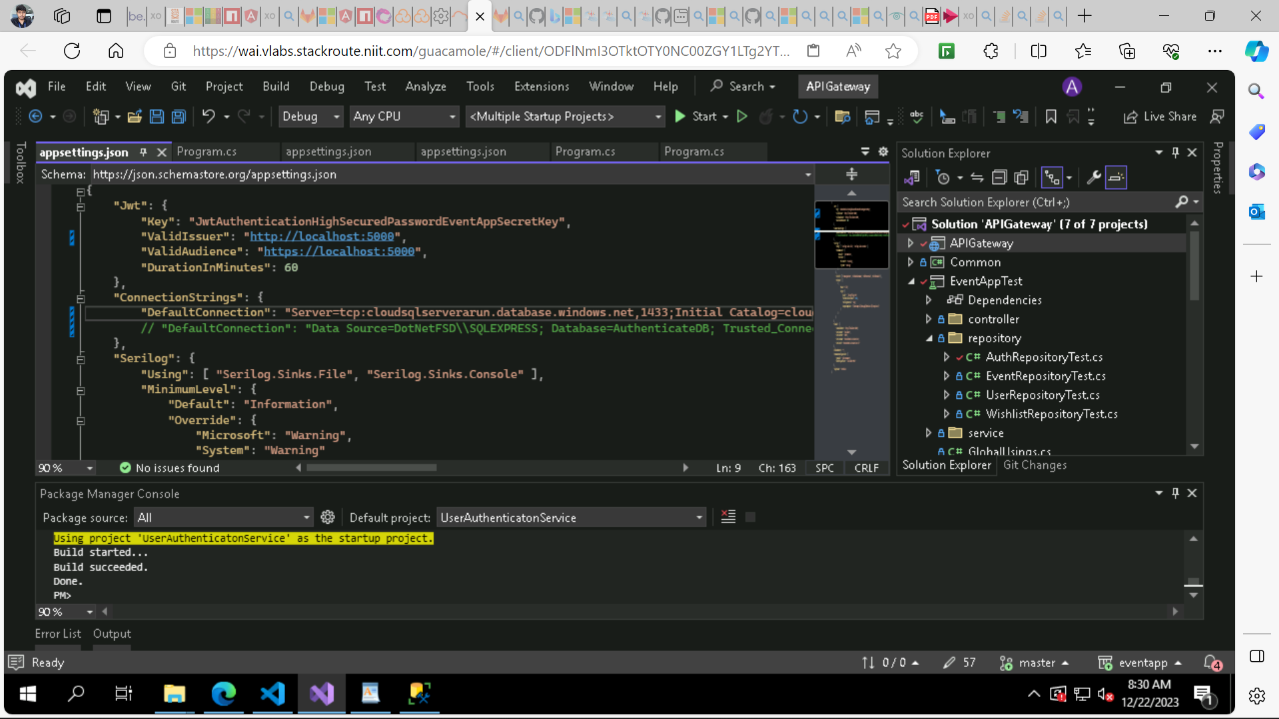

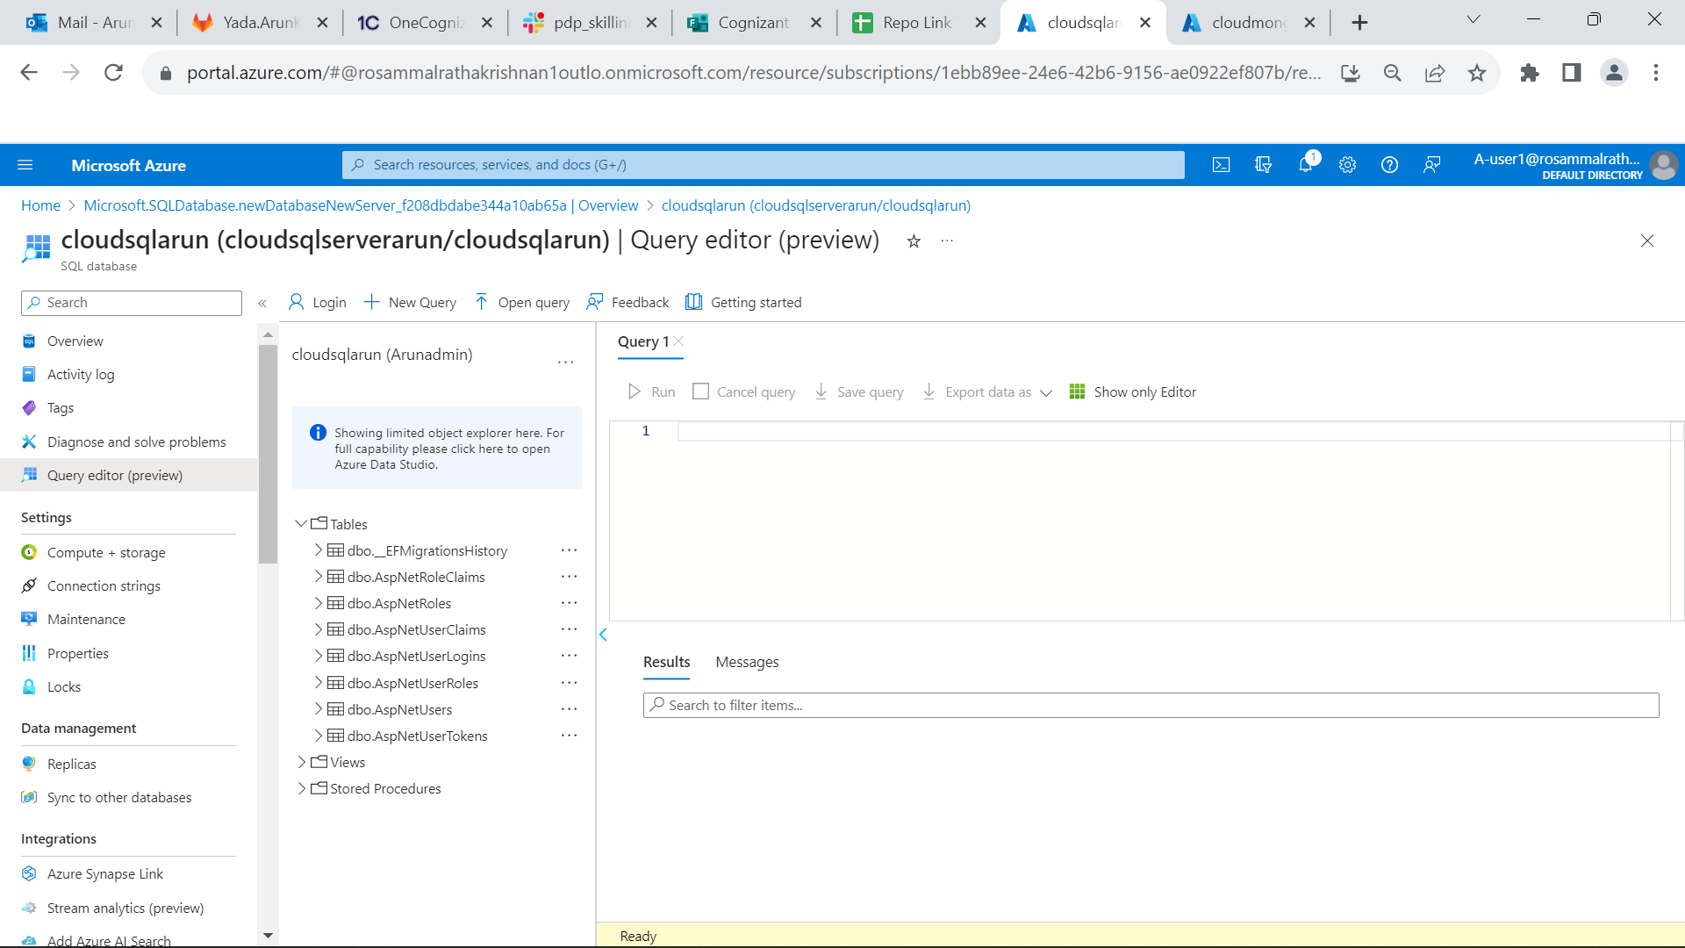

**Angular Application deploying using azure app service web app:**

* In Extensions – Install Azure Account, App service and then sign in to your azure account.

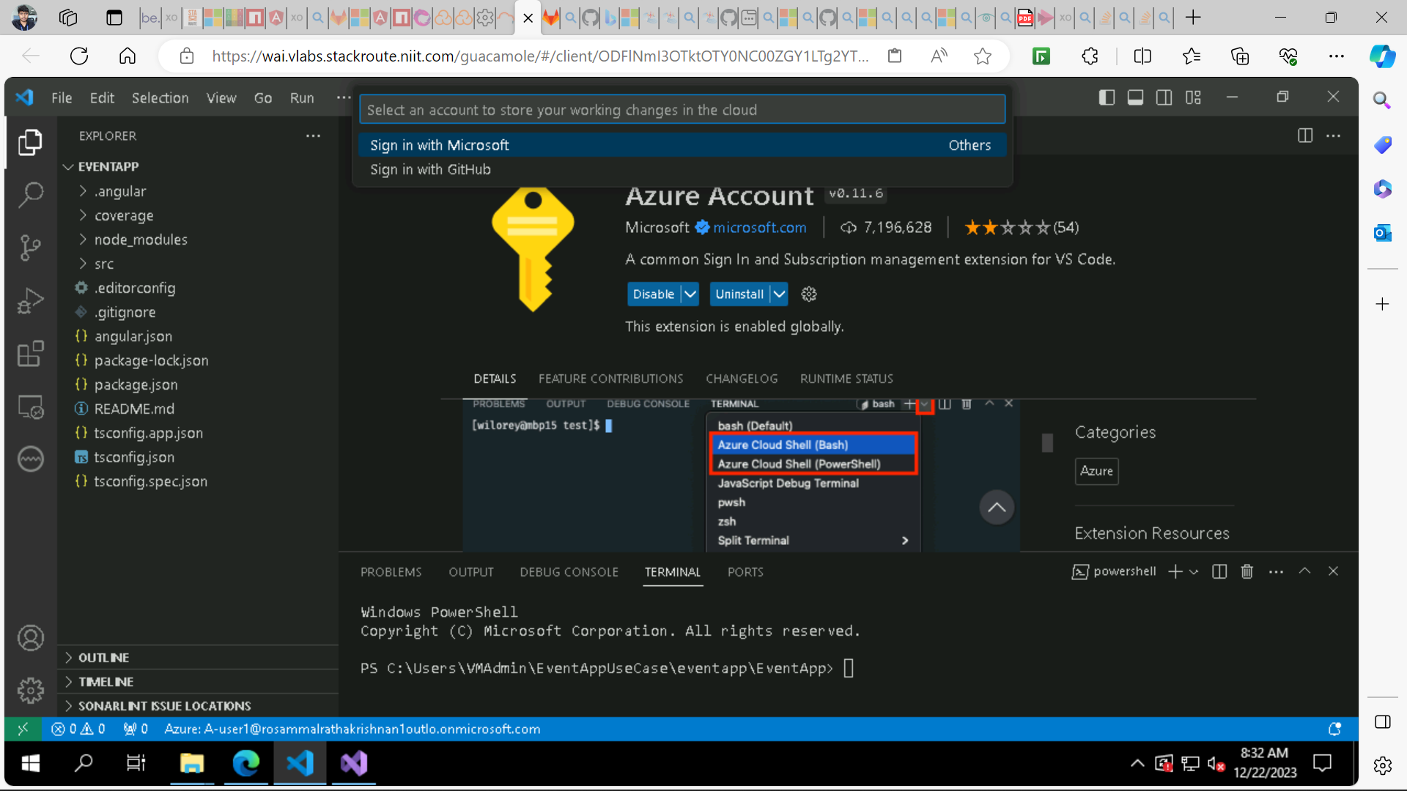

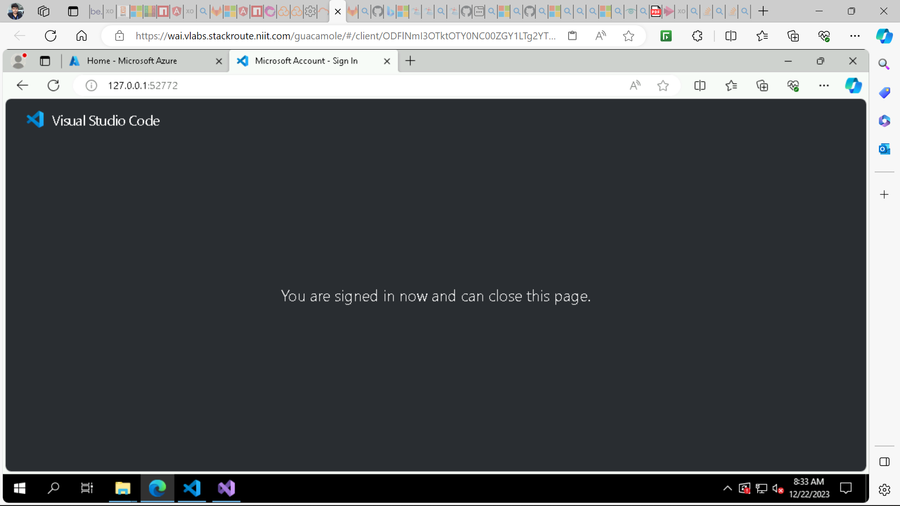

* Now select your subscription**.**
* Go to App services create new Web App
* Give unique name to your web app, select runtime stack as .NET7(STS), **select Free F1** and enter.
* Then your Web app will be created successfully.

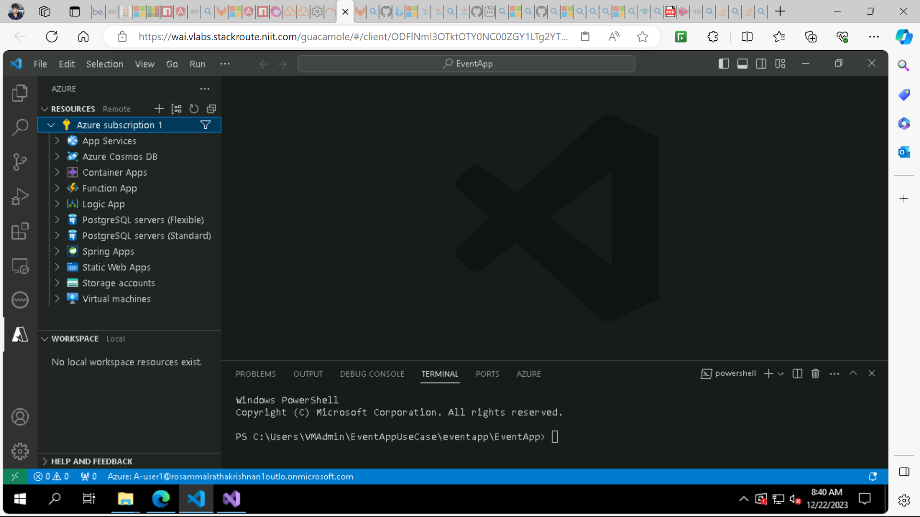

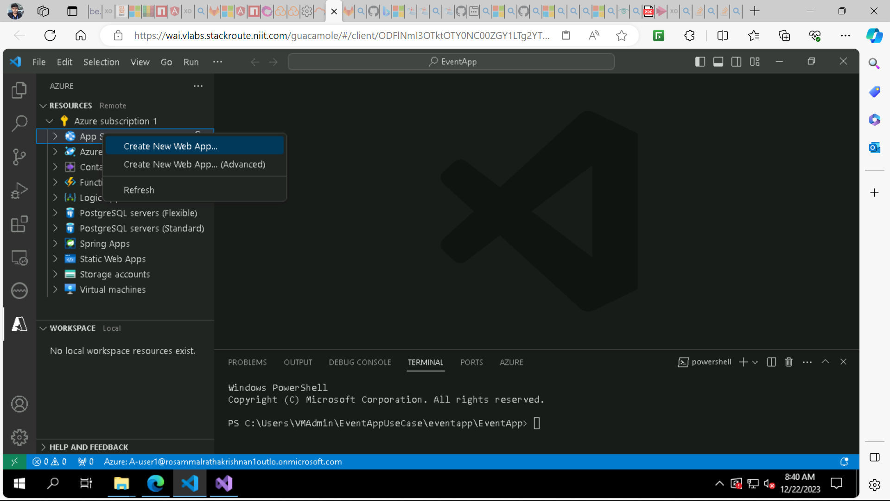

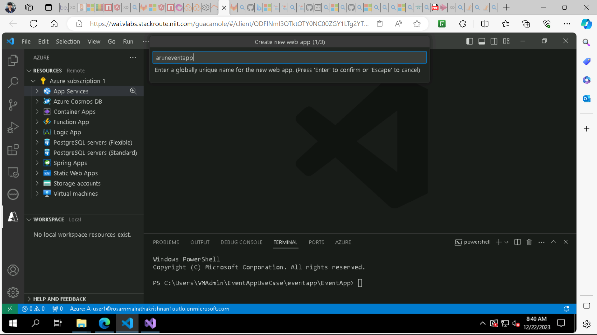

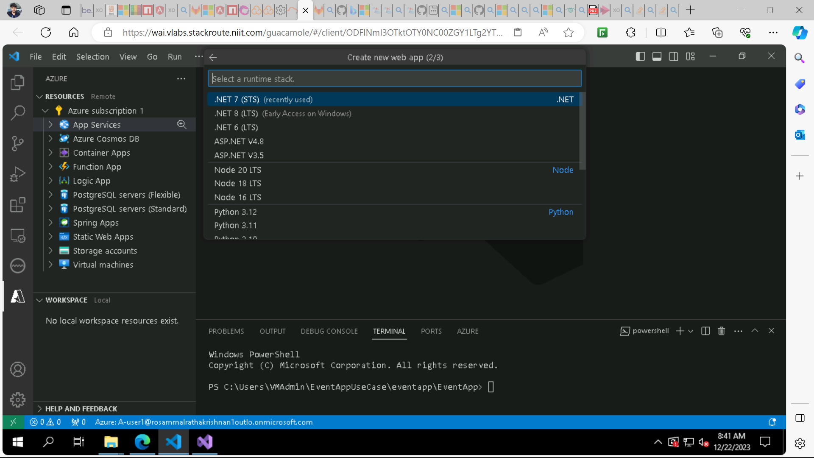

**Next select Free F1.**

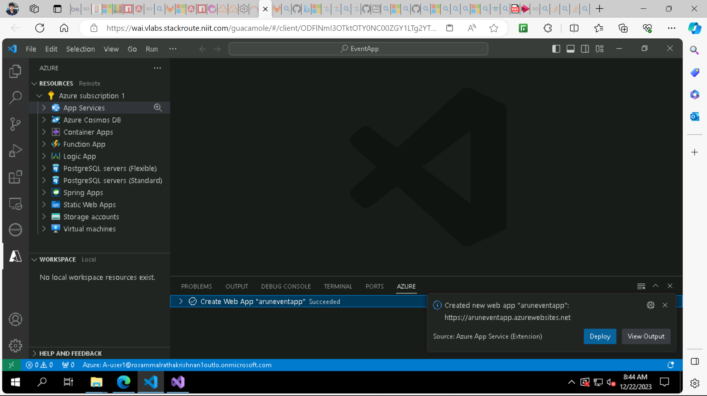

**For working on refresh page also add these things in your app.module.ts and app-routing.module.ts**

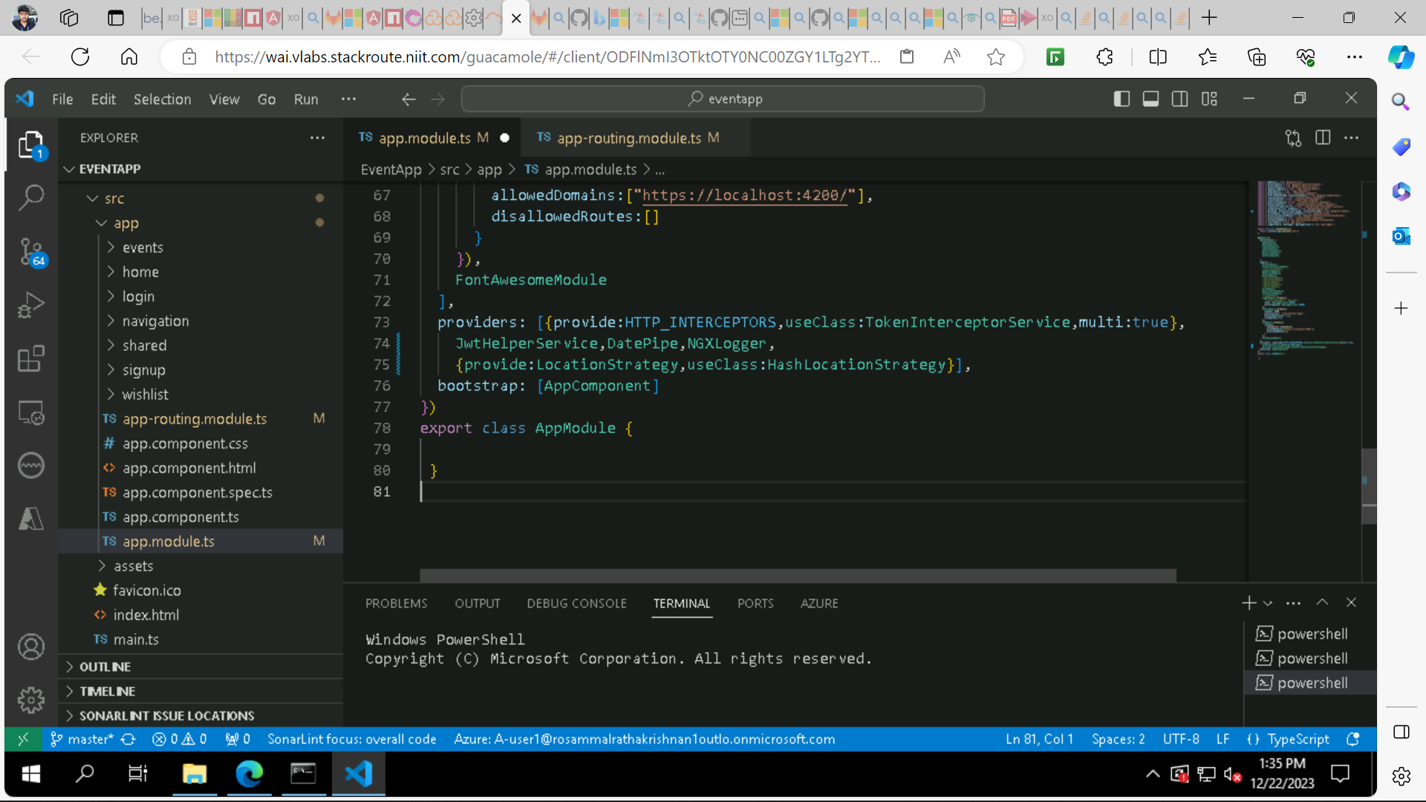

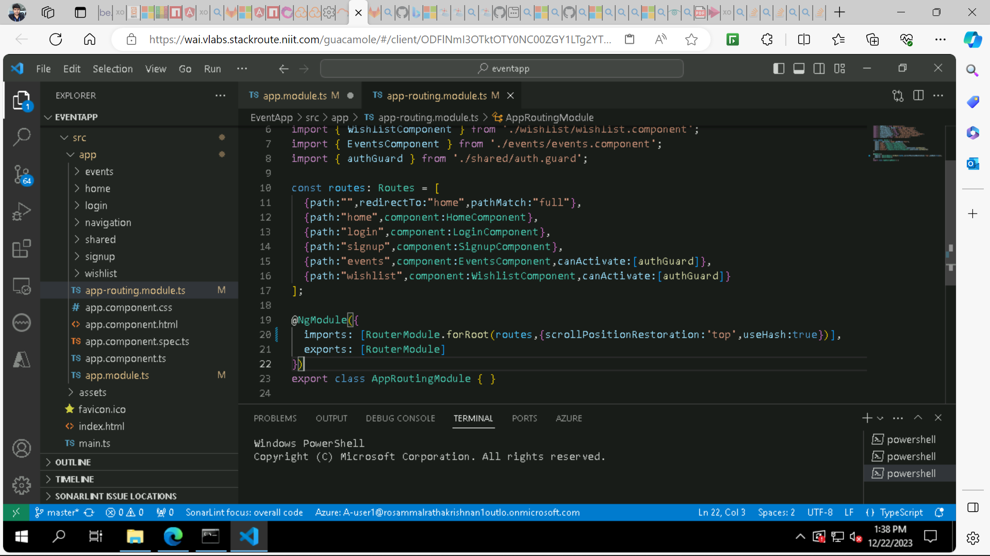

**Before deploying build your angular app to get dist folder**

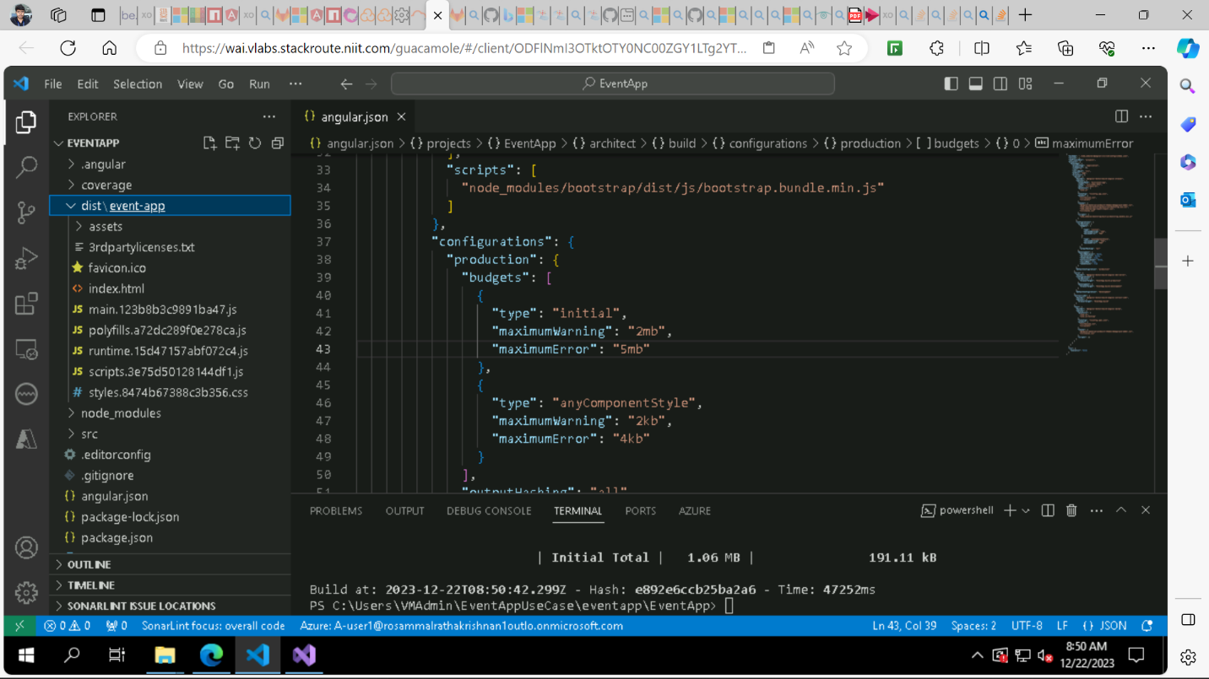

**After ng build is successfully and dist folder is created. Deploy the web app.**

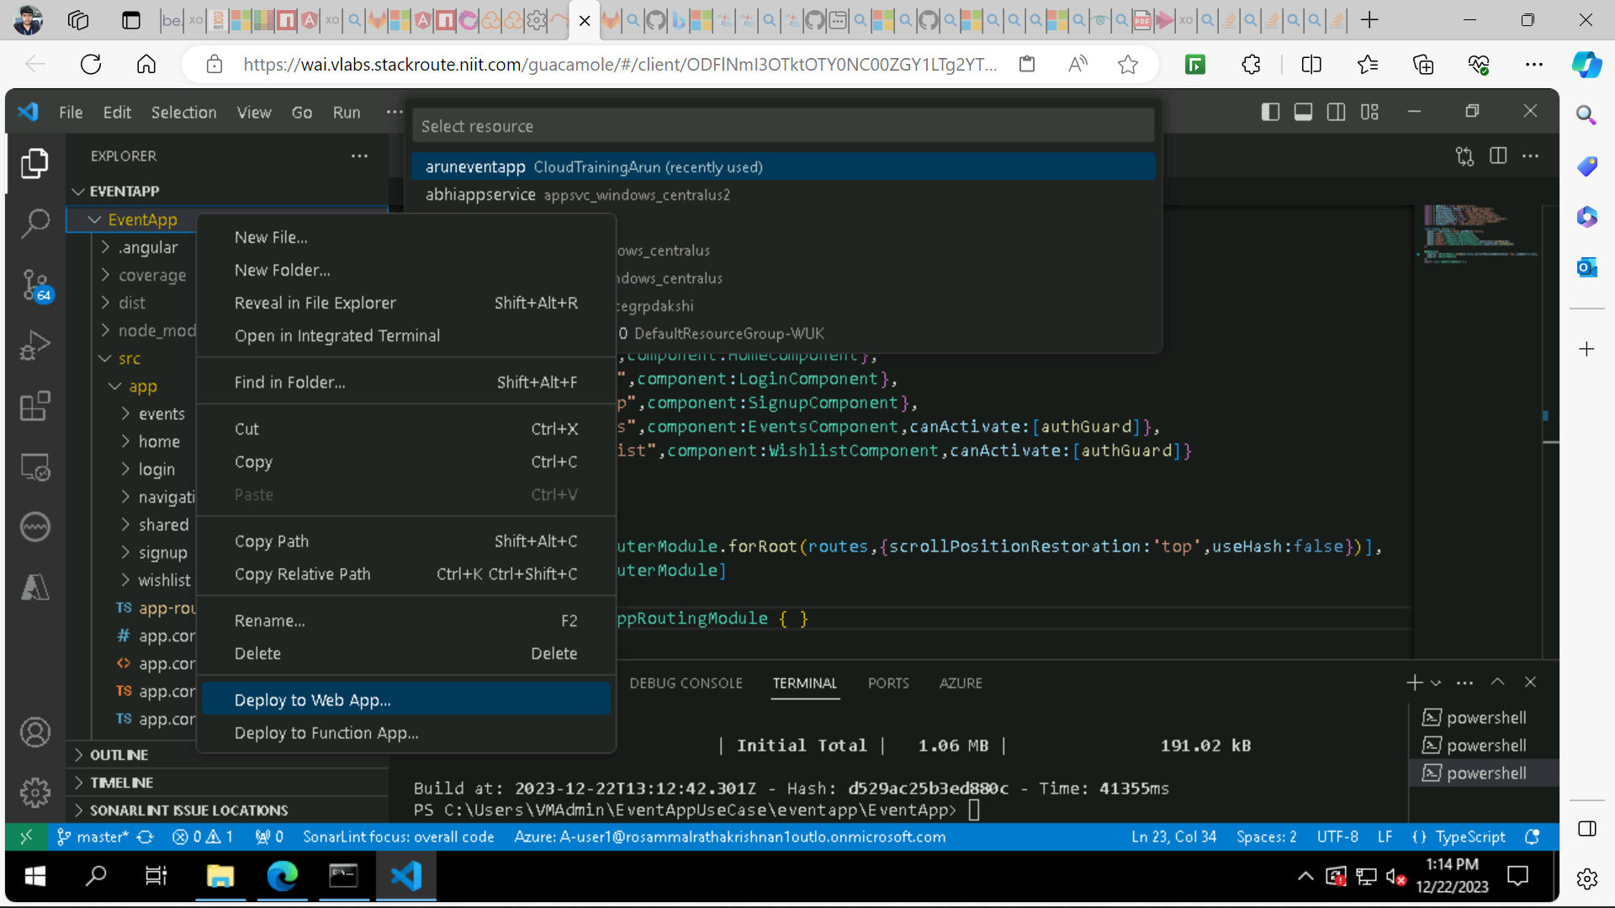

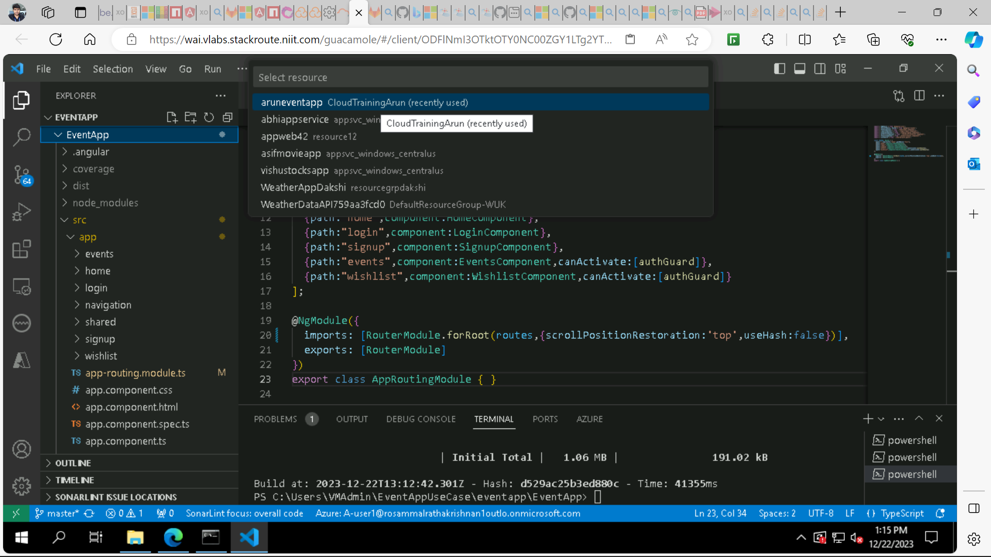

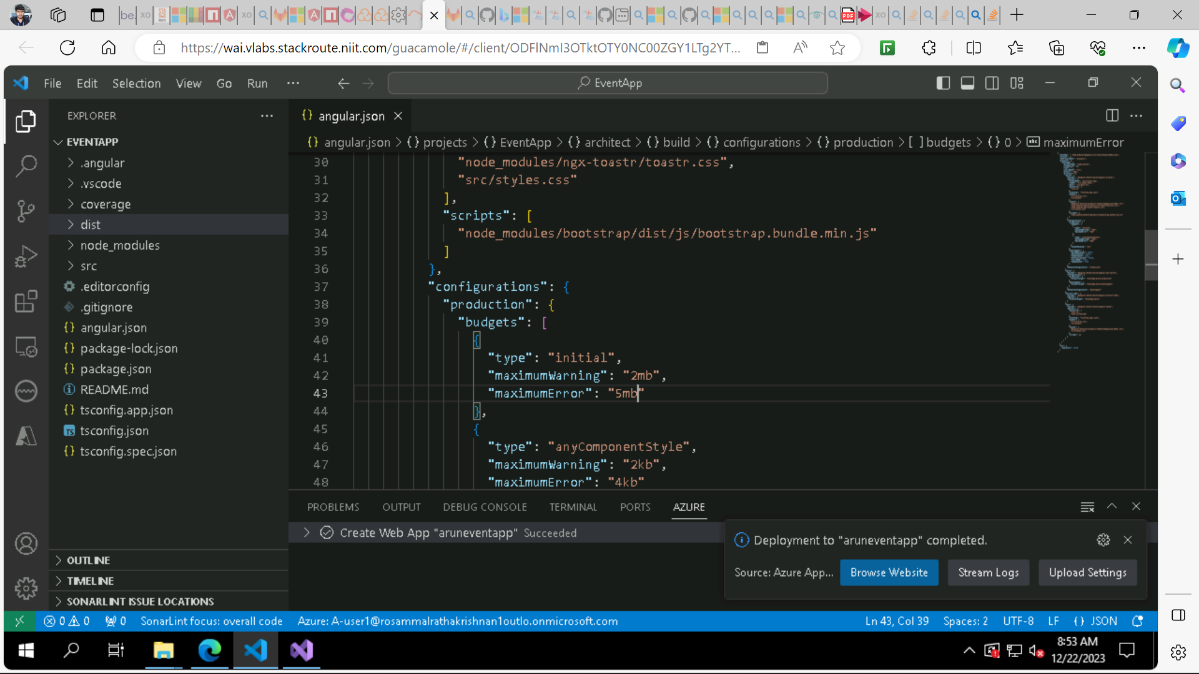

* After successful deployment.
* Open azure portal and open your App service web app that created.
* Navigate to Console from side navigational menu.
* Then run command DIR to see the structure that is your index.html in [www.root](http://www.root) or inside of that [www.root](http://www.root) of any folder. Here I am having my index.html in dist/event-app so I will edit the virtual path in Configuration-> Path mappings and add this dist/event-app and save it.
* Then go to Configuration from side navigational menu.
* Add an application setting:

- SCM_DO_BUILD_DURING_DEPLOYMENT

- Set it to true and save.

* Delete all default documents and index.html.
* And click save to save your configuration.

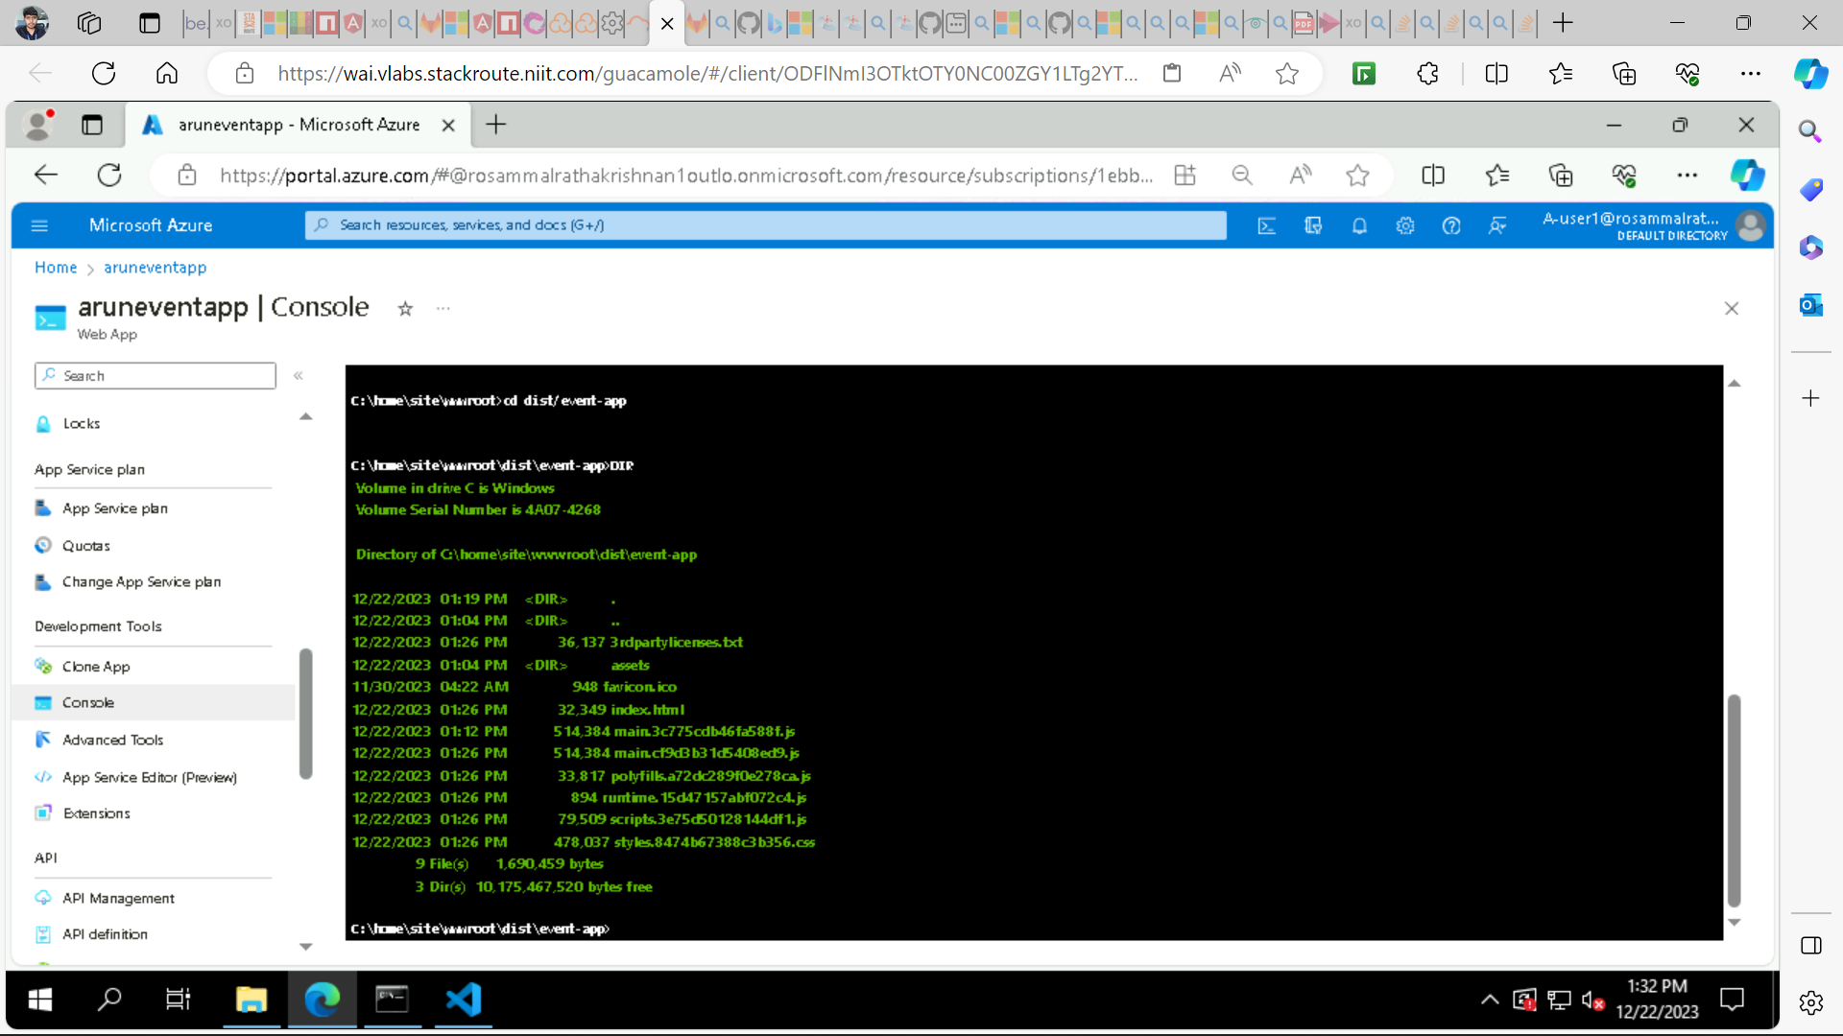

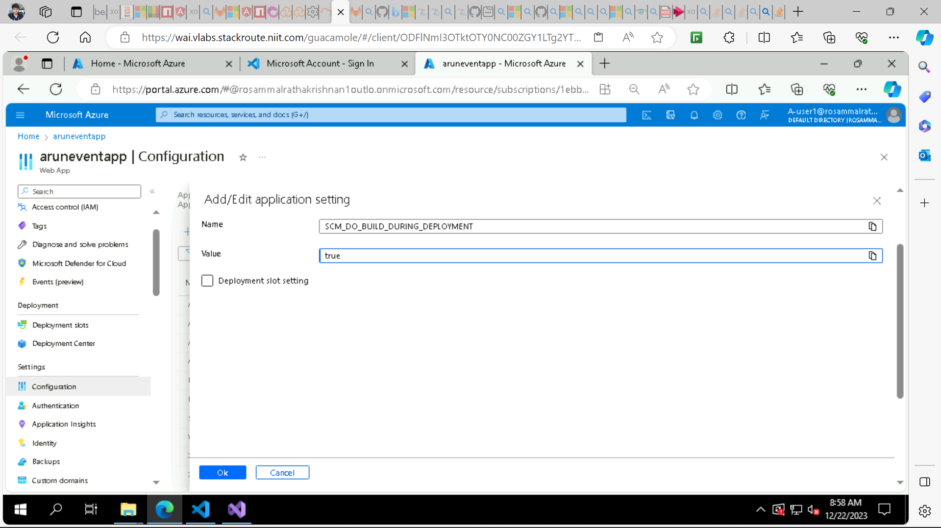

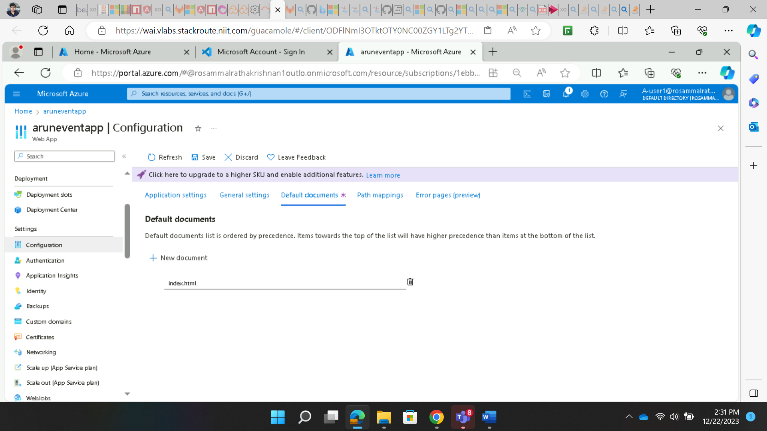

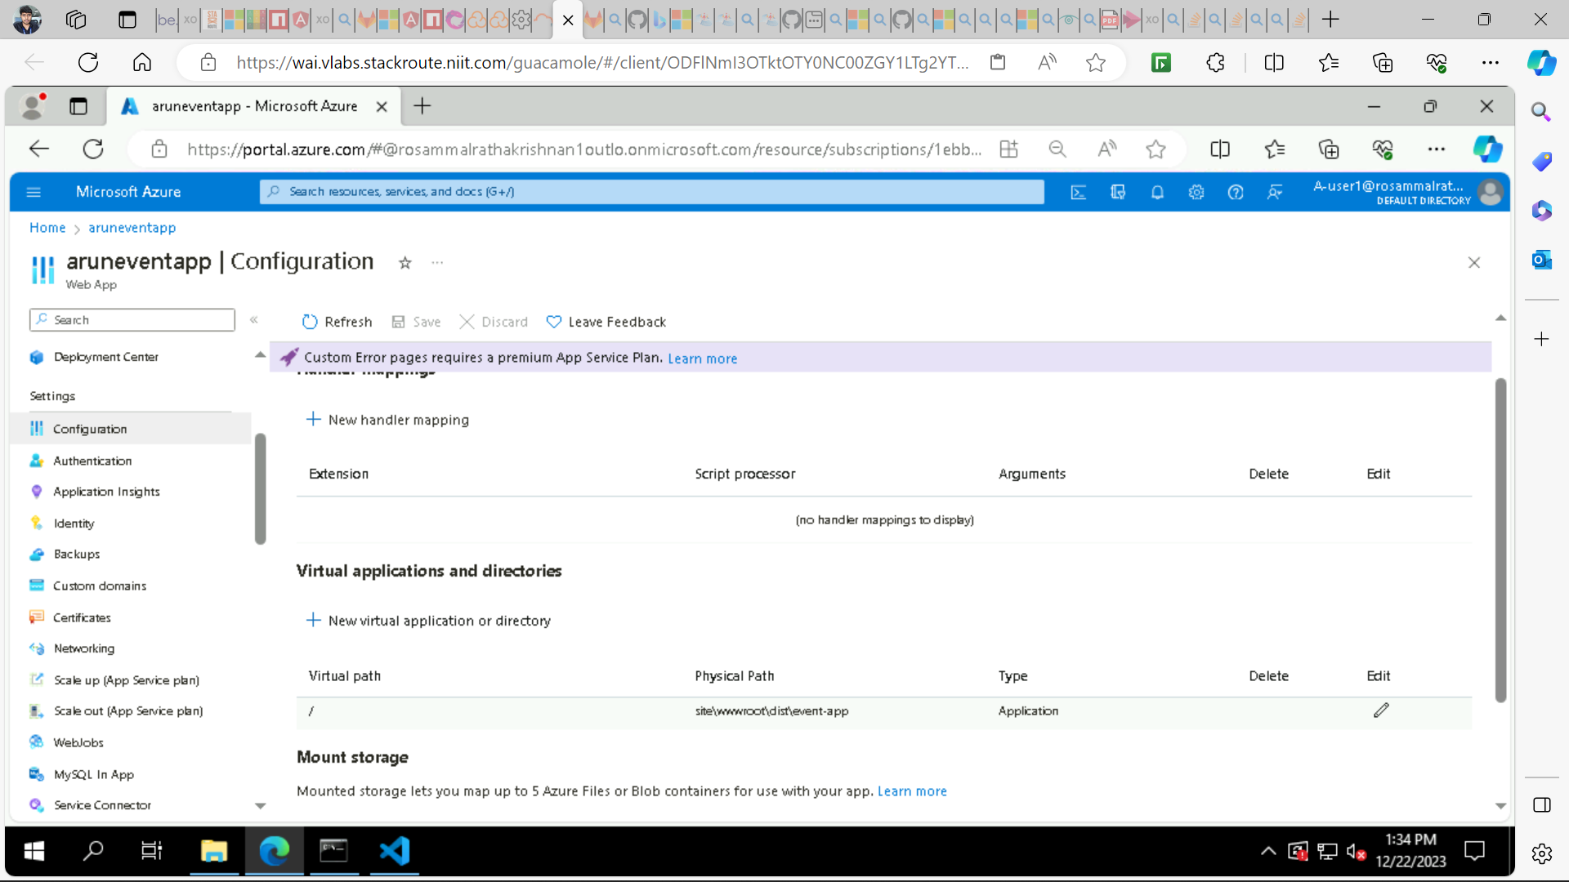

* Navigate to Overview from side navigational menu and click browse your app will open in browser.
* And run consul server, zookeeper, Kafka, backend application.
* And don’t forget to change the Cors policy of WithOrigins to *

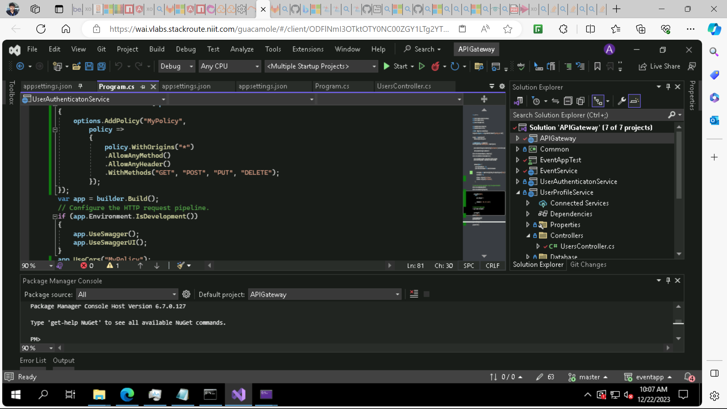

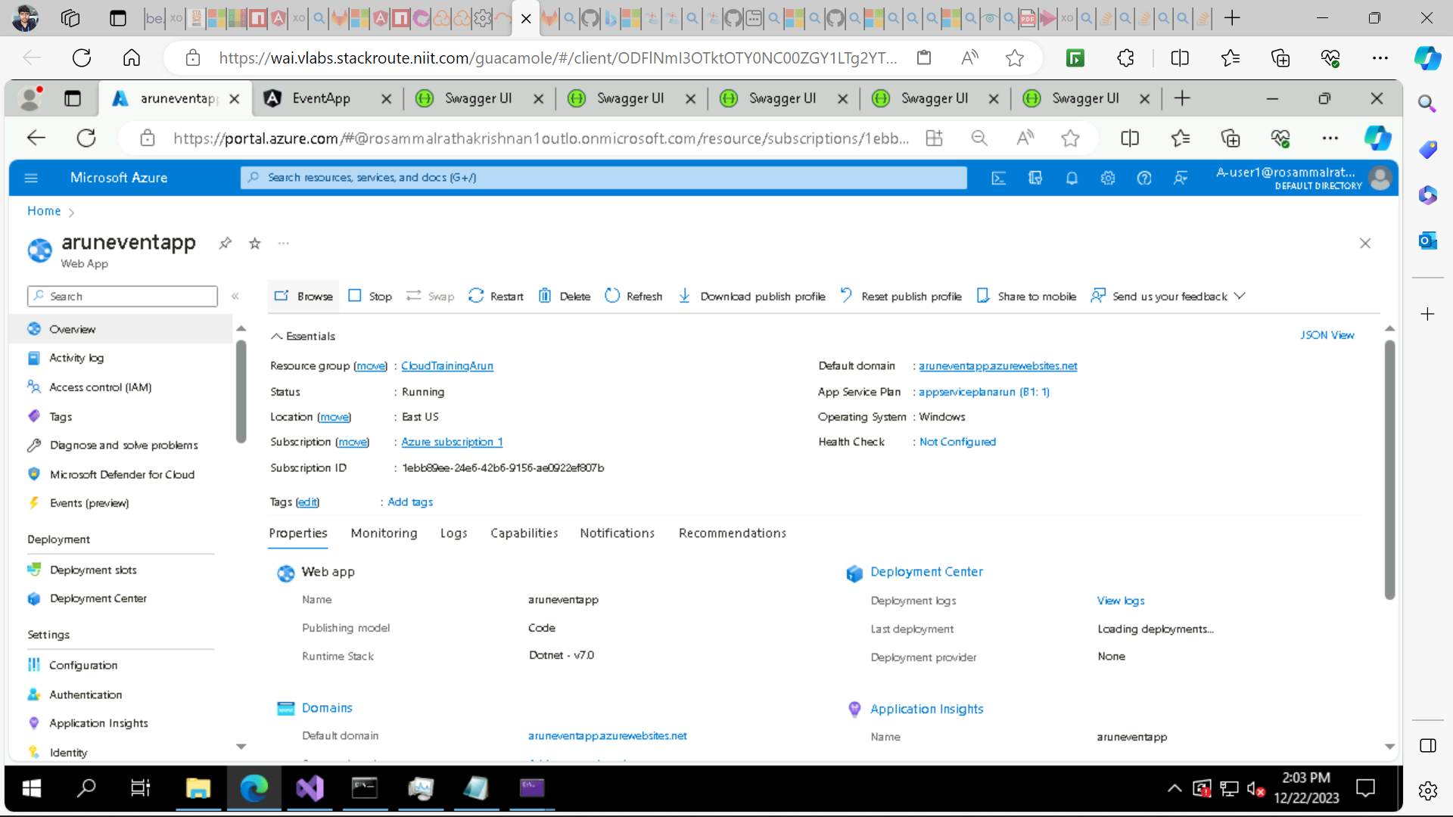

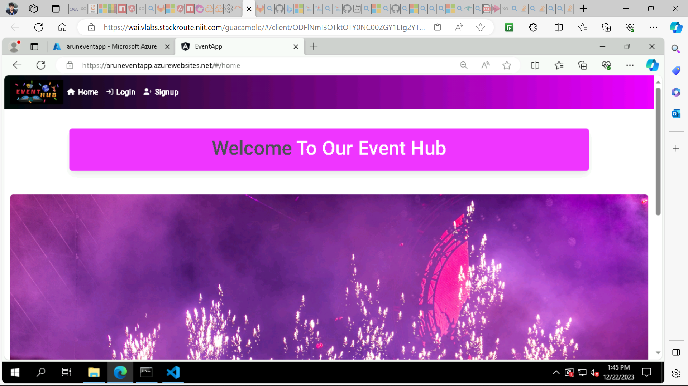

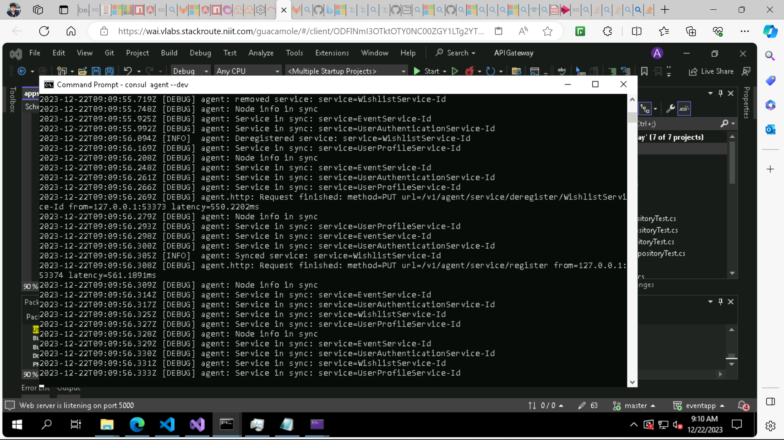

* Navigate to signup and register a user.
* Then login with that user credentials.
* And add an event to Wishlist.
* now check that your data is getting stored in your database or not.
* Open cloud MongoDB navigate to data explorer and refresh the DB.
* Now see in data that UserDB and WishlistDB got created check the documents having data or not.
* Now open cloudsqlarun and navigate to query editor and run select top 1000 and see the data is added or not.
* Try all other features of your web app is all are working fine or not.

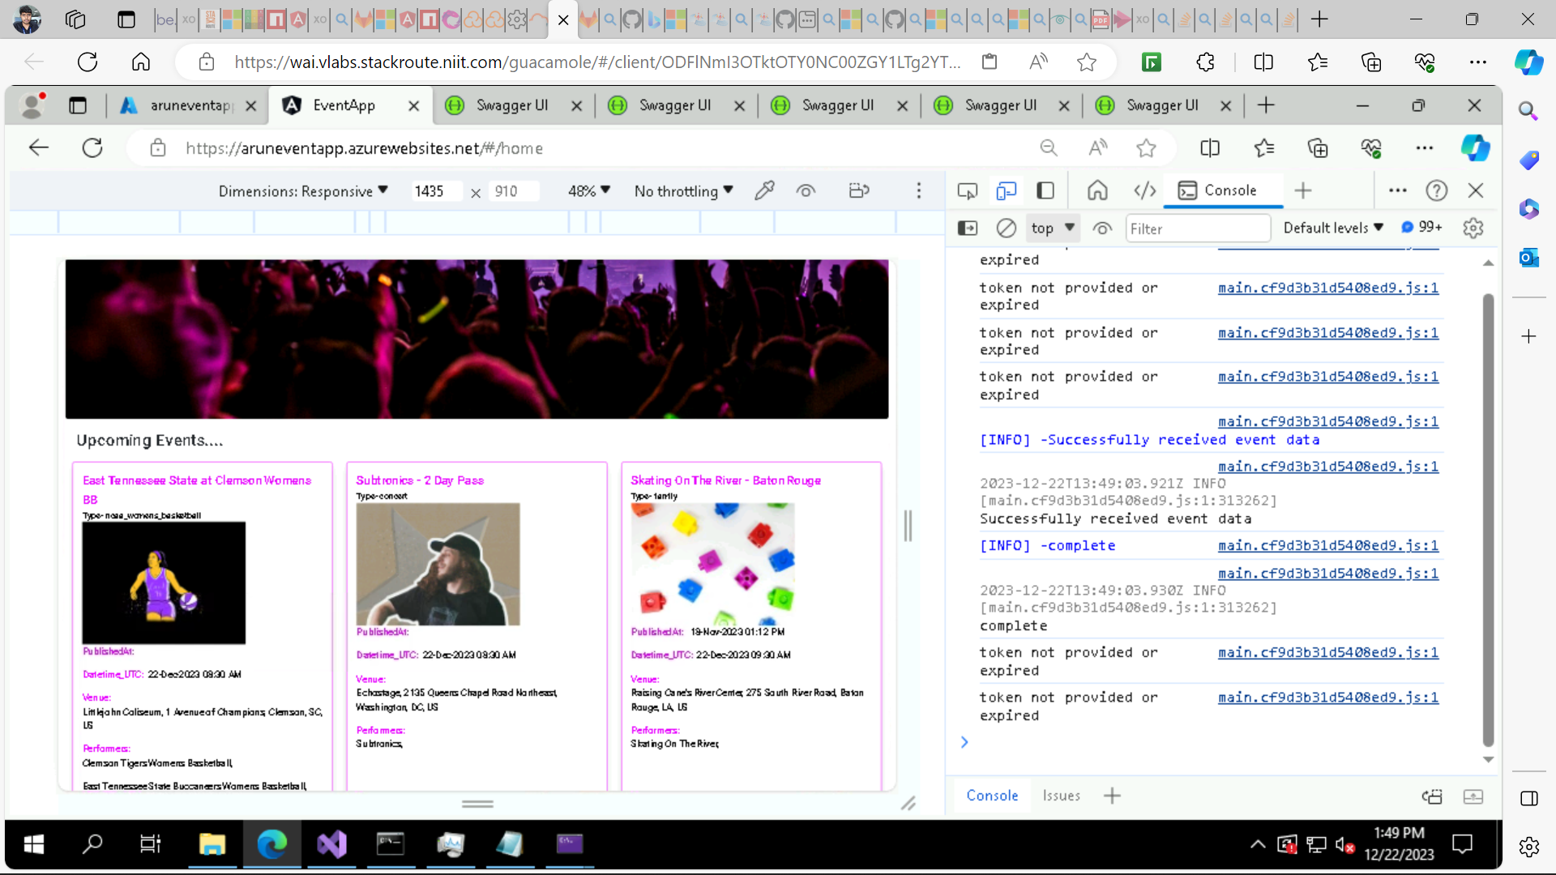

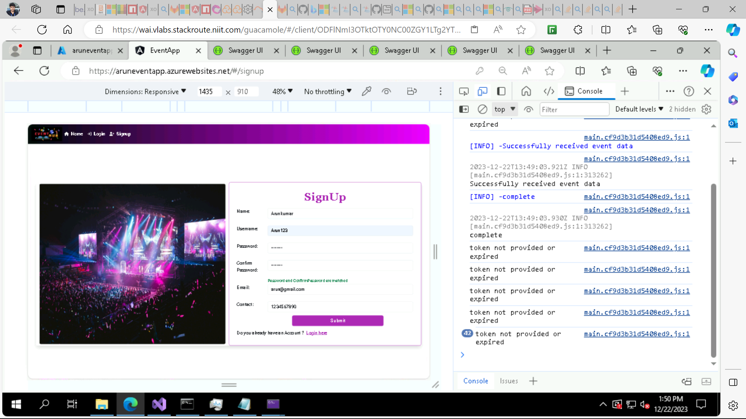

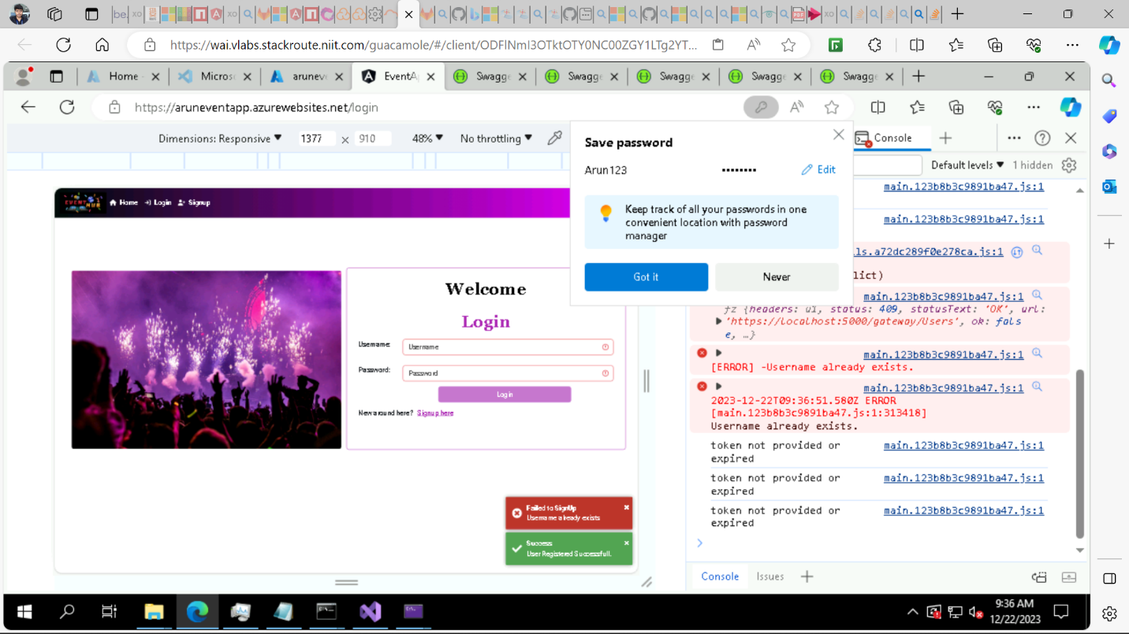

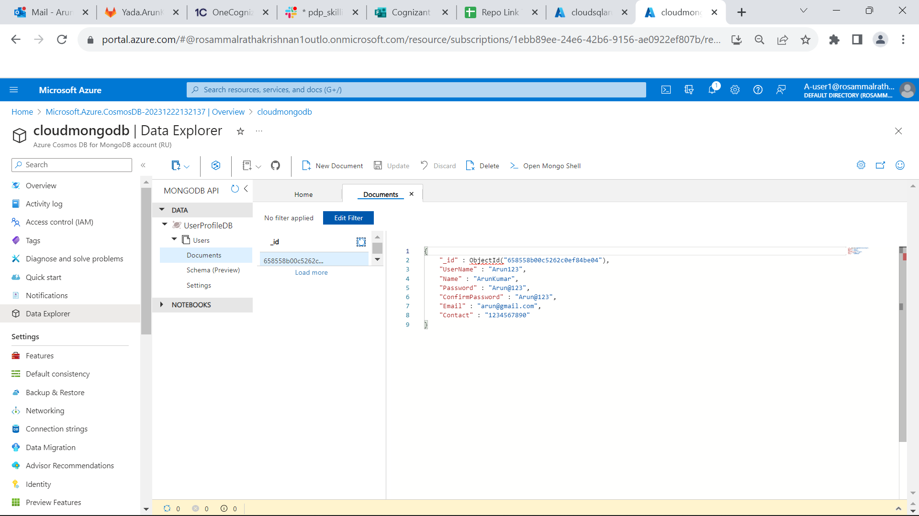

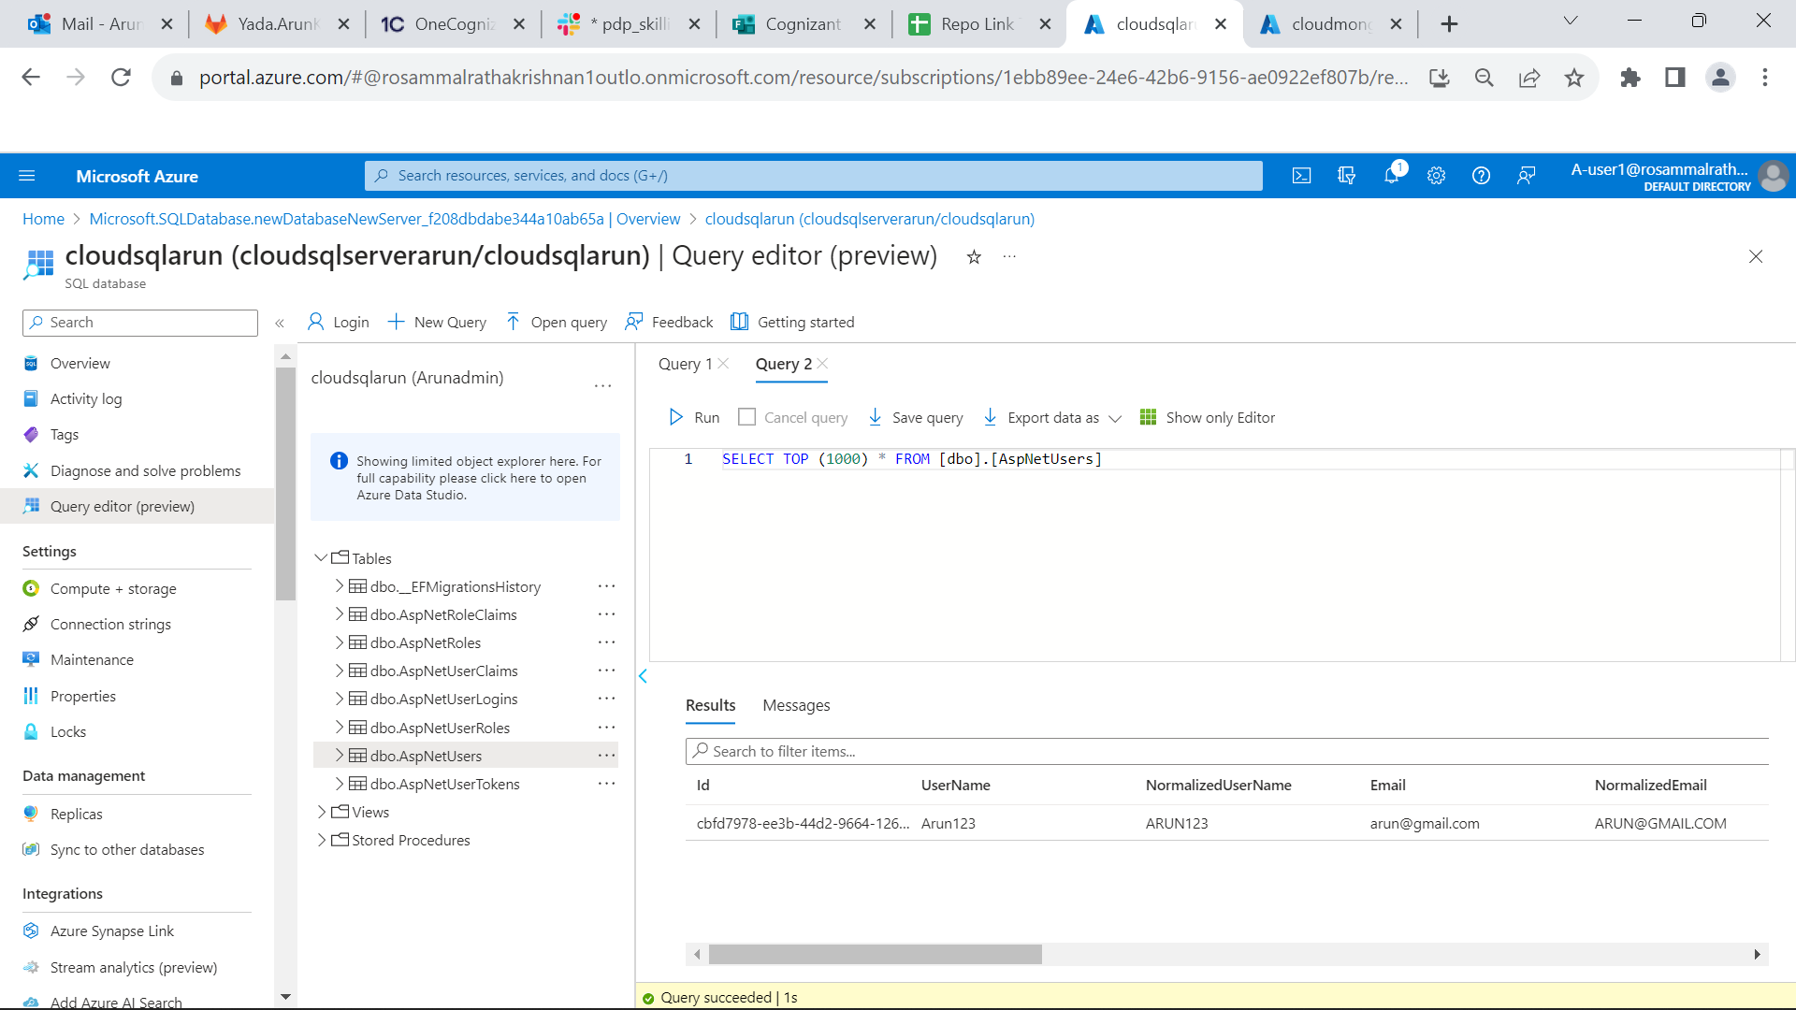

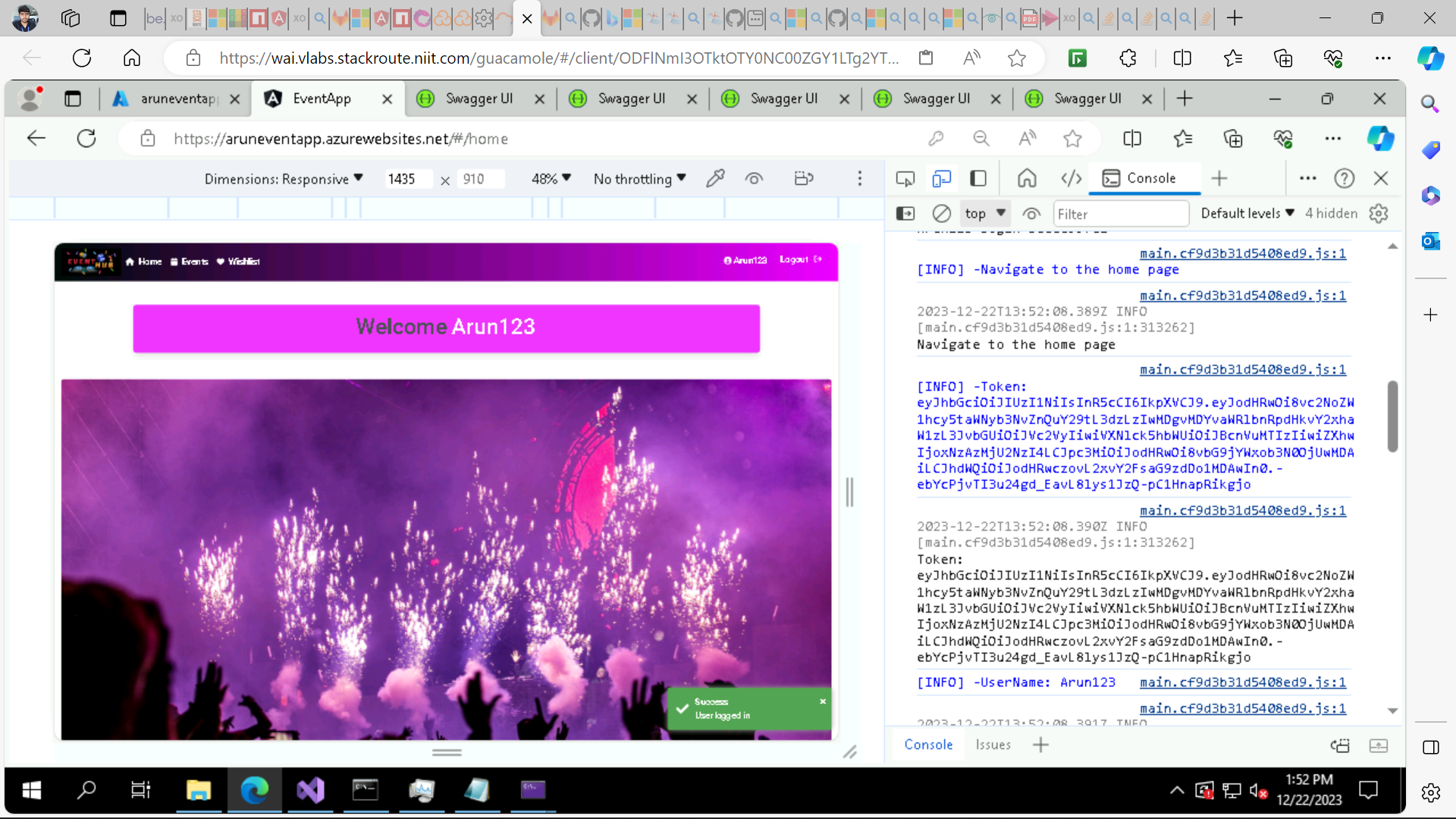

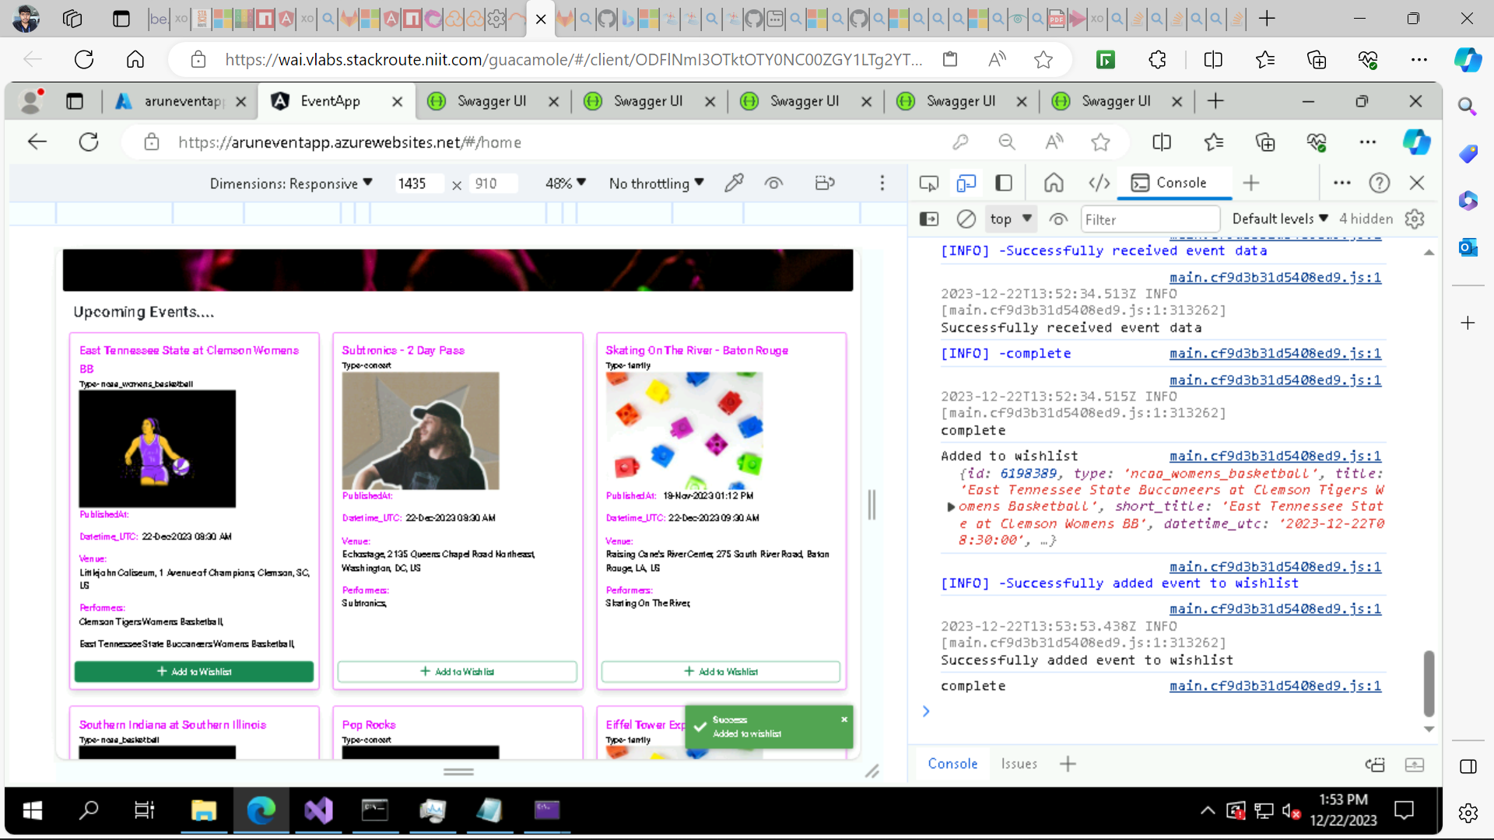

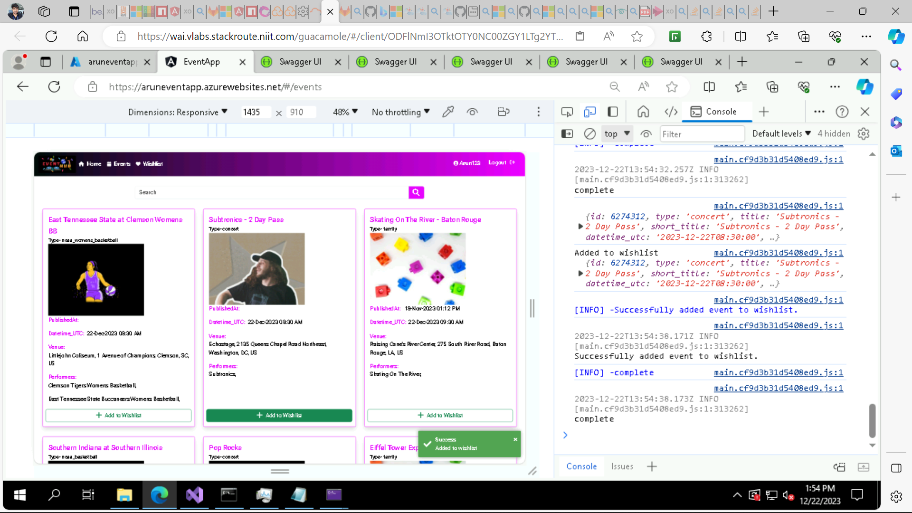

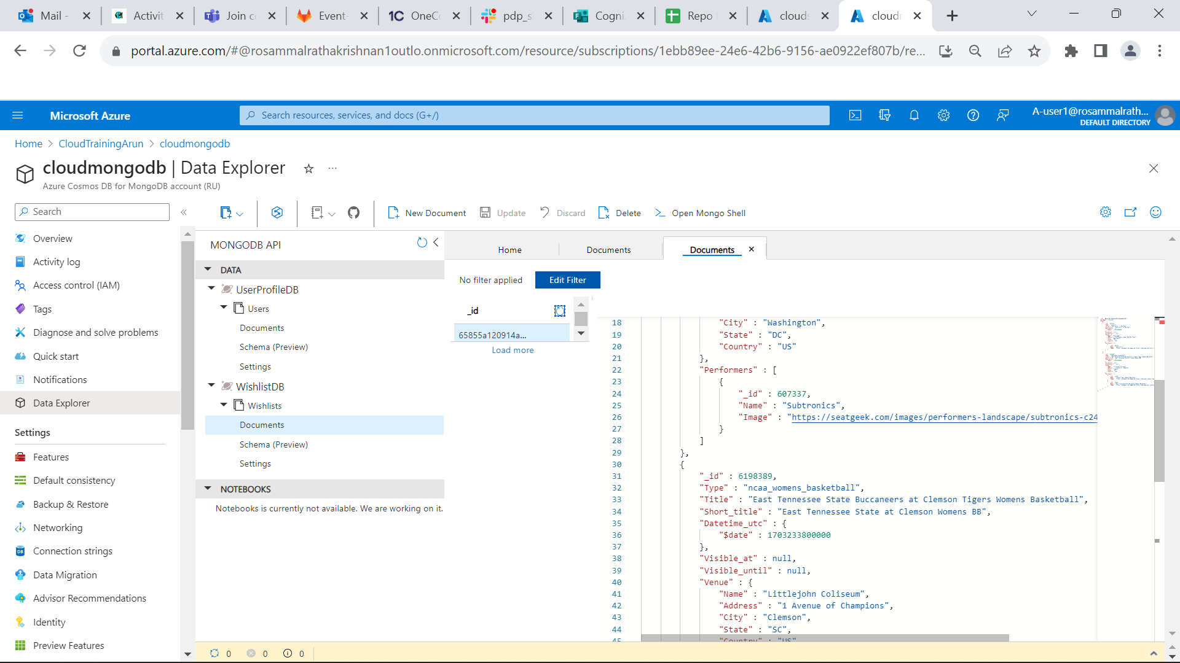

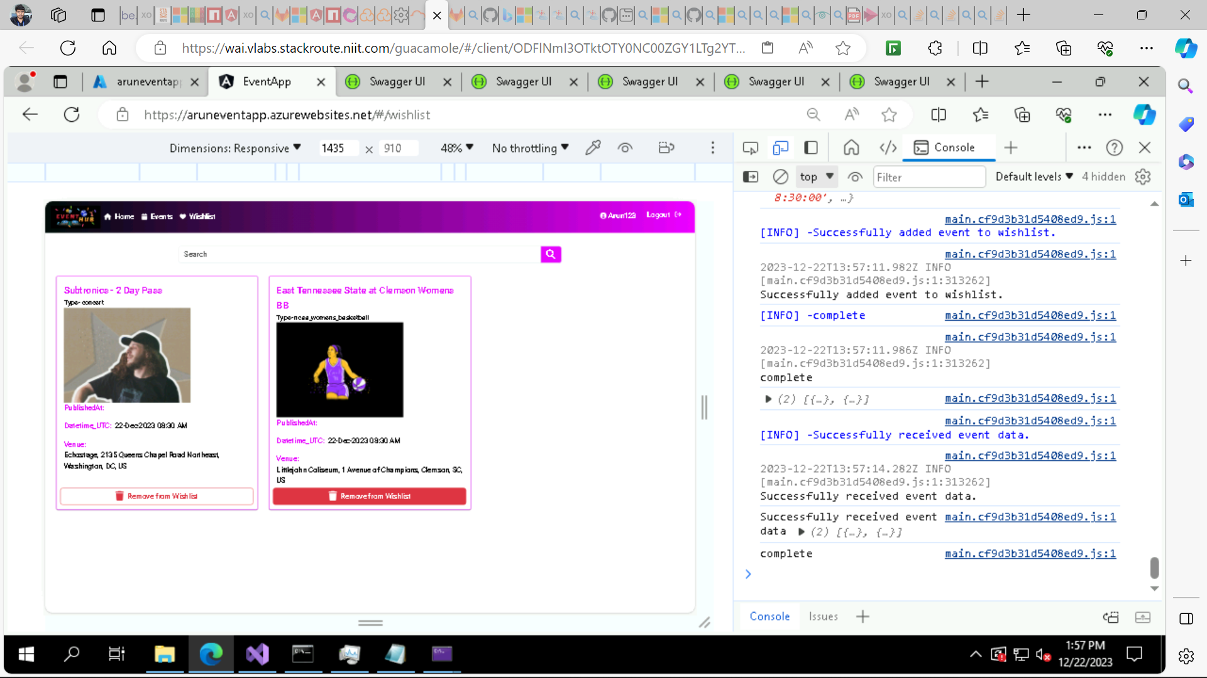

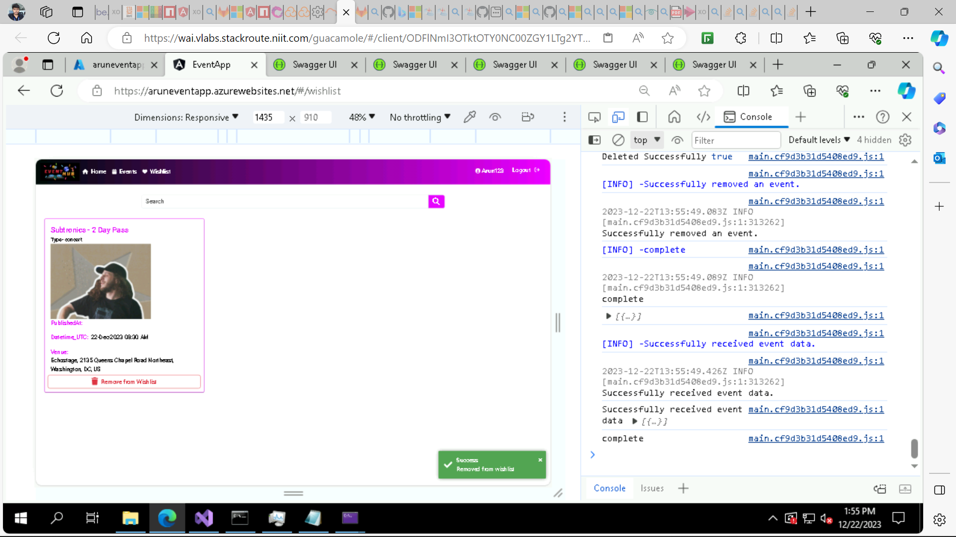

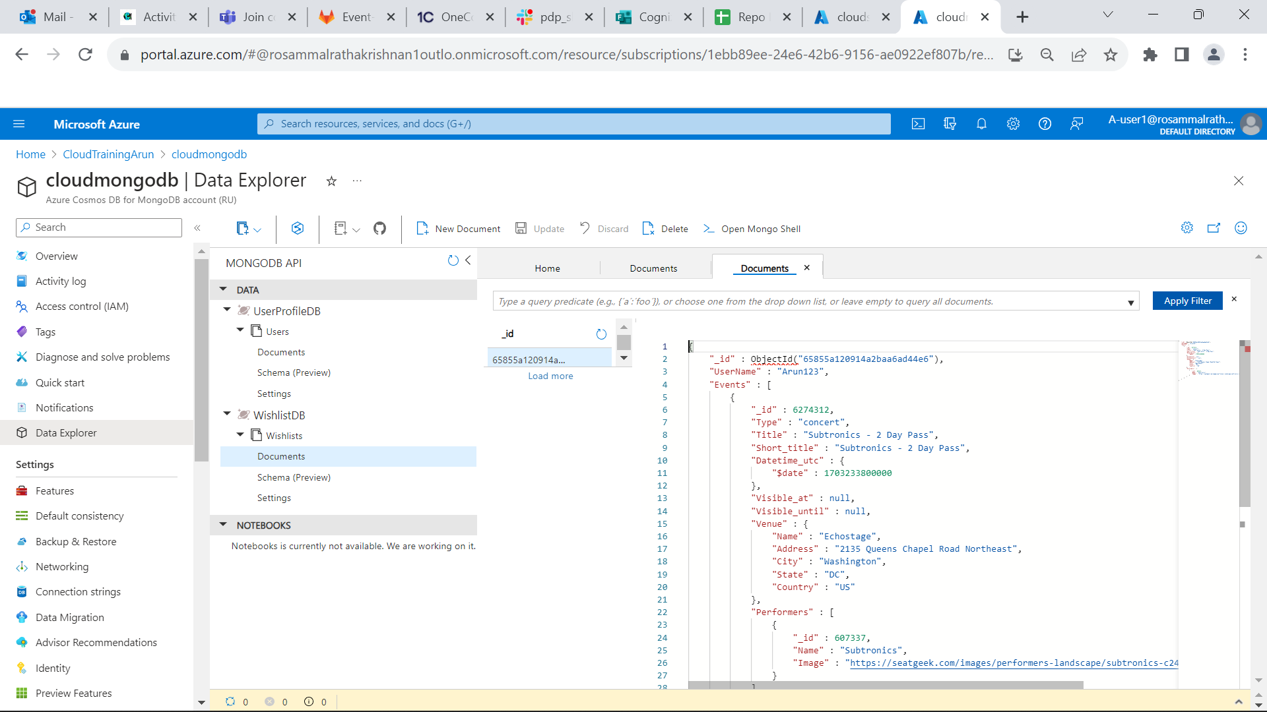

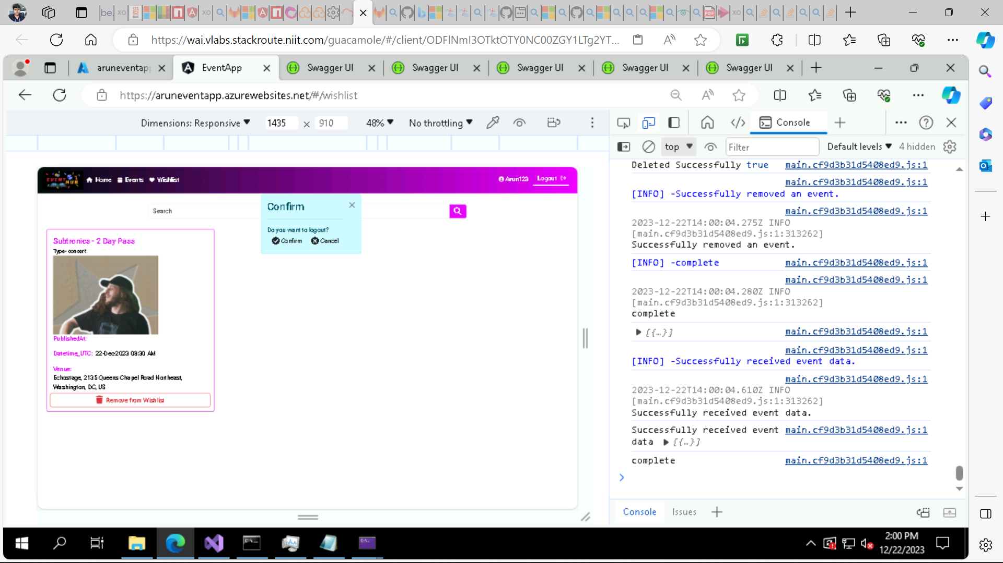

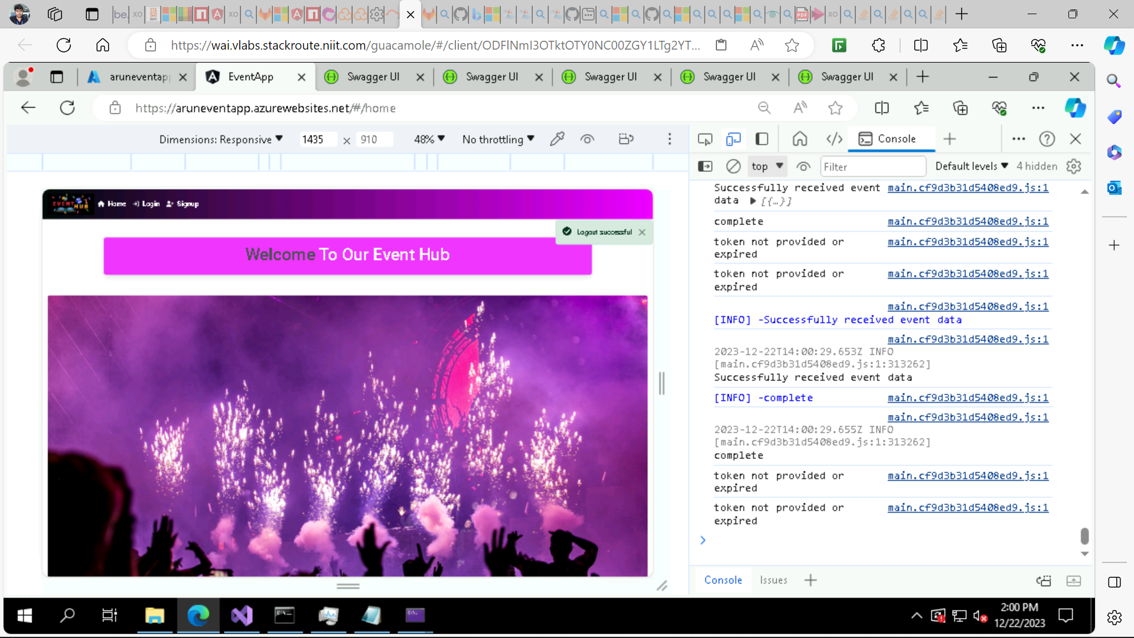

**After clicking on Add to Wishlist it redirects to login page.**

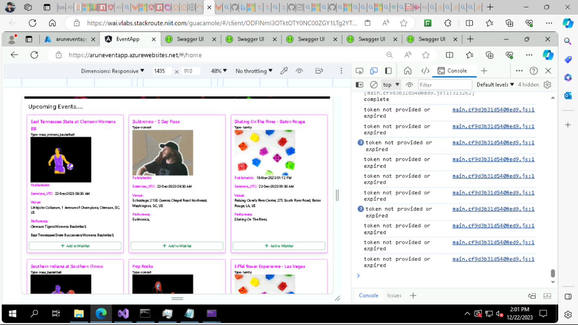

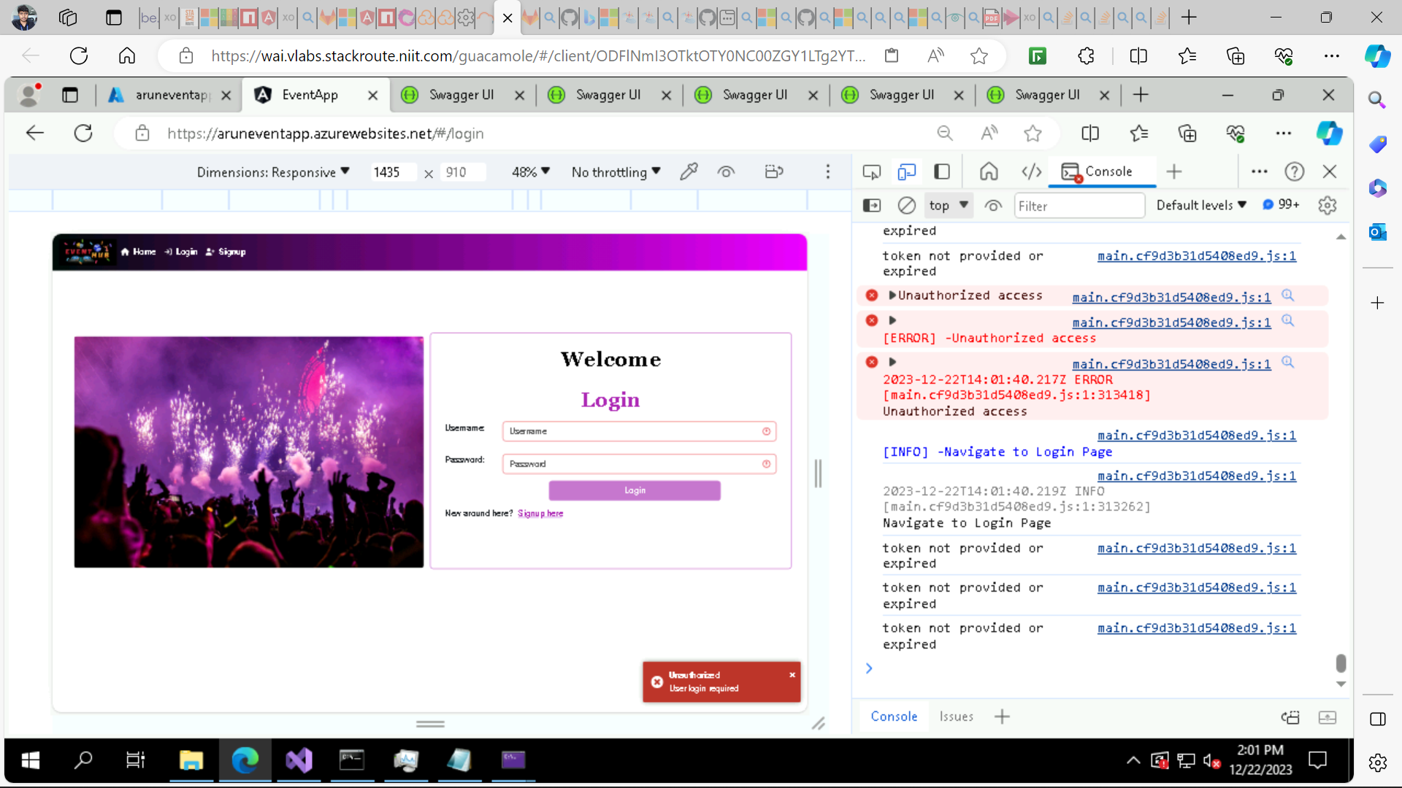

**Azure Queue Storage and Azure Function to add user login message to Queue- myqueueitems and process the message by using Azure Function Queue Trigger:**

**Create an Azure Storage Account:**

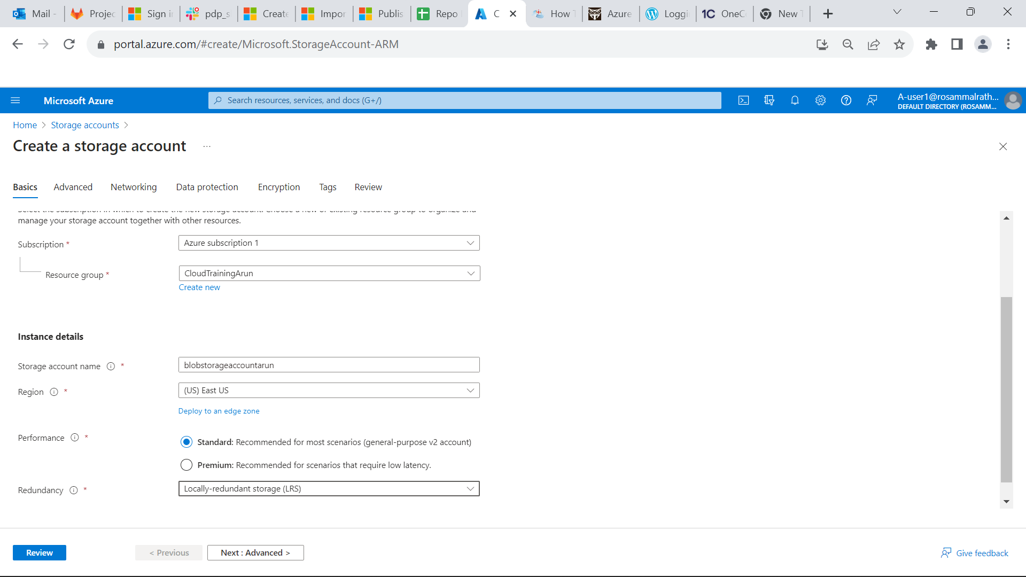

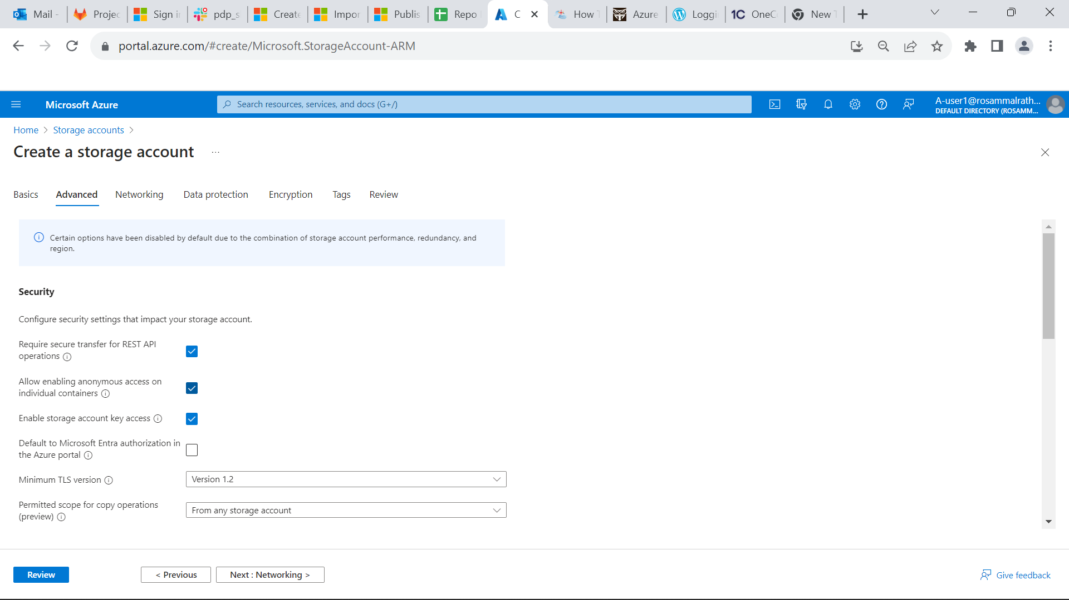

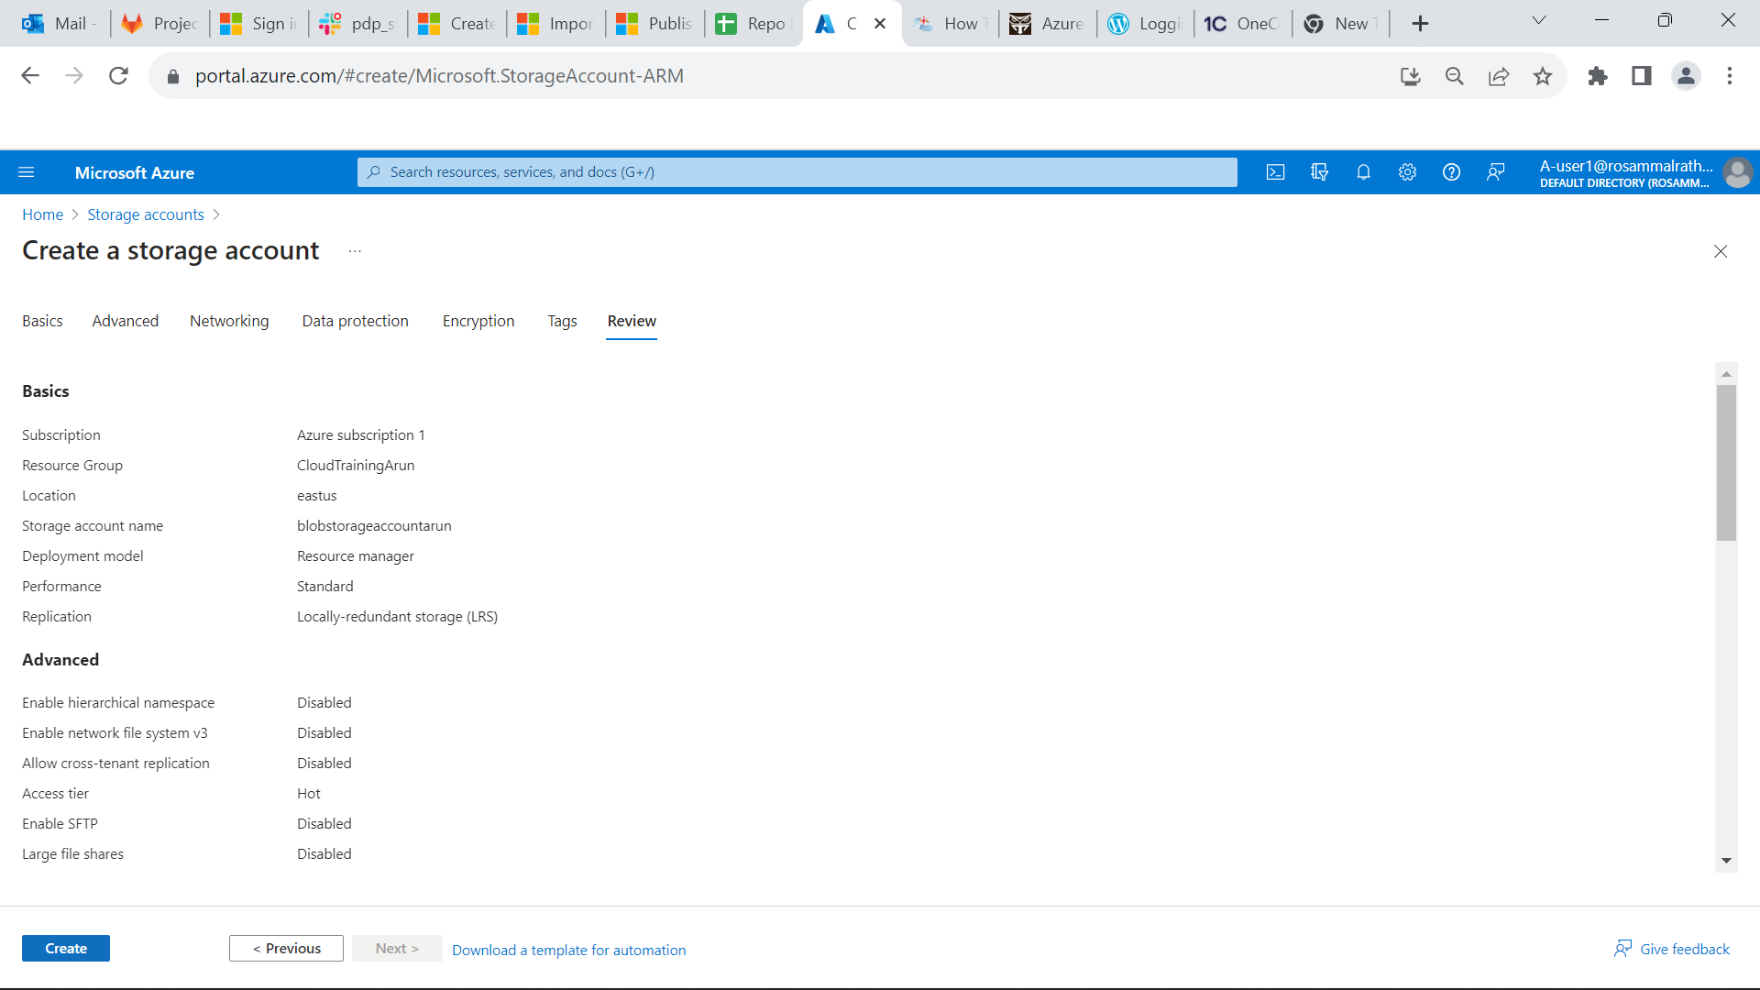

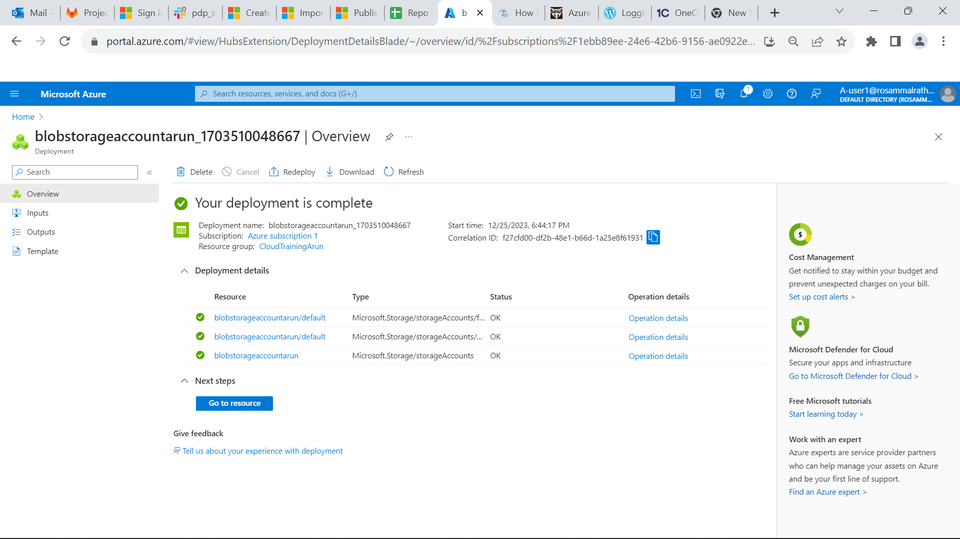

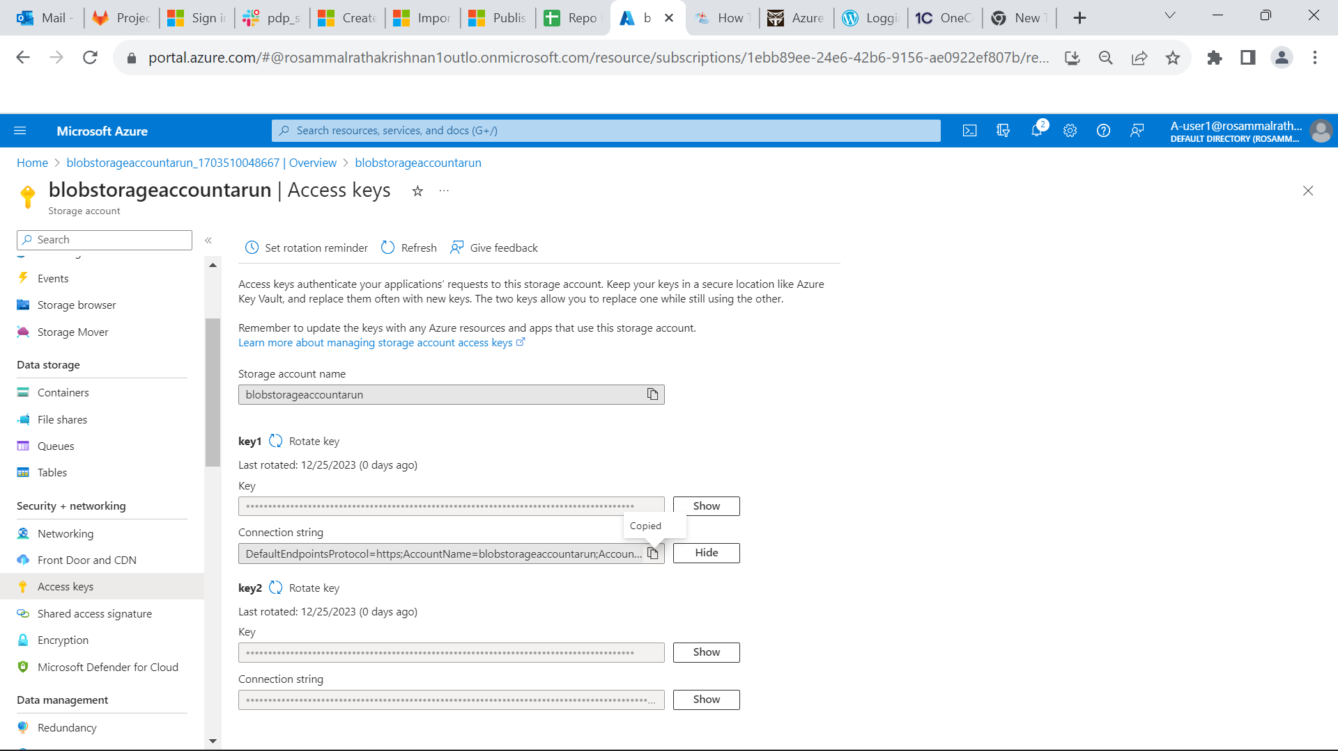

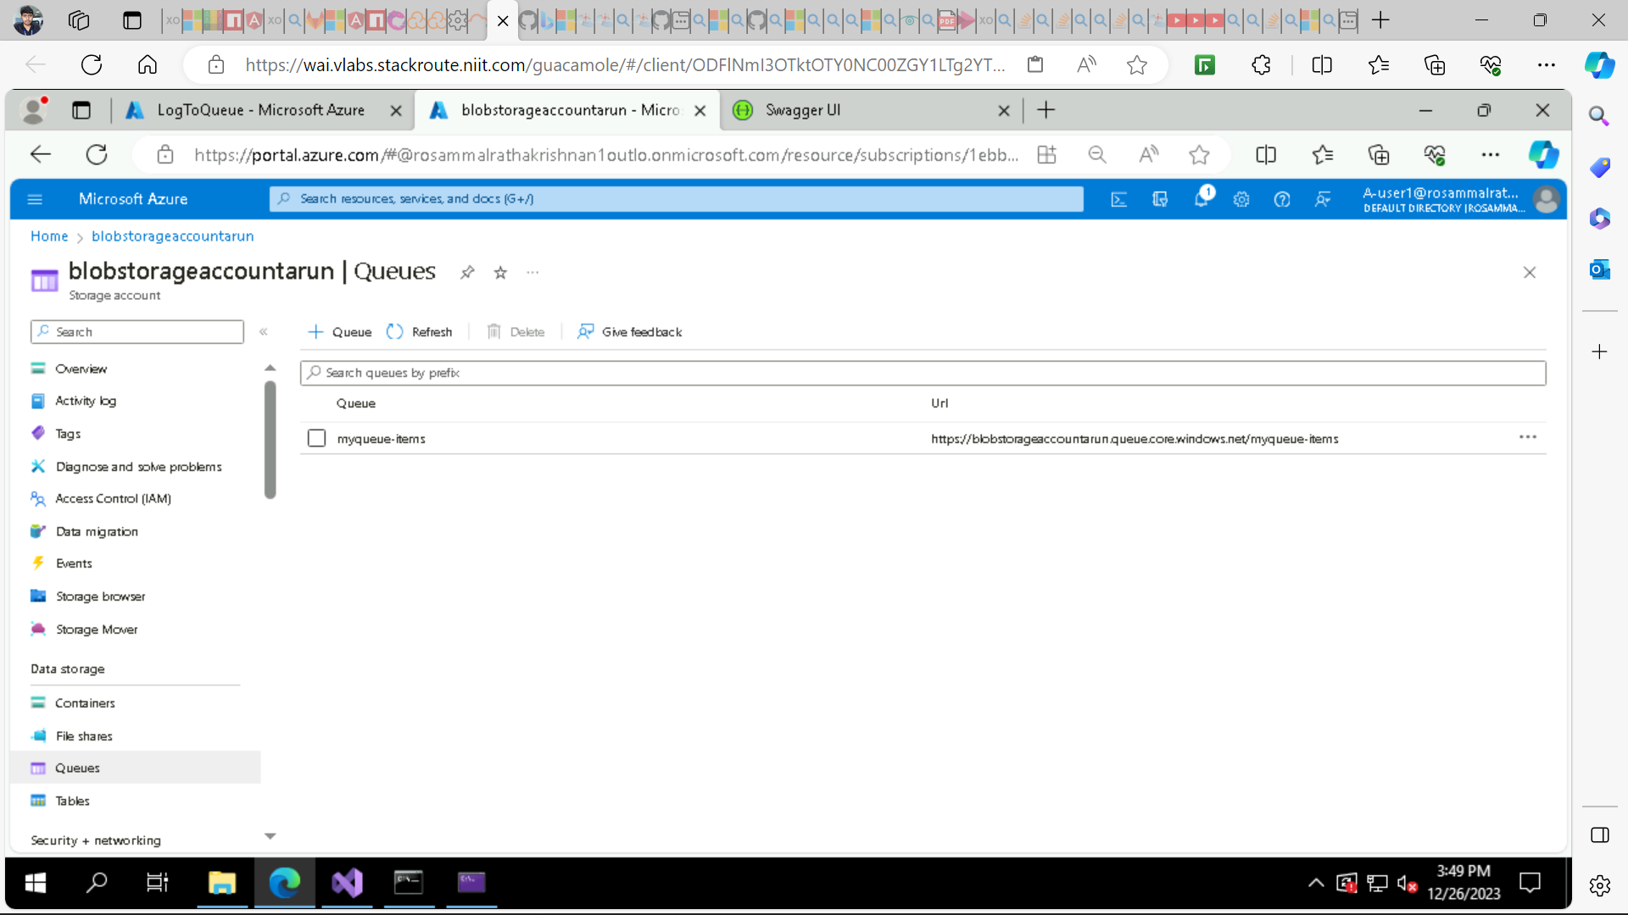

**Create a Function App**

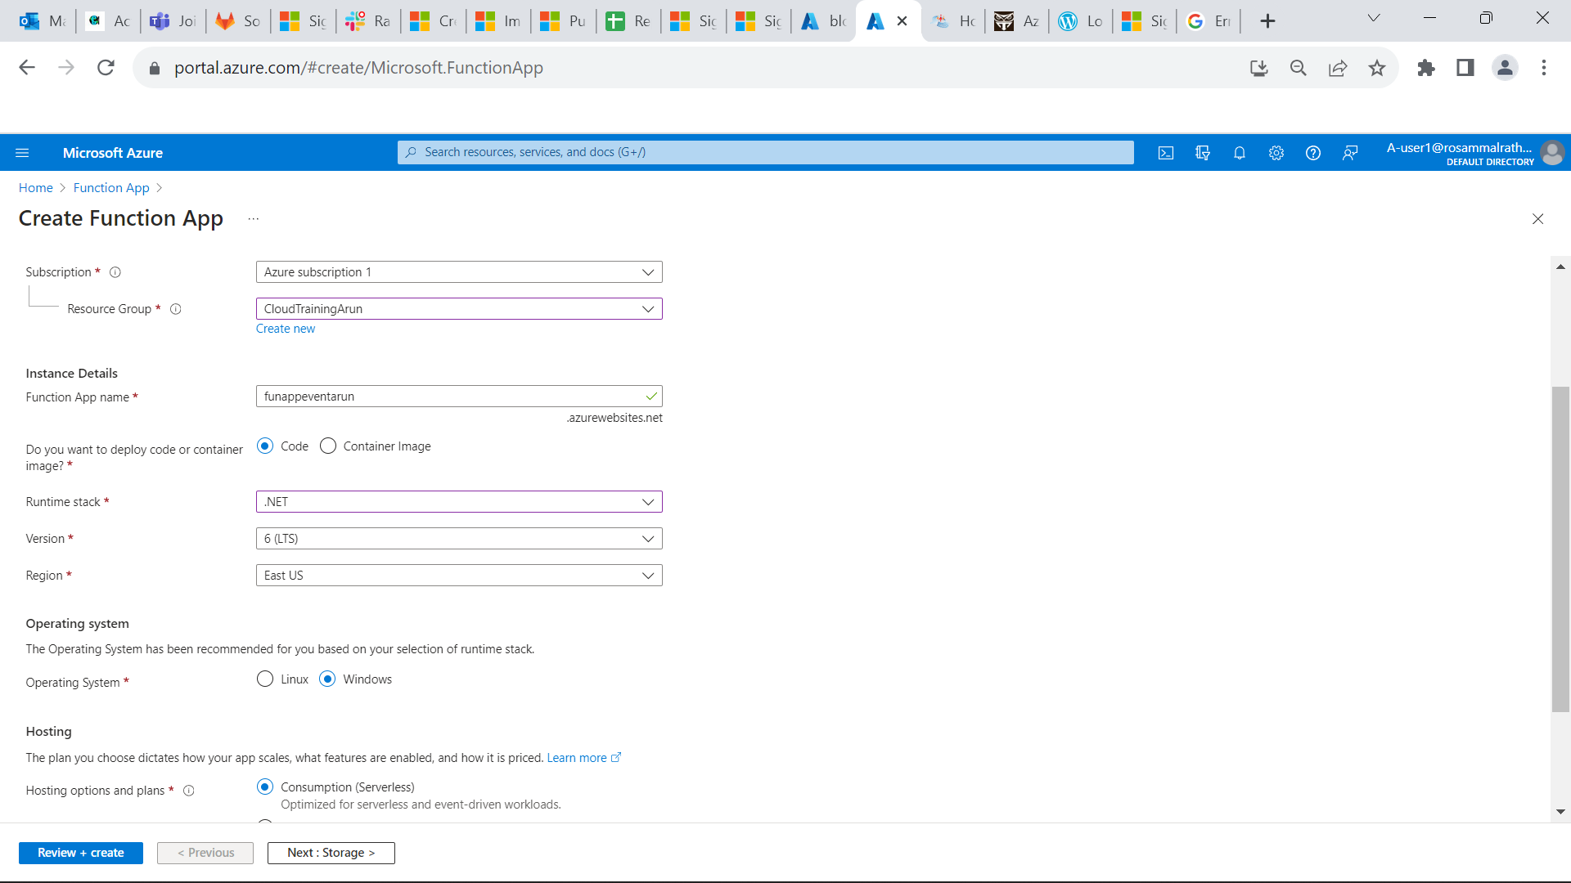

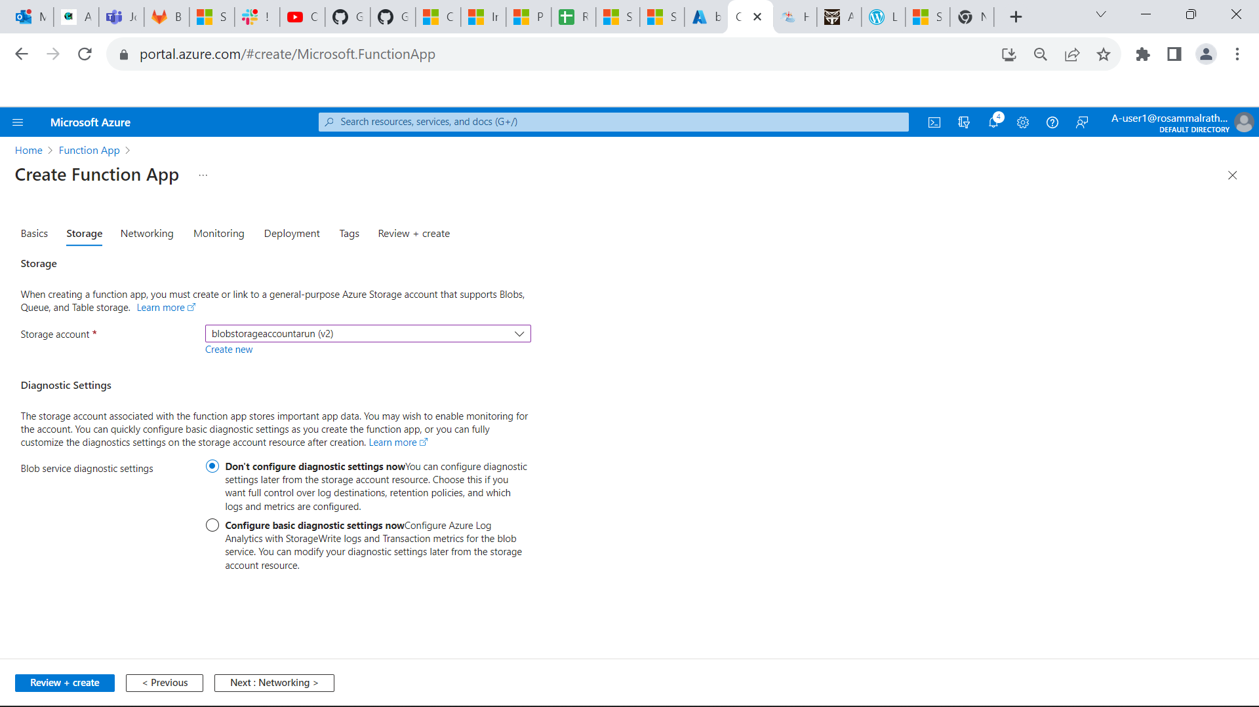

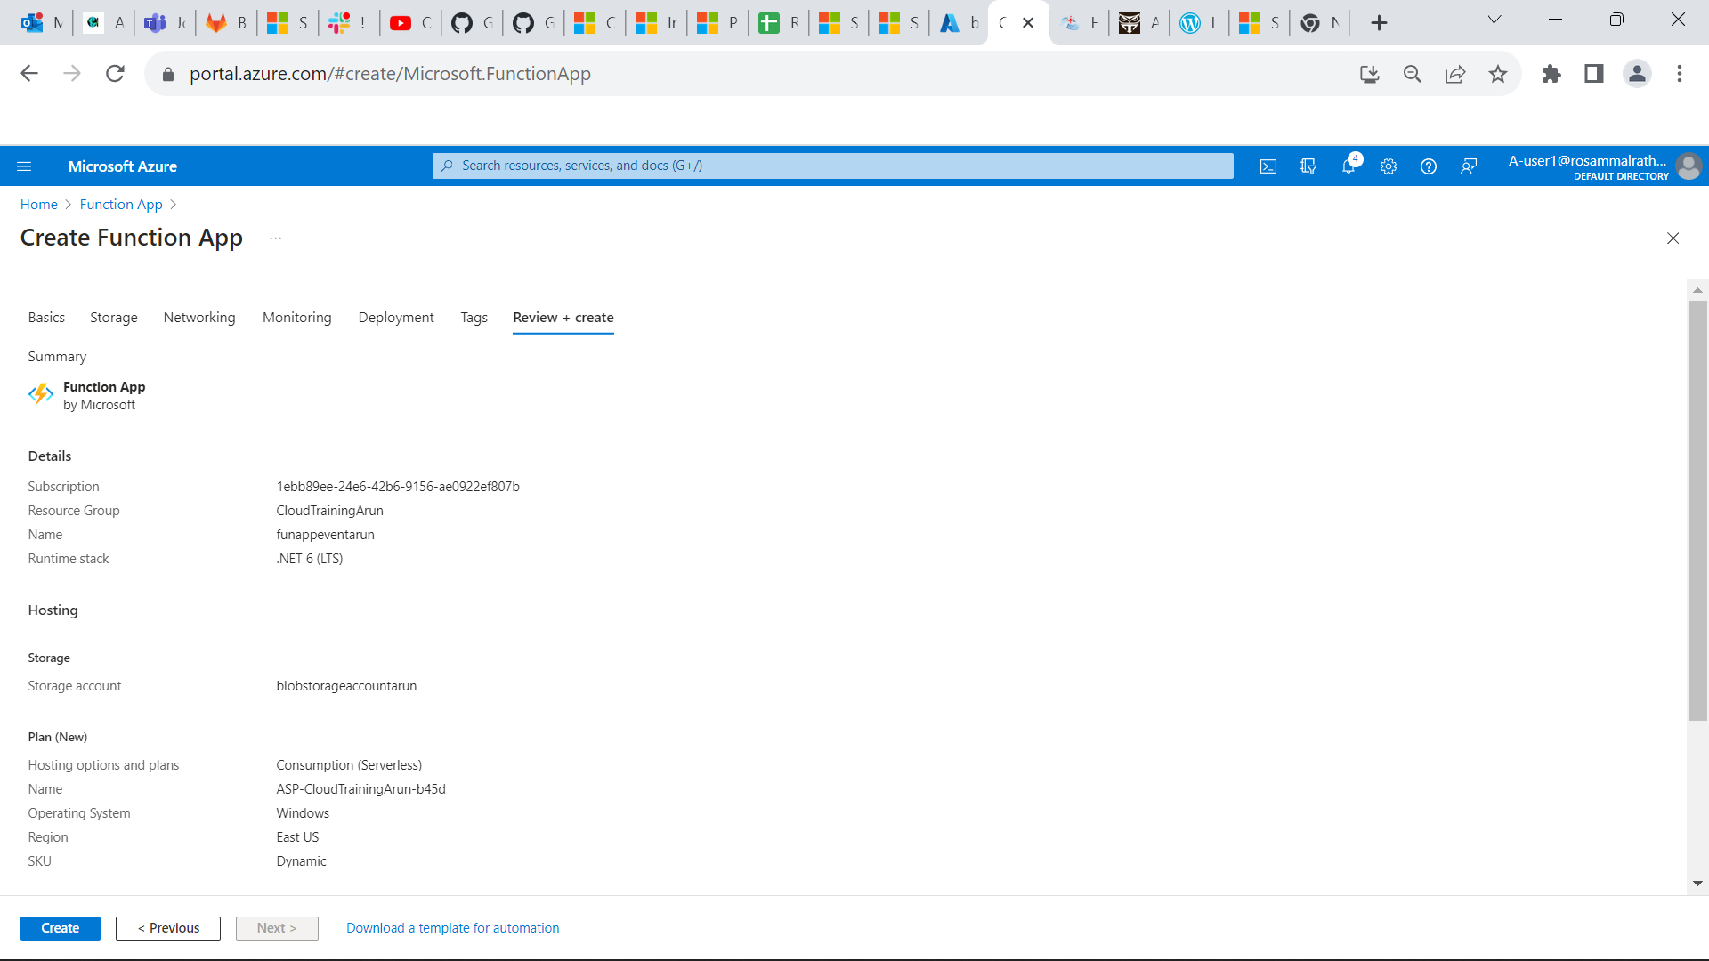

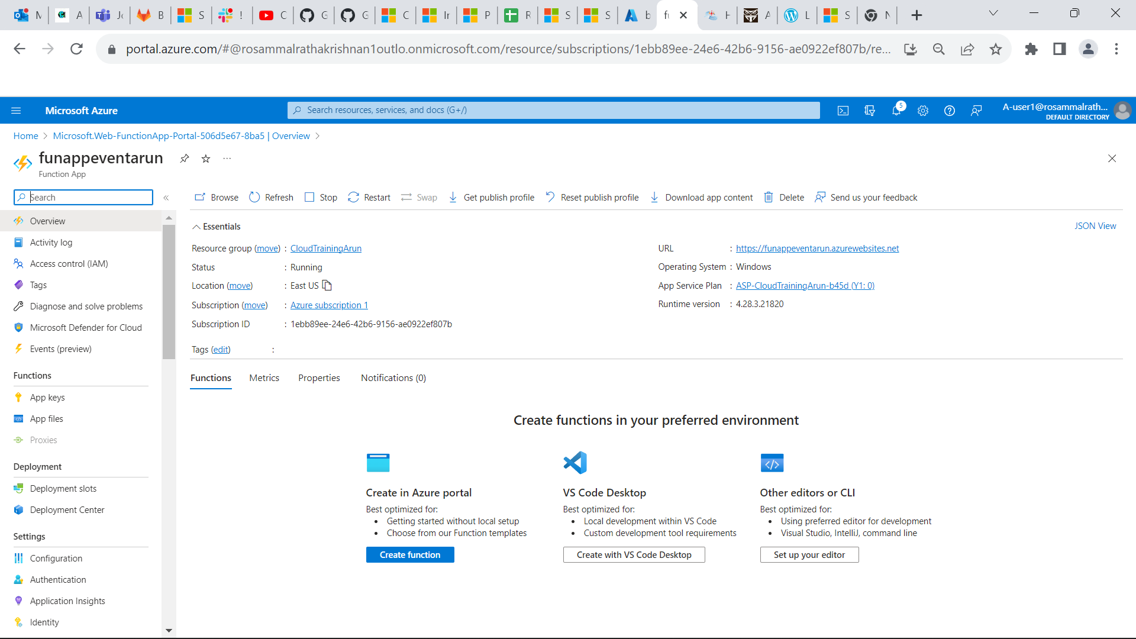

**Now open visual studio and create a function app in your backend and create a Queue Trigger function to process the message that added by UserAuthenticationService and add the follow code to UserAuthenticationService that adds message to queue.**

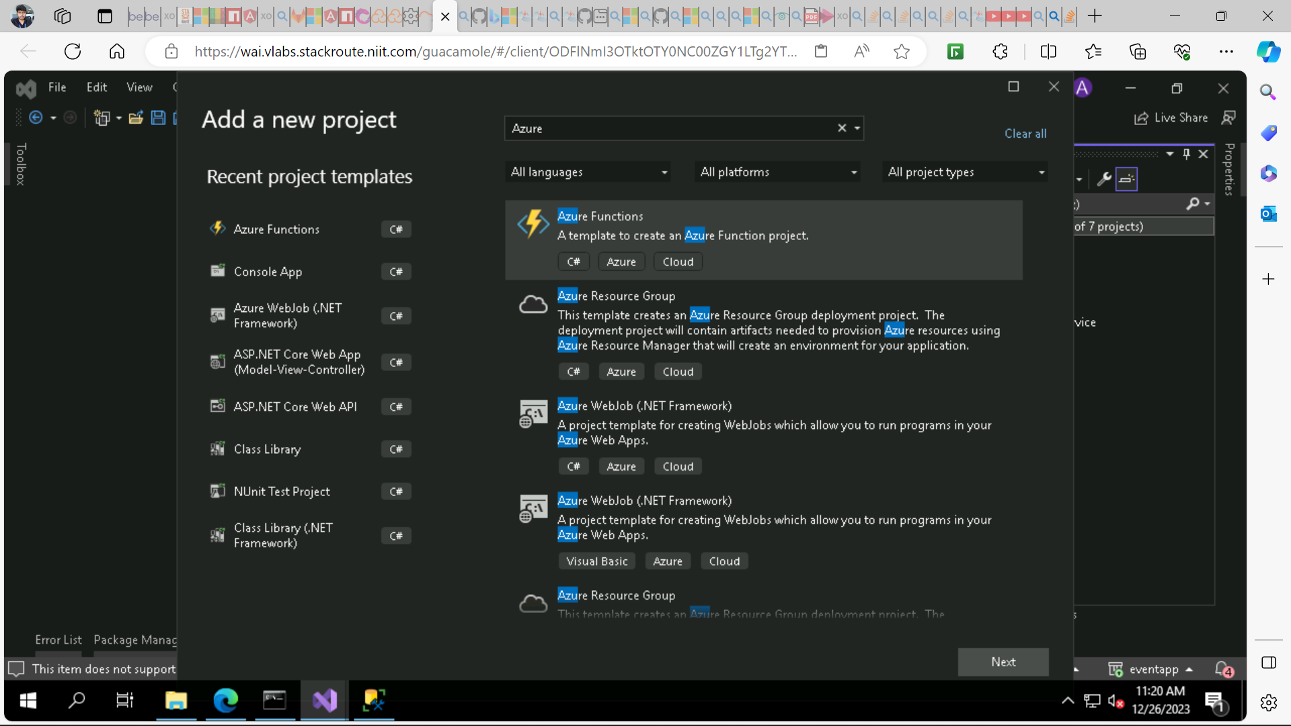

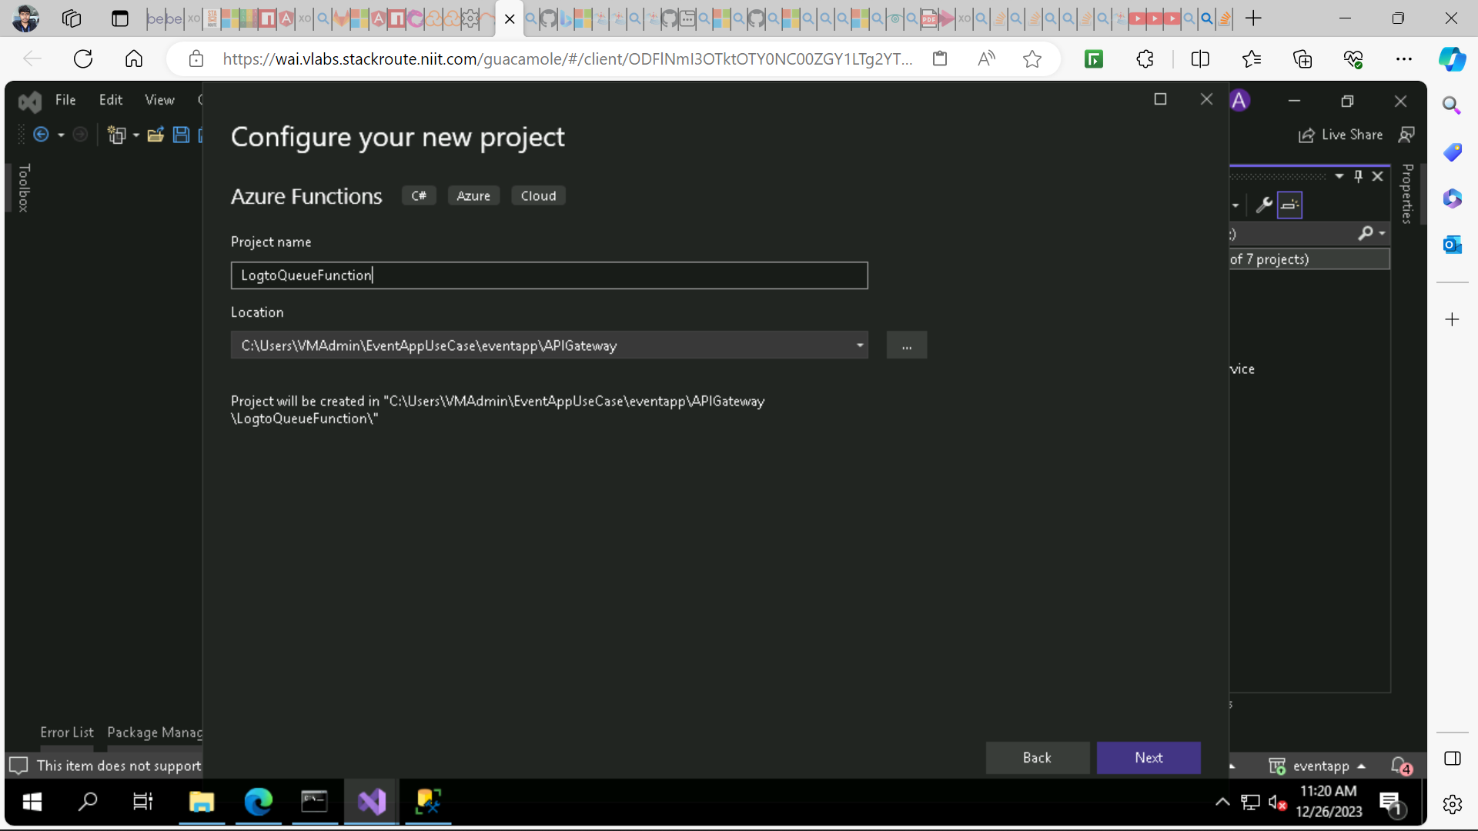

**QueueName:myqueue-items**

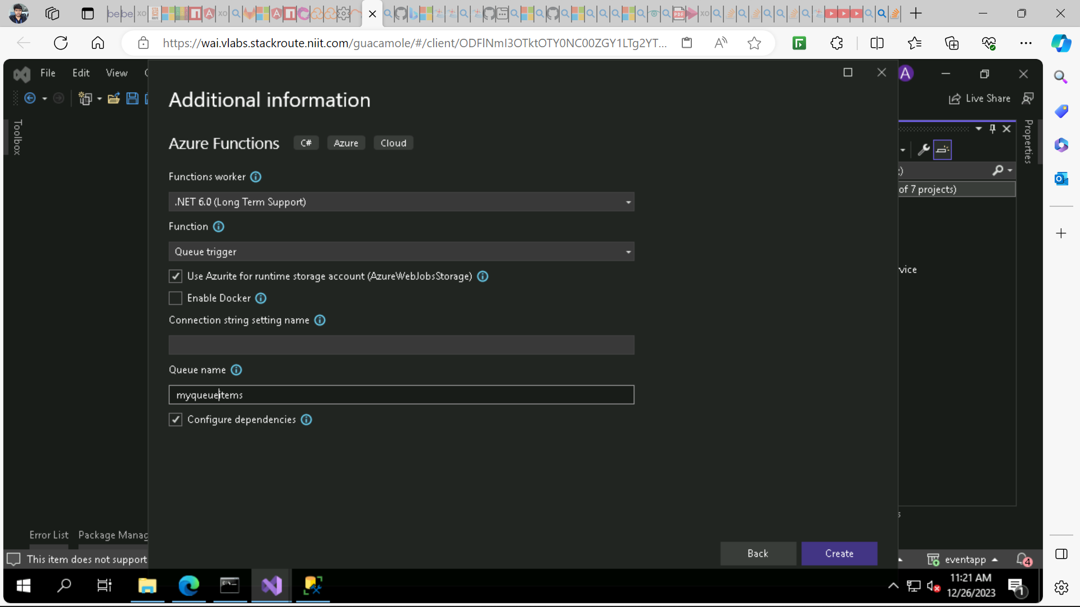

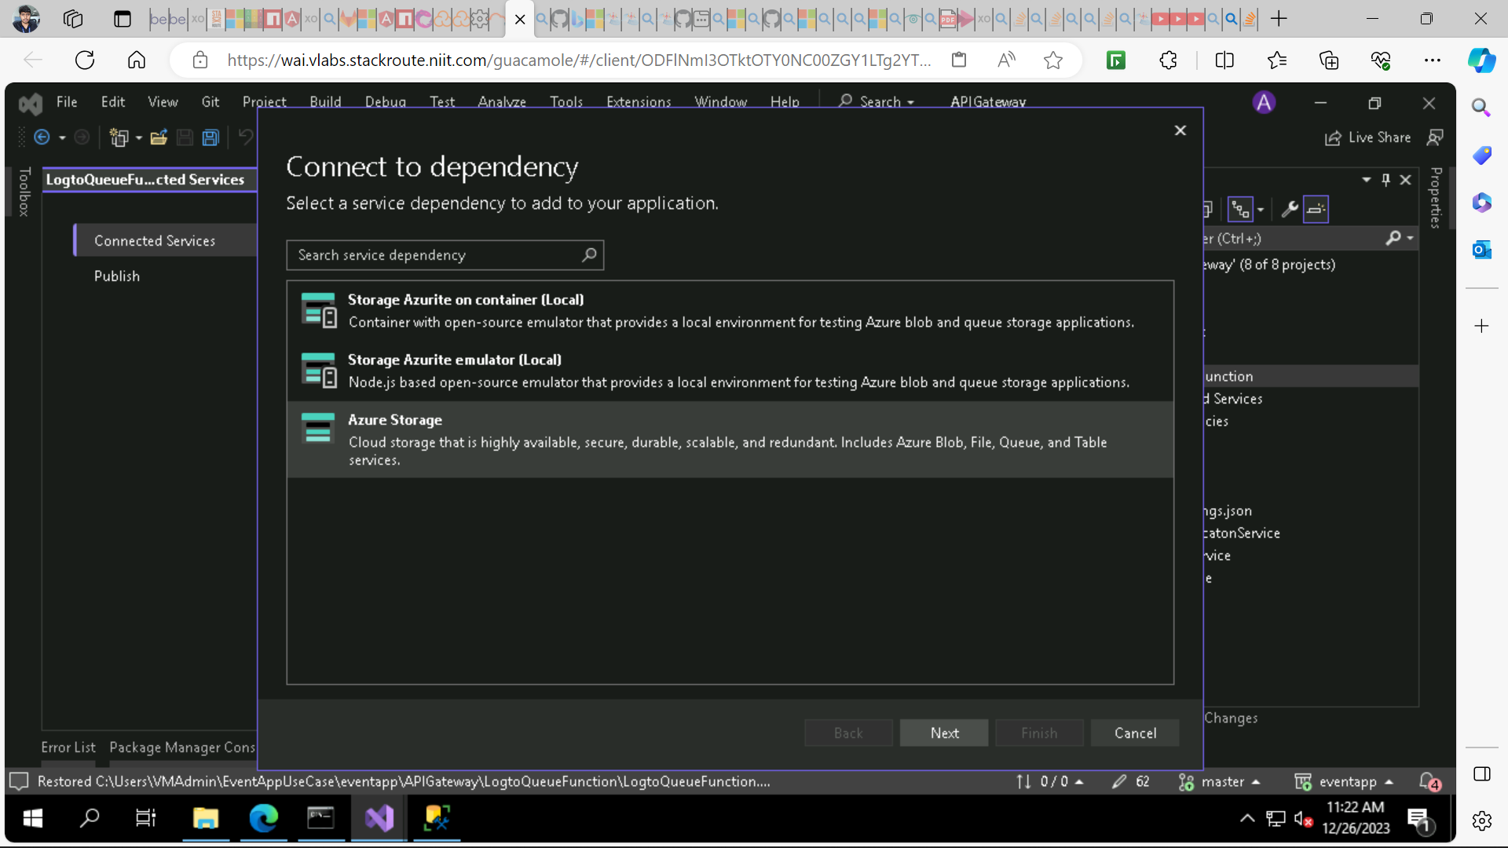

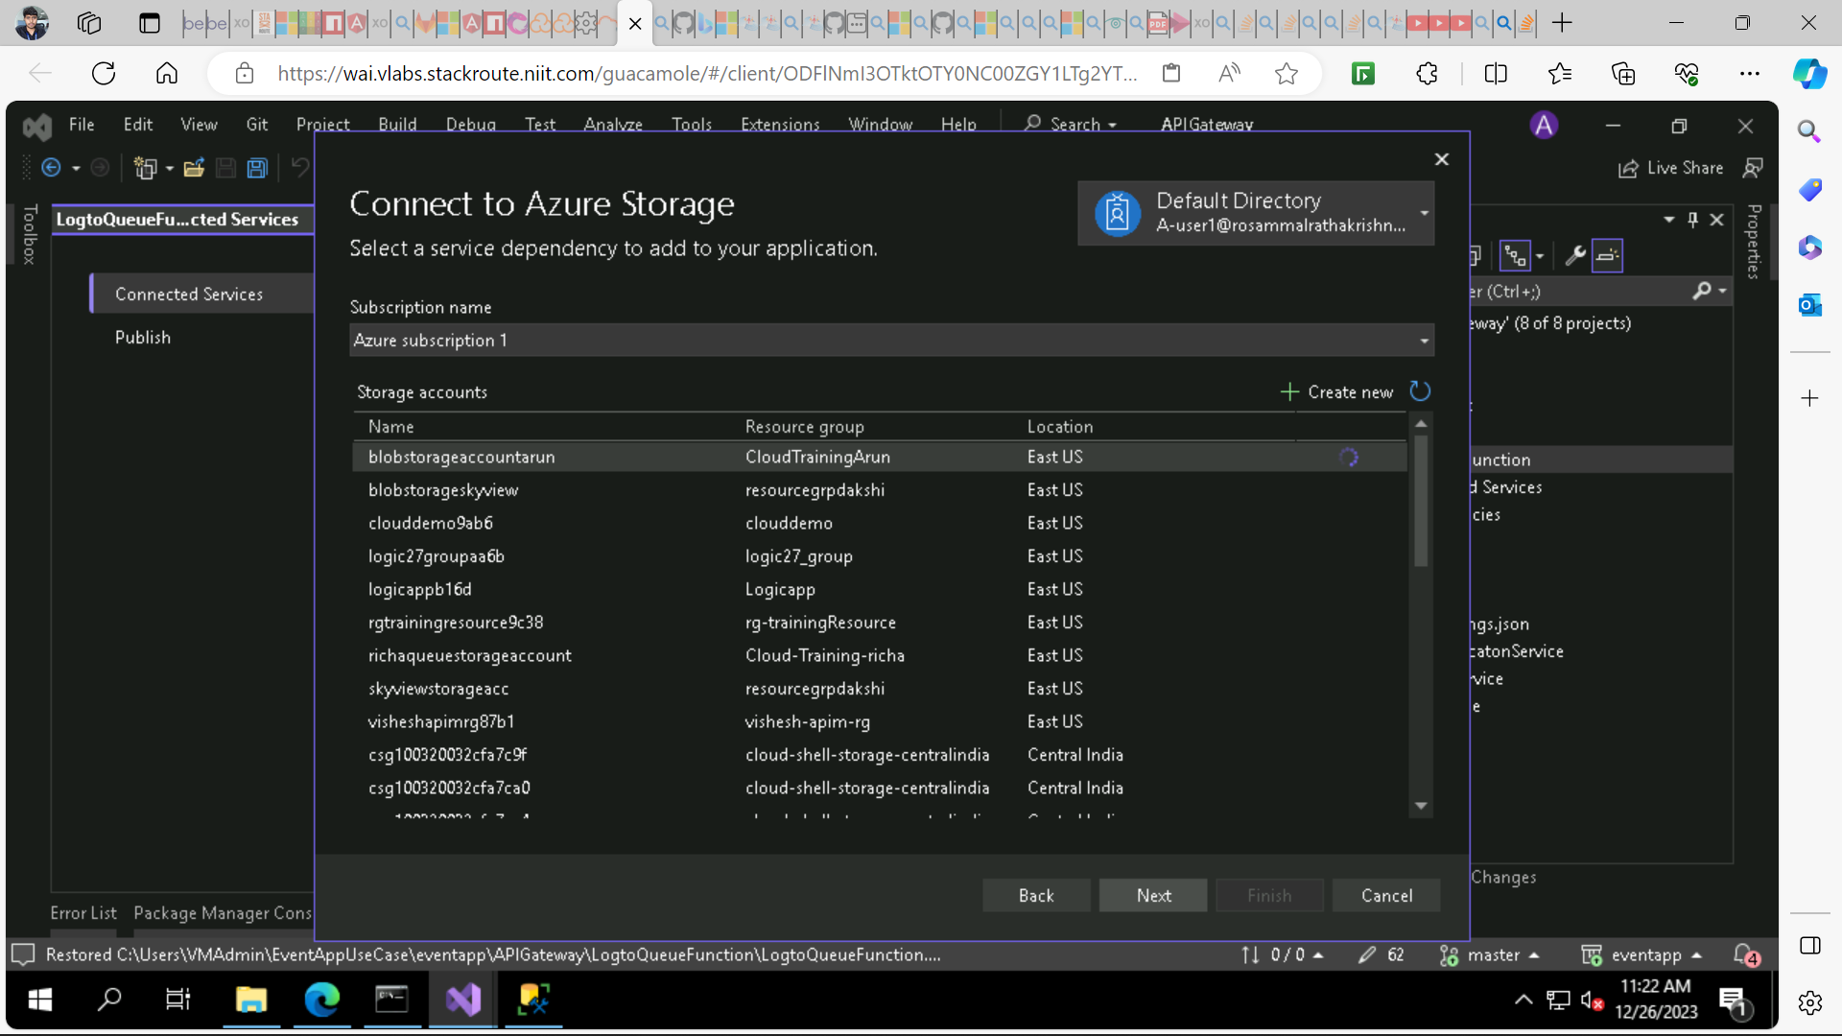

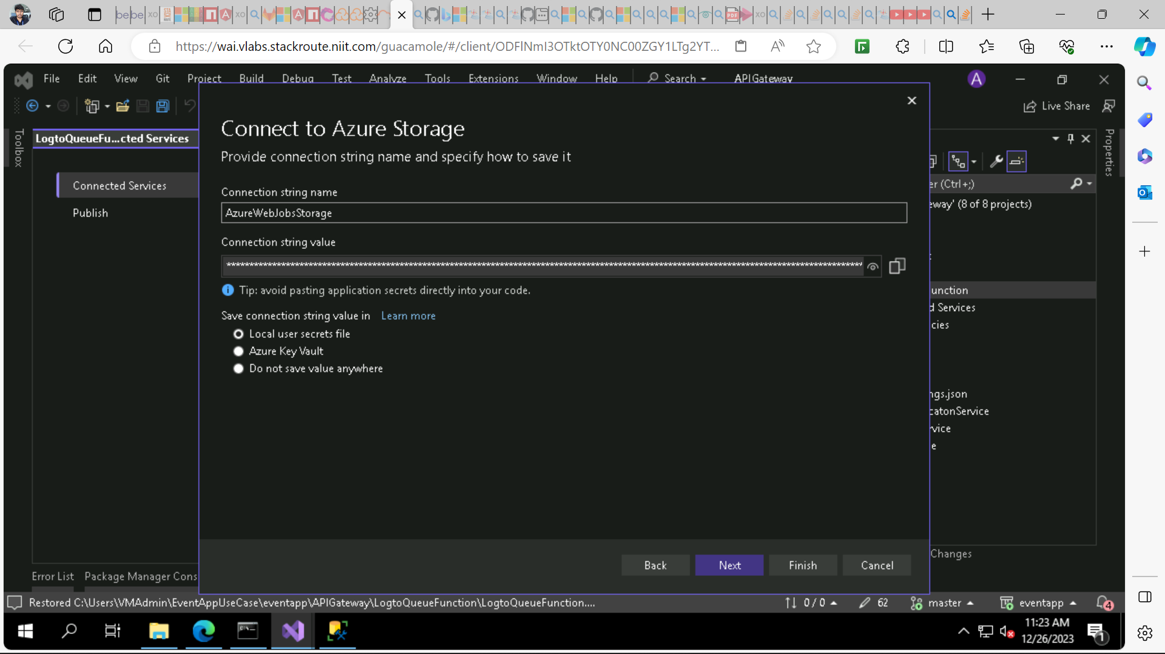

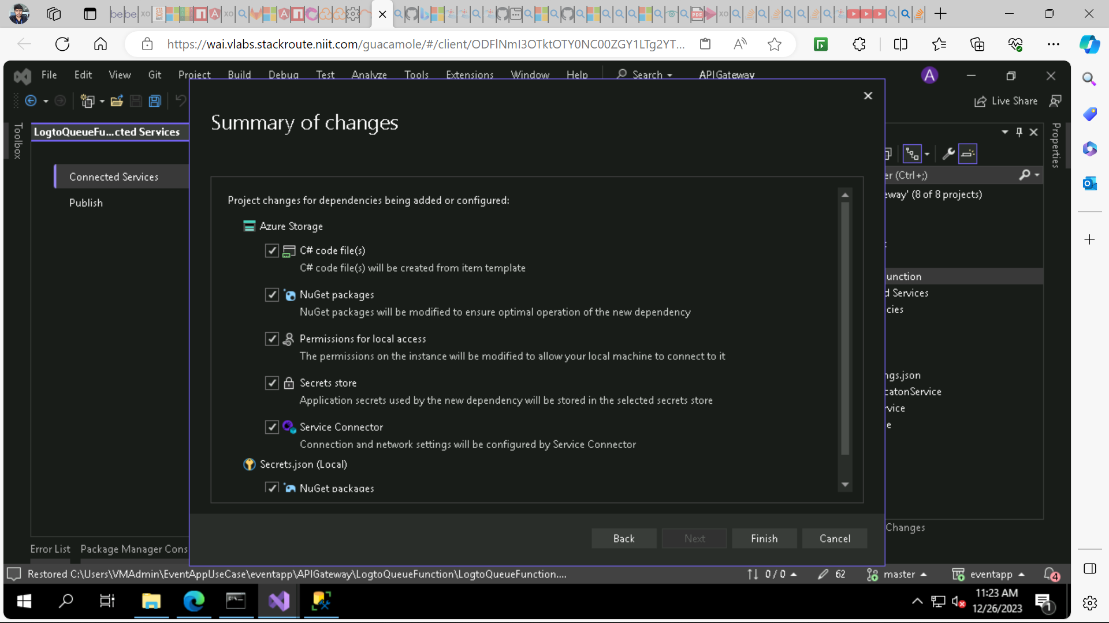

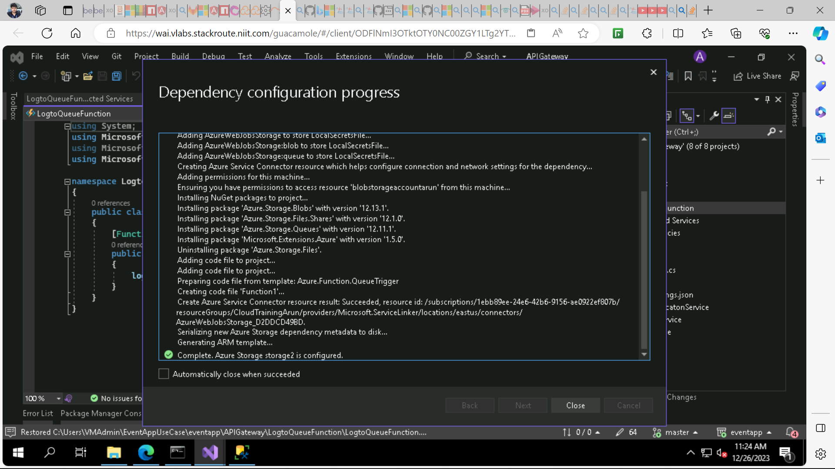

* **Here is the code that need to be added in UserAuthenticationService.**

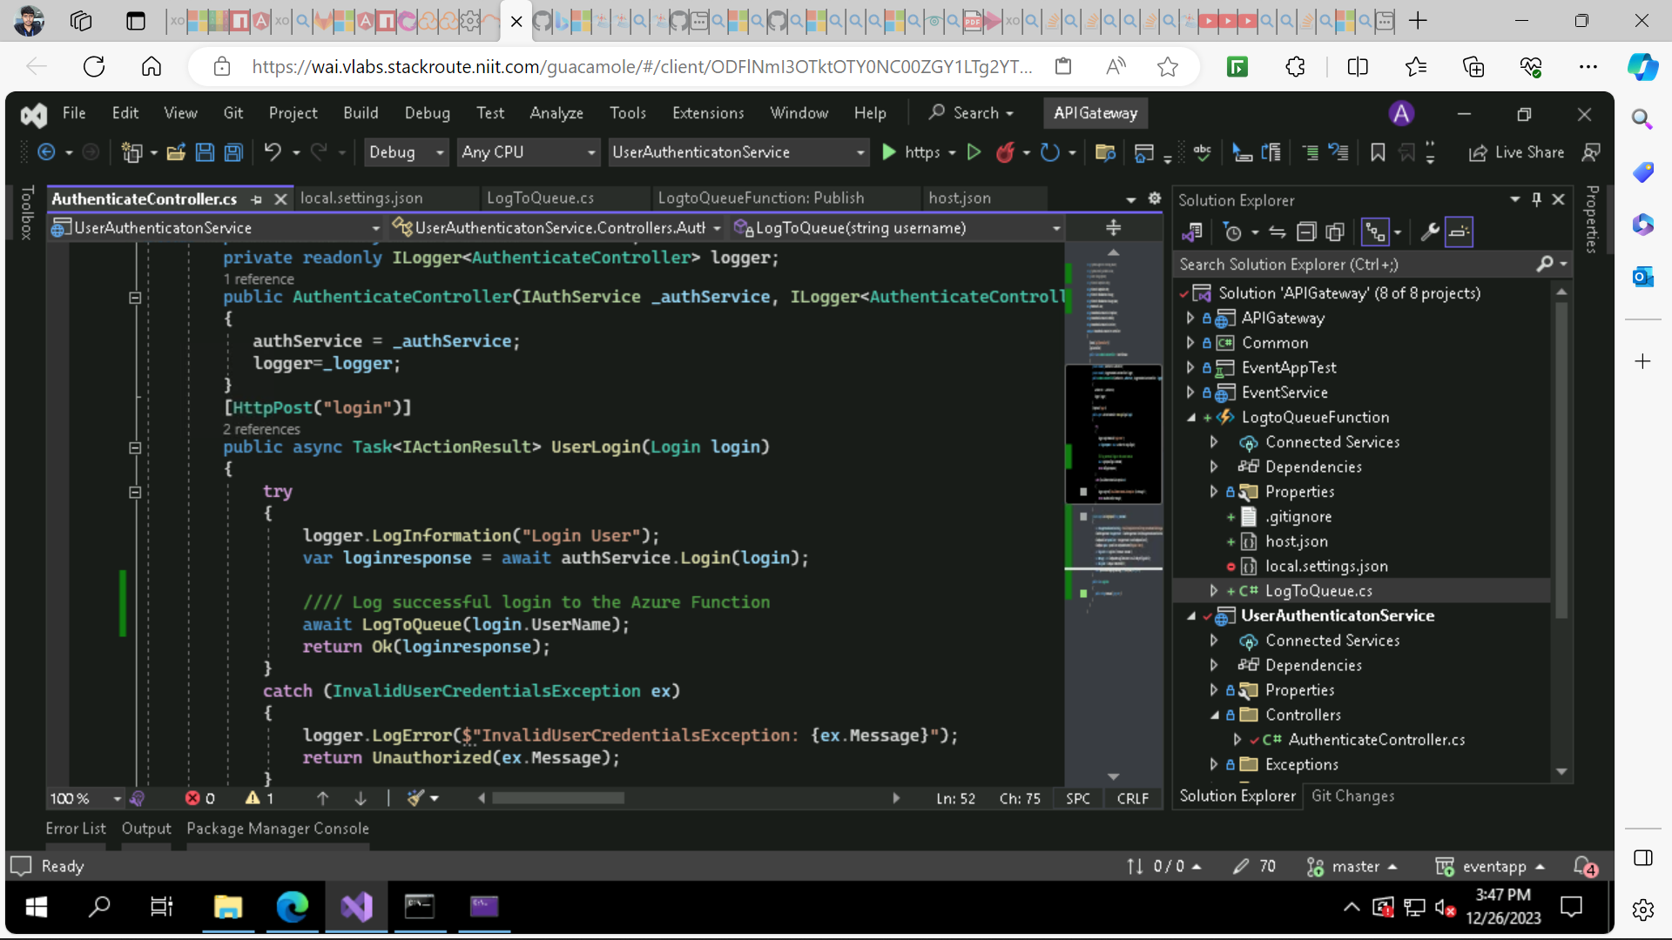

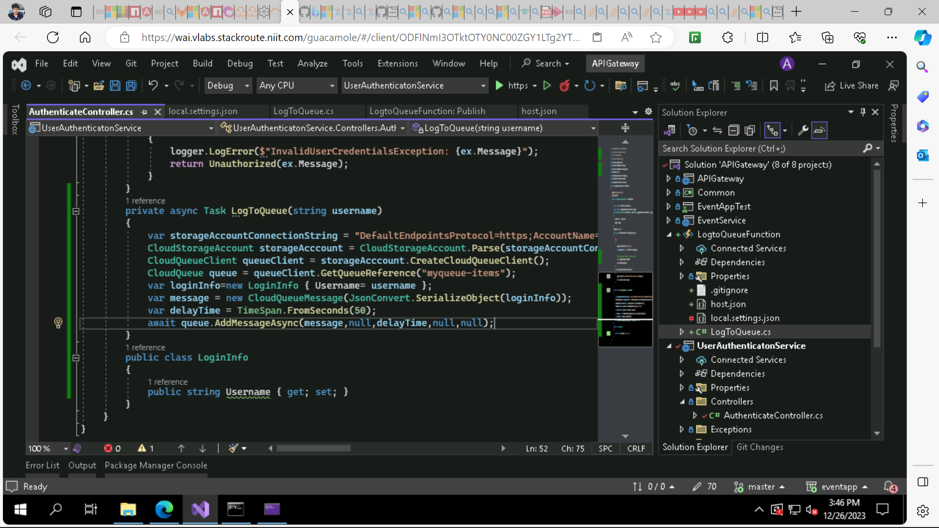

* **Here is the Queue Trigger Function**

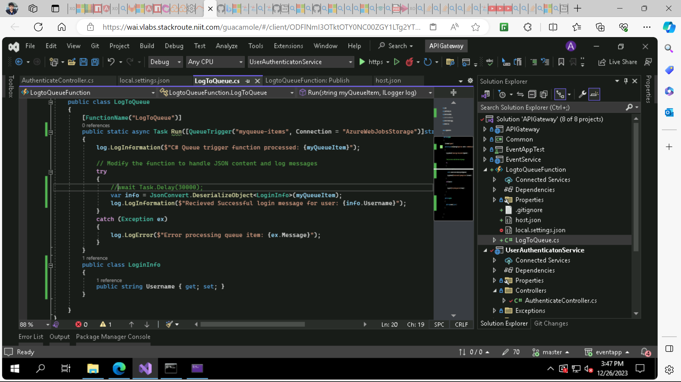

* **Publish the trigger to Function app.**

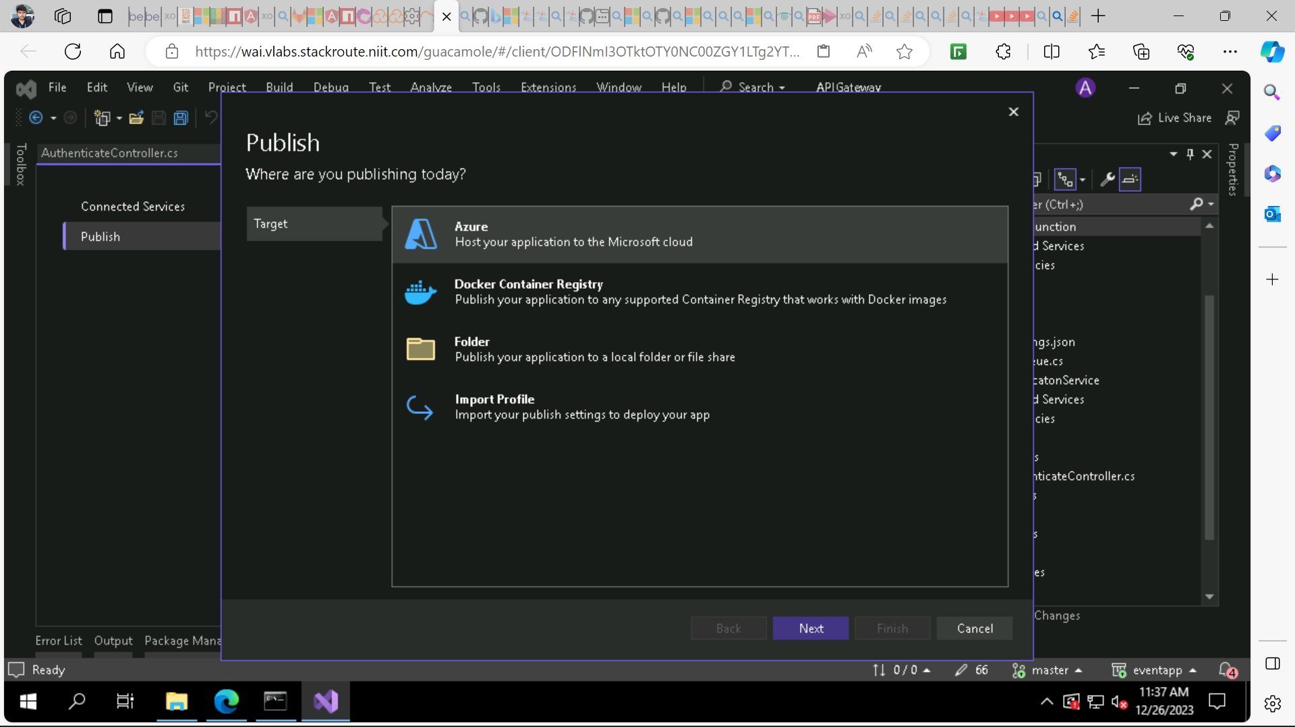

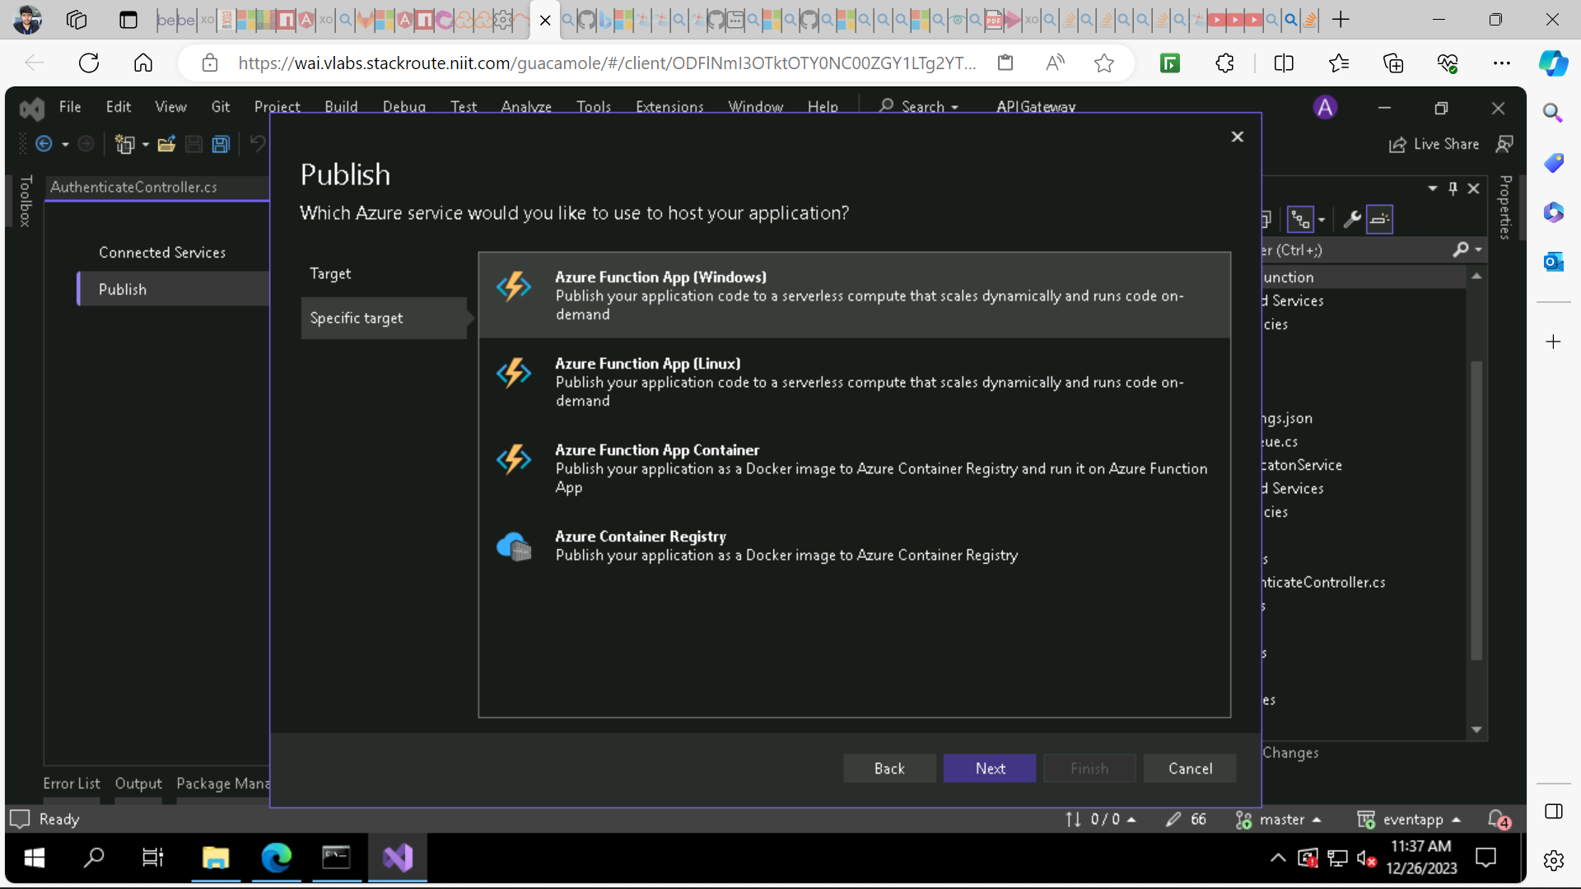

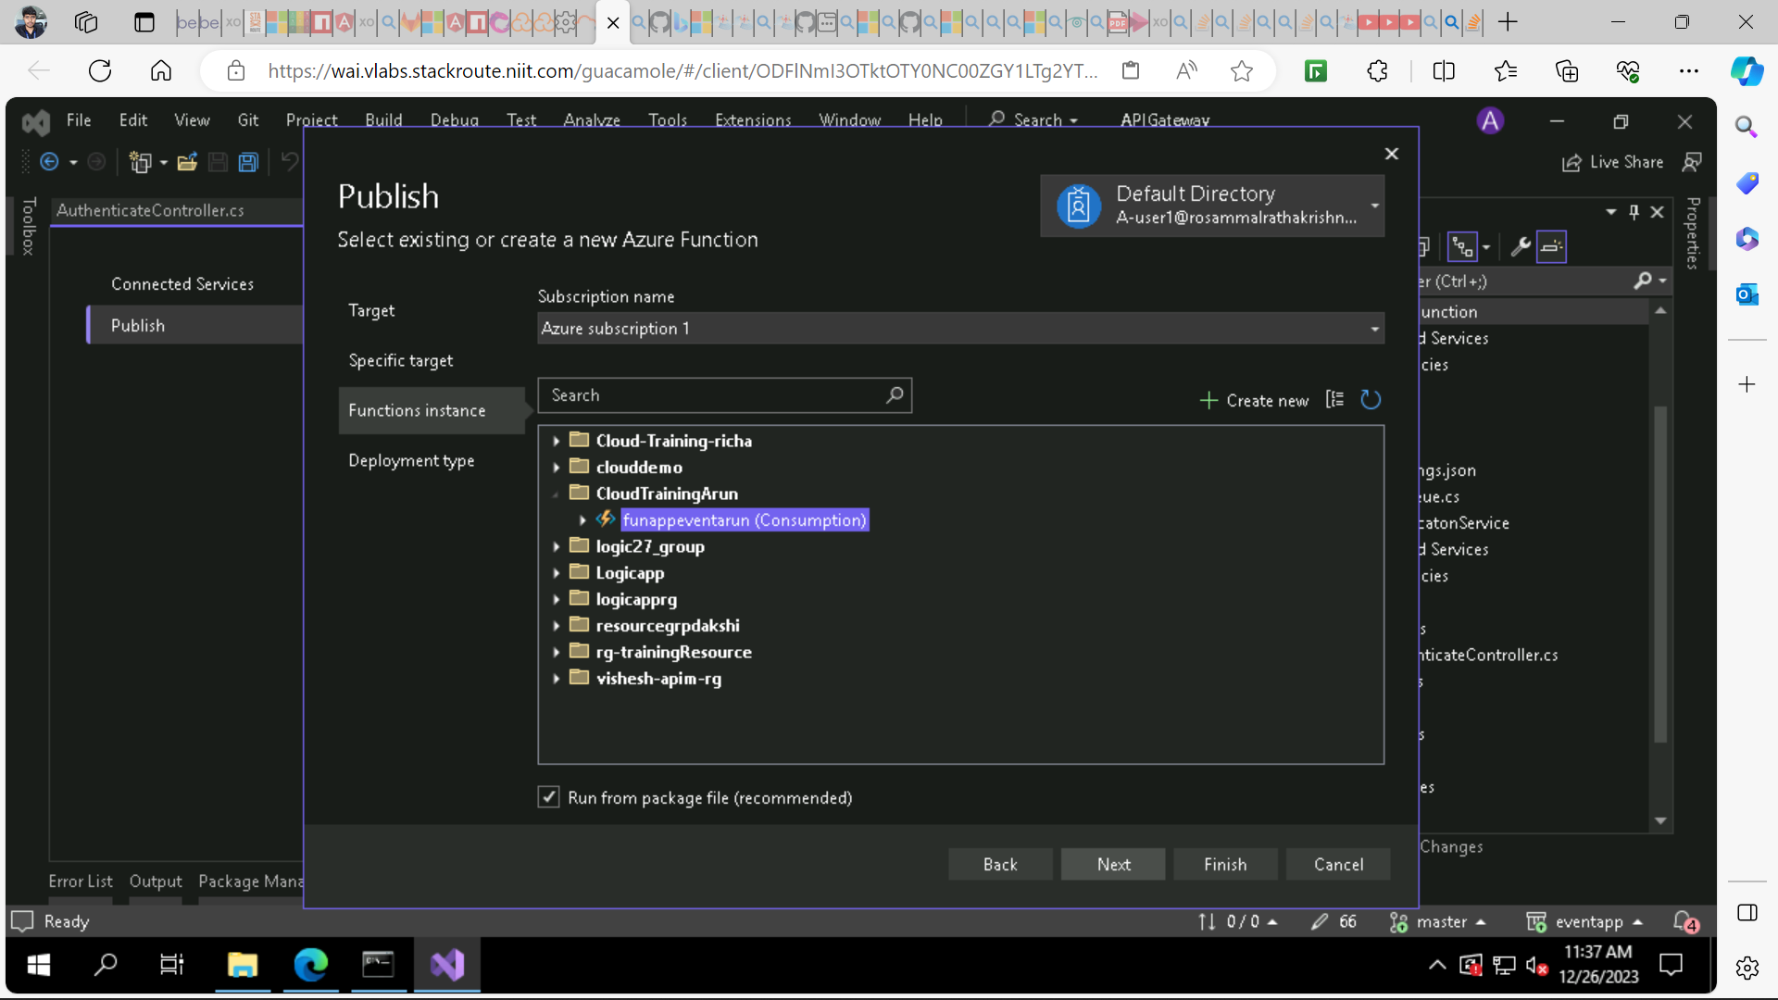

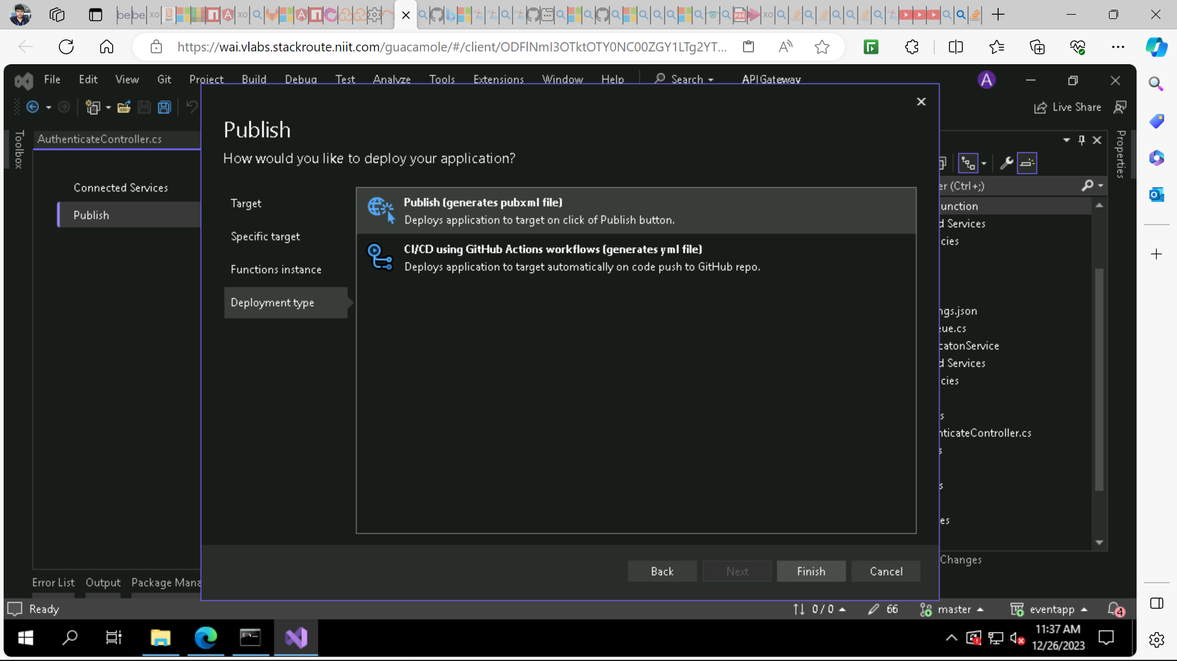

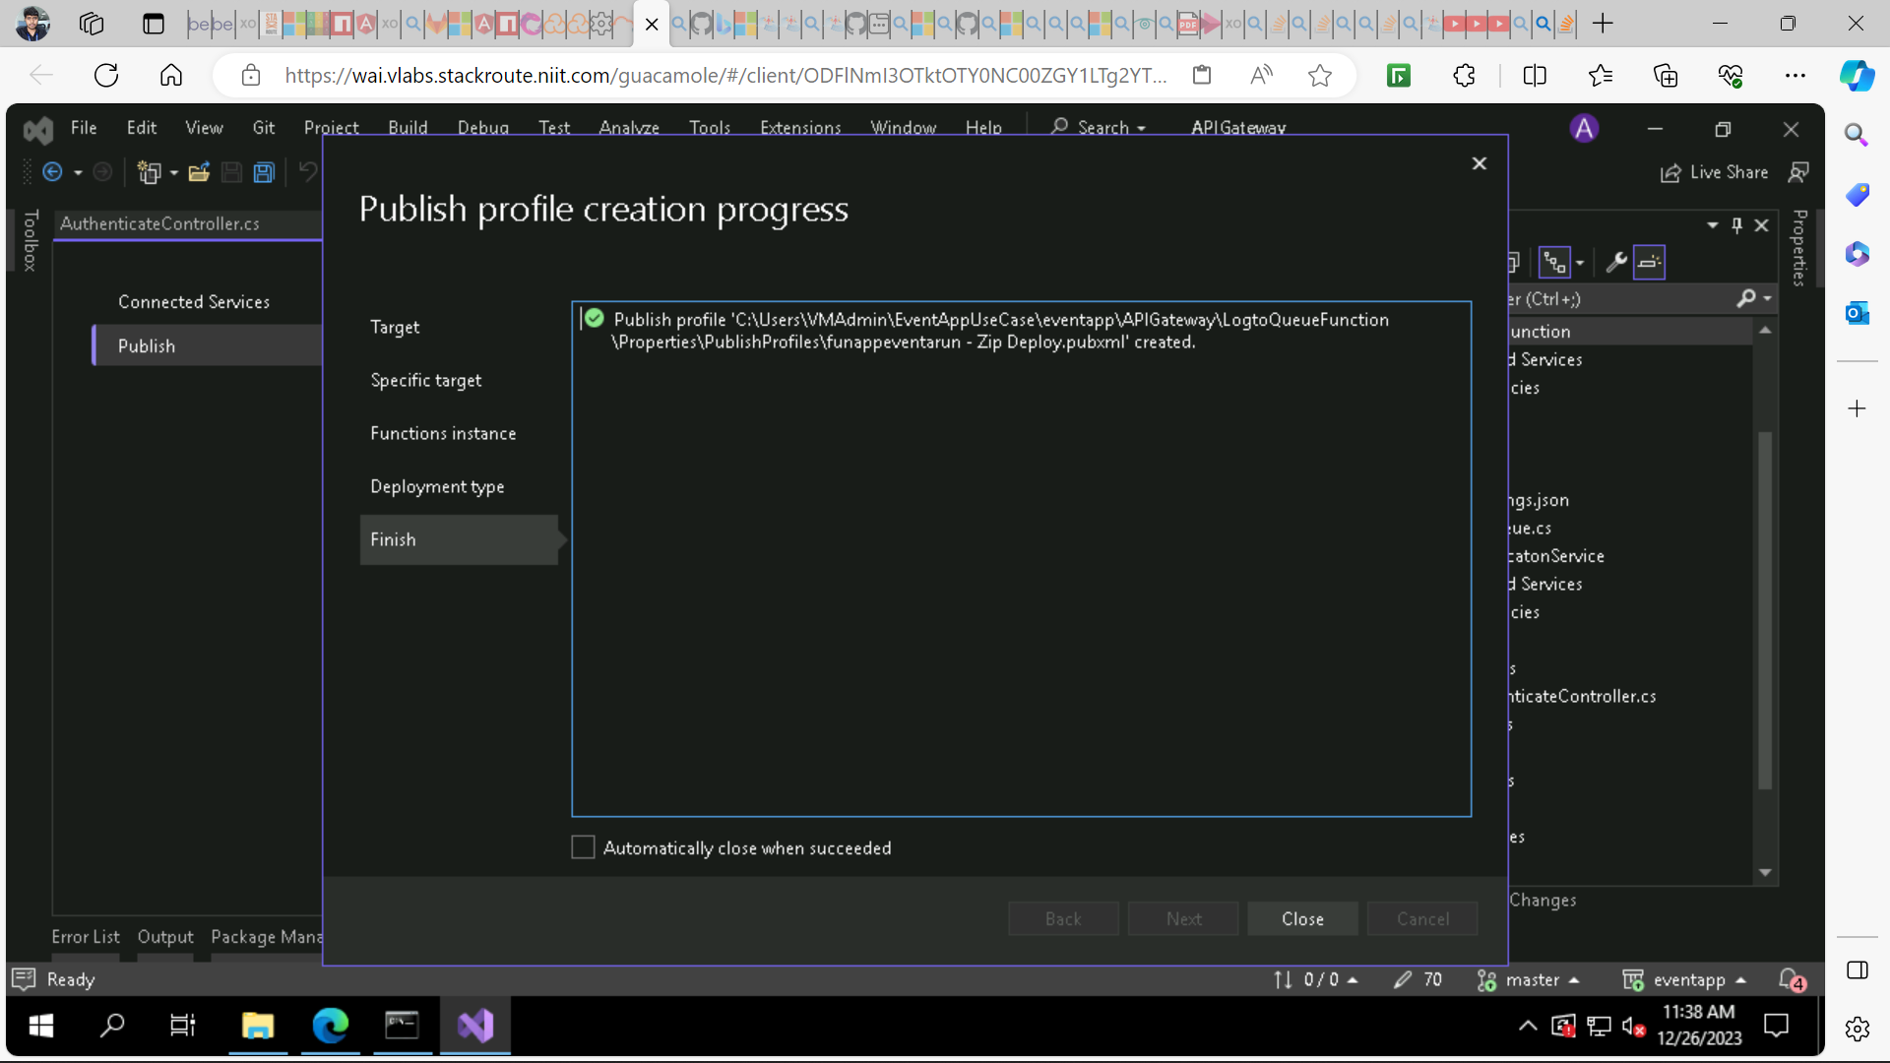

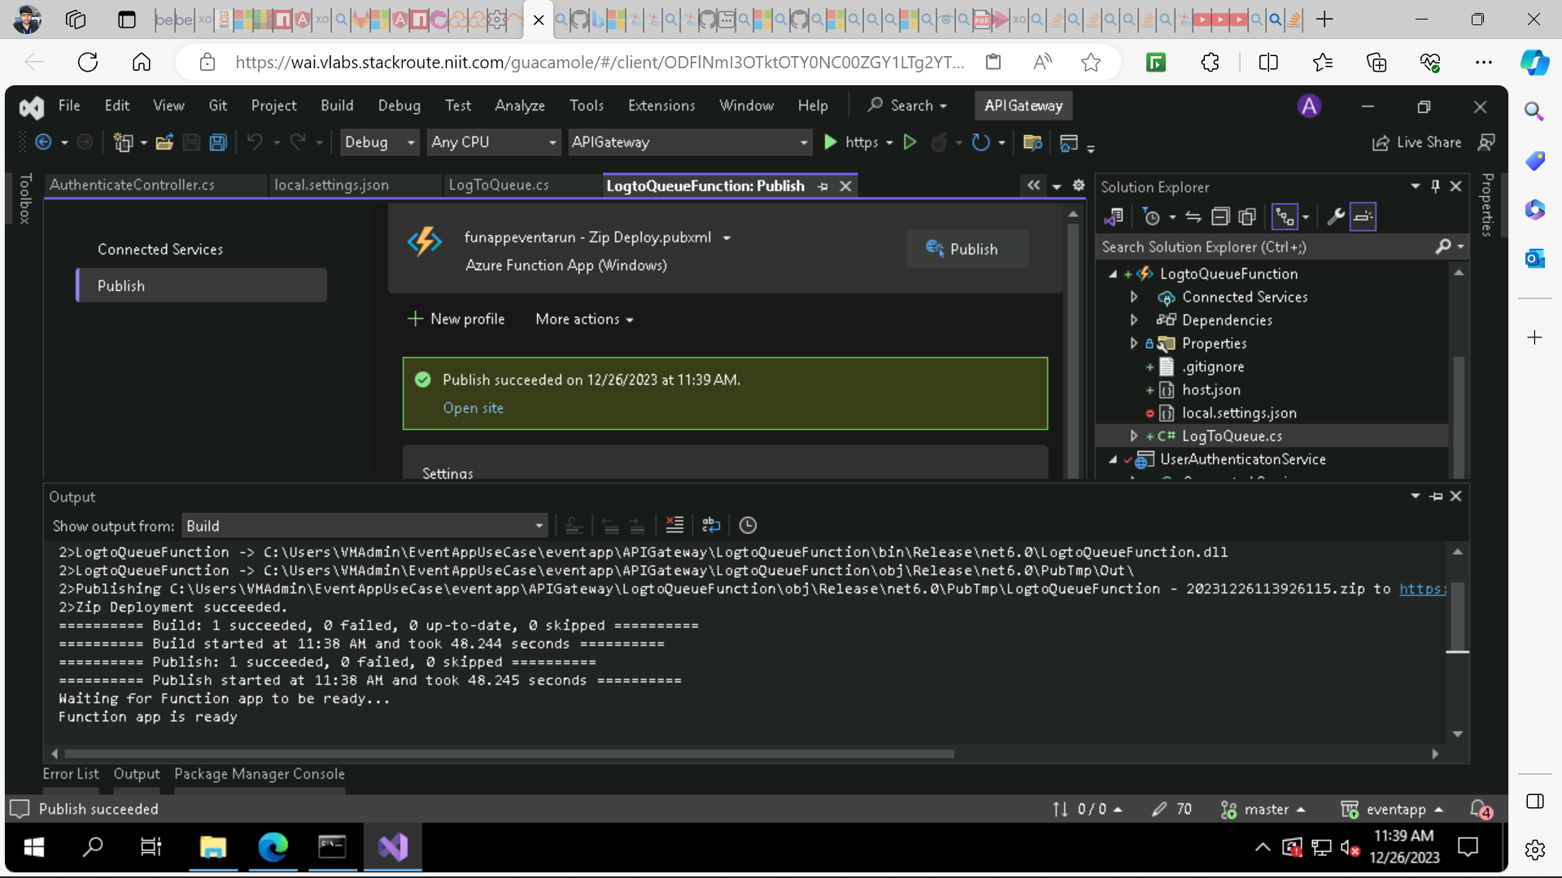

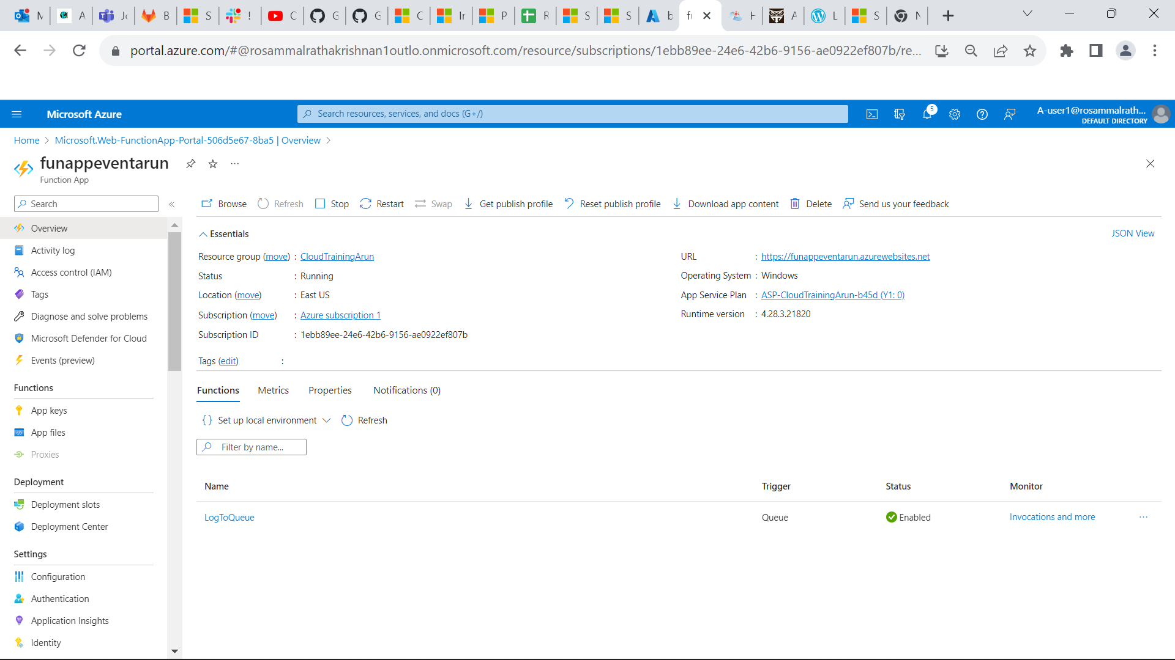

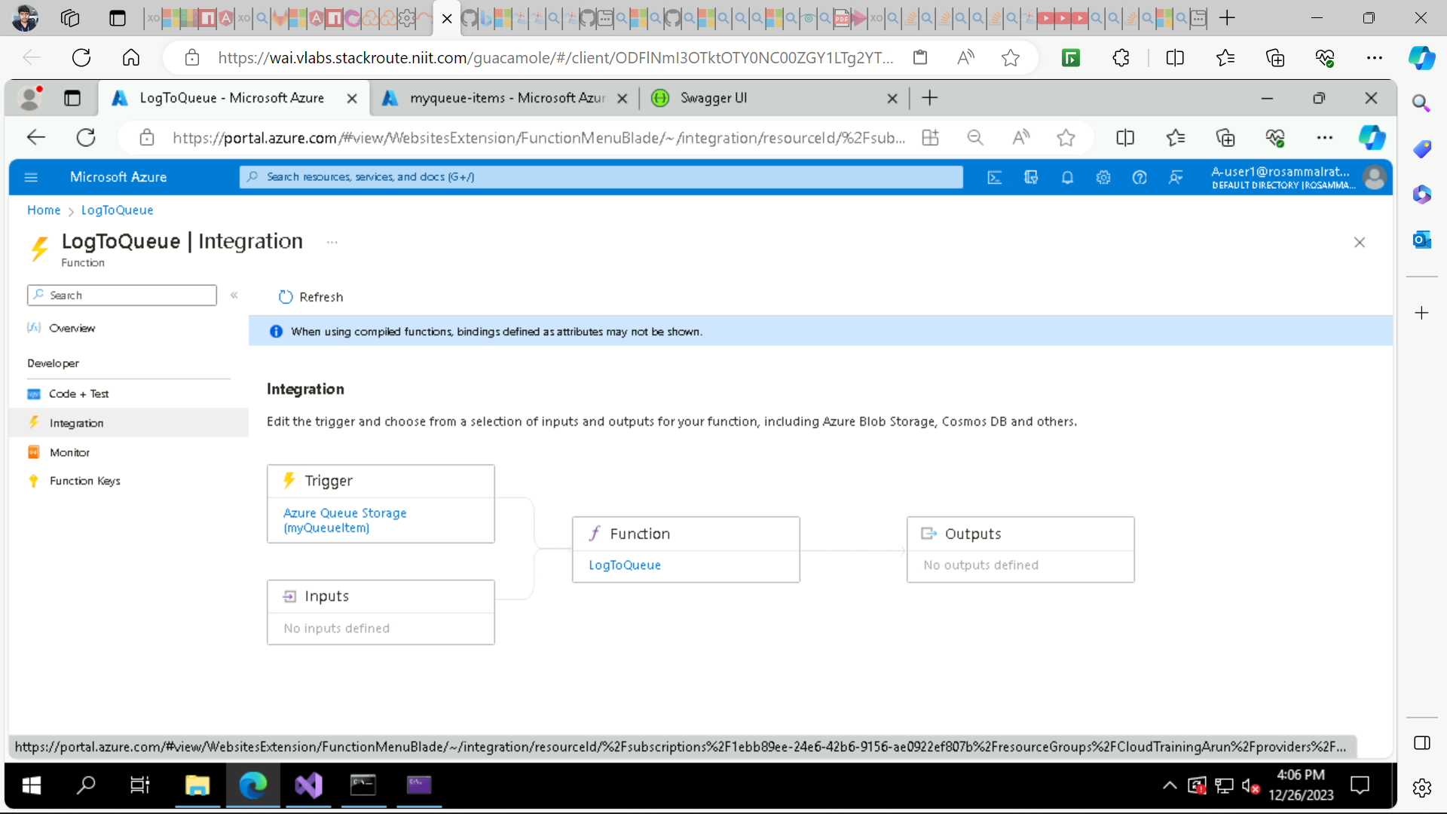

**Now execute the login endpoint in swagger then the message will be added to queue**

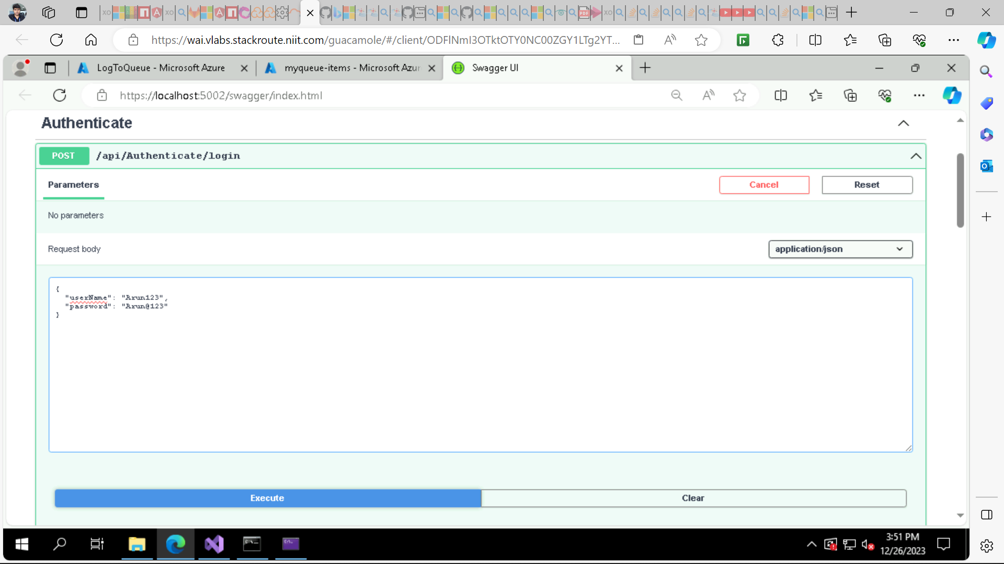

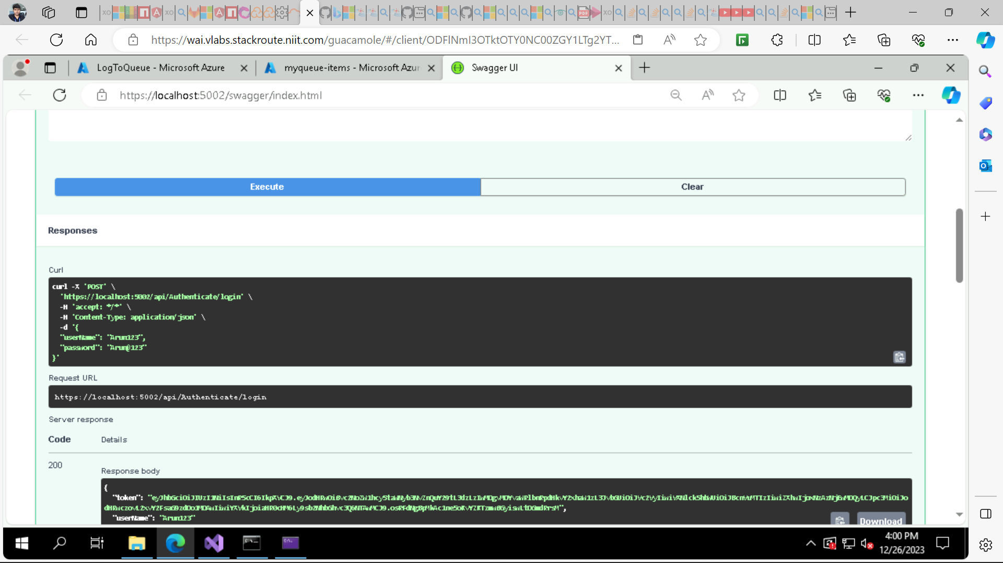

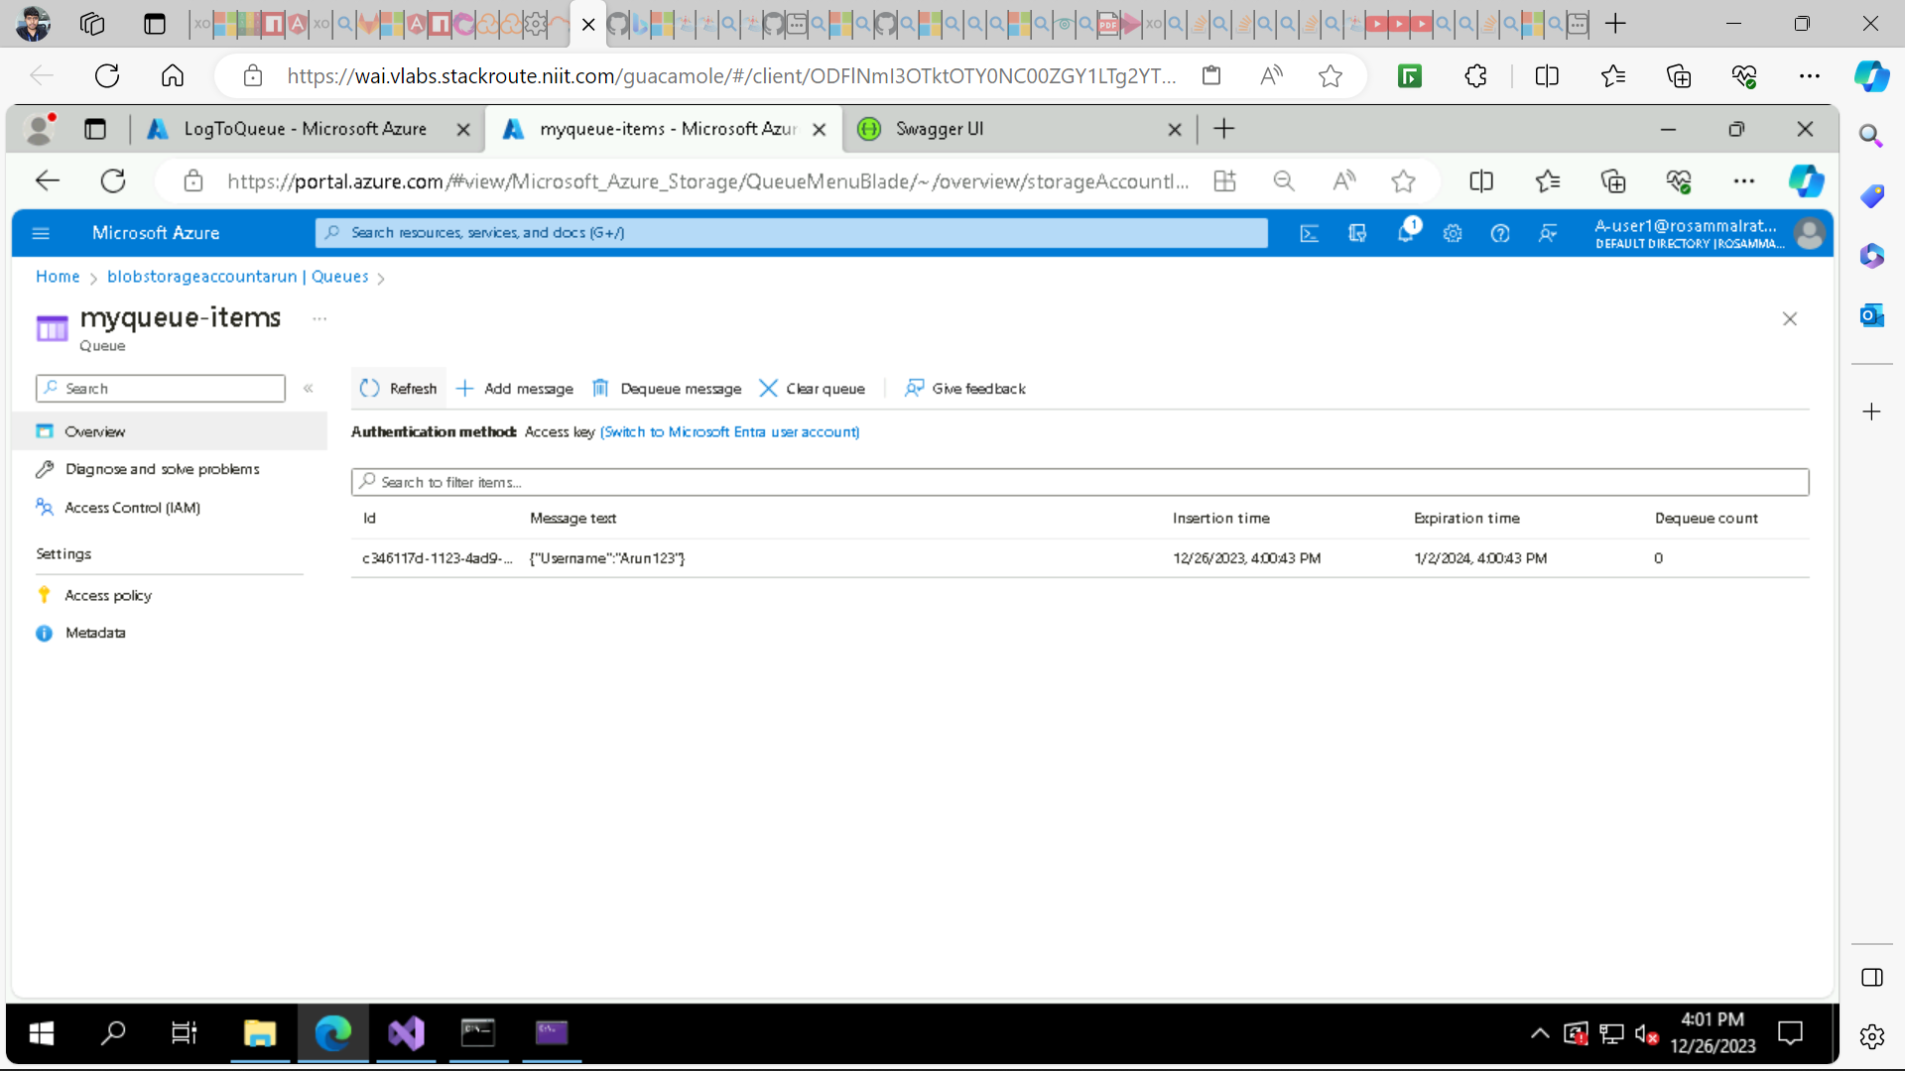

* **The message {“Username”: “Arun123”} is processed from queue as you can see in logs.**

